**KAIZEN Training Material**  **(Combined)**

**Revision History**

|  |  |  |  |
| --- | --- | --- | --- |
| Version | Date | Description | Author |
| 1.0 | 4/3/2025 | Training Material for both Designer and Developer Tutorials based on KAIZEN v24.10.1 | Amanda, Haryanto, Wei Han, Yong Heng, Yong Li |
| 2.0 | 28/3/2025 | Enhance tutorial steps | Amanda, Haryanto, Wei Han, Yong Heng, Yong Li |
| 2.2 | 26/5/2025 | Enhance Tutorial 1 Login Page to be mobile responsive | Amanda |

**Content Page**

**Introduction ............................................................................................................................... 8 Designer Materials .................................................................................................................. 12 Tutorial 0: Foundational Concepts ........................................................................................ 12** Studio Console .................................................................................................................... 13 App Designer ...................................................................................................................... 14 **Tutorial 1: Creating a Login page .......................................................................................... 25** Practical 1.1: Add Background Image ................................................................................. 27 Practical 1.2: Create Layout ................................................................................................ 31 Practical 1.3: Add 4 Text components ................................................................................. 37 Practical 1.4: Add Form Template ....................................................................................... 41 **Tutorial 2: Creating the Landing Page ................................................................................... 47** Practical 2.1: Create Initial Layout ....................................................................................... 49 Practical 2.2: Create heading .............................................................................................. 51 Practical 2.3: Add Image Background to root page .............................................................. 53 Practical 2.4: Add Button Group .......................................................................................... 57 Practical 2.5: Create responsive card .................................................................................. 60 **Tutorial 3: Creating the Listing Page (Optional) ................................................................... 81** Practical 3.1: Create Initial Layout ....................................................................................... 82 Practical 3.2: Create Heading and Breadcrumb ................................................................... 83 Practical 3.3: Create Search form ........................................................................................ 85 Practical 3.4: Create List header ....................................................................................... 103 Practical 3.5: Create Table ................................................................................................ 108 **Tutorial 4: Creating a Form with Steps ................................................................................ 135** Introduction: Form Fields ............................................................................................. 138 Introduction: Form Validation ....................................................................................... 139 Practical 4.1: Setting up the Form ..................................................................................... 140 4.1.1 Creating the Form skeleton ................................................................................. 140 4.1.2 Form Setup Complete ......................................................................................... 160 4.1.3 The Source Code Panel ..................................................................................... 161 Practical 4.2: Form Fields and Form Validation ................................................................. 165 4.2.1 Context ............................................................................................................... 165 4.2.2 Objective ............................................................................................................ 167 4.2.4 Course Info Form Validation ............................................................................... 175 4.2.5 Form Completion ................................................................................................ 178 Practical 4.3: Create the ‘Instructor Particulars’ Form ........................................................ 179 4.3.1 Context ............................................................................................................... 179 4.3.2 Objective ............................................................................................................ 179 4.3.3 Requirements ..................................................................................................... 180 4.3.4 Hints ................................................................................................................... 180

4.3.5 Expected Result ................................................................................................. 181 Practical 4.4: ‘Class Location’ Form .................................................................................. 182 4.4.1 Context ............................................................................................................... 182 4.4.2 Objective ............................................................................................................ 182 4.4.3 Requirements ..................................................................................................... 183 4.4.4 Creating a Field with 2 inputs .............................................................................. 184 4.4.5 Styling for the Inputs ........................................................................................... 188 4.4.6 Validation for both input fields ............................................................................. 191 4.4.8 Form Completion ................................................................................................ 193 Practical 4.5: Class Schedule Form ................................................................................... 194 4.5.1 Context ............................................................................................................... 194 4.5.2 Objective ............................................................................................................ 194 4.5.3 Requirements ..................................................................................................... 195 4.5.4 Custom Date Validation ...................................................................................... 196 4.5.5 Creating the Form field that can add new Rows .................................................. 201 4.5.6 Form Completion ................................................................................................ 213 Practical 4.6: Cascade Dropdown ..................................................................................... 214 4.6.1 Context ............................................................................................................... 214 4.6.2 Requirements ..................................................................................................... 214 4.6.3 Adding the Logic ................................................................................................. 214 Practical 4.7: Setting field values using Form Variables (Optional) .................................... 219 4.7.1 Context ............................................................................................................... 219 4.7.2 Requirements ..................................................................................................... 219 4.7.3 Adding the ‘MyInfo’ Button .................................................................................. 220 4.7.4 Adding the logic .................................................................................................. 223 Practical 4.8: Binding it all together ................................................................................... 225 4.8.1 Adding the code .................................................................................................. 225 4.8.2 Bind currentStep variable to Step Component .................................................... 226 4.8.3 OnClick Events for the Next buttons ................................................................... 227 4.8.4 Set conditions for the Forms to be visible ........................................................... 229 Practical 4.9: Modal Dialog Box ......................................................................................... 233 4.9.1 Steps for Creating a Modal Dialog ...................................................................... 233 4.9.2 Adding the logic for the Modal Dialog ................................................................. 235 And Finally… ..................................................................................................................... 243 Additional Information ........................................................................................................ 245 **Tutorial 5: Tables, Sorting and Pagination .......................................................................... 247** Practical 5.1: The Table Component ................................................................................. 248 5.1.1 Setting up the Table Component ........................................................................ 248 5.1.2 Setting the Table Headers .................................................................................. 251 5.1.3 Adding a Static Dataset to the Table ................................................................... 253 Practical 5.2: Table Sorting & Pagination .......................................................................... 258

5.2.1 Setup .................................................................................................................. 258 5.2.2 Sorting ................................................................................................................ 259 5.2.3 Pagination .......................................................................................................... 263 5.2.4 Page Sizing ........................................................................................................ 270 Practical 5.3: Download functionality (Optional) ................................................................. 273 5.3.1 Add a download button ....................................................................................... 273 5.3.2 Add the download code ...................................................................................... 274 5.3.3 Event bind the download button .......................................................................... 274 **Tutorial 6: Charts and Graphs .............................................................................................. 276**  Practical 6.1: Adding Graph Components .......................................................................... 276 6.1.1 Setup Steps ........................................................................................................ 276 6.1.2 Adding a Bar Graph ............................................................................................ 278 6.1.3 Sending Data to the Graph ................................................................................. 278 6.1.4 Adding a Pie Chart ............................................................................................. 280 6.1.5 Sending Data to the Graph ................................................................................. 280 **Tutorial 7: Using External JS Libraries ................................................................................ 283**  Practical 7.1: Importing a UUID JS Library (Demonstration) .............................................. 284 7.1.1 Setup Steps ........................................................................................................ 284 7.1.2 Adding the Library .............................................................................................. 287 7.1.3 Using the library .................................................................................................. 289 **Tutorial 8: Theme Designer .................................................................................................. 290**  Practical 8.1: Customize new theme ................................................................................. 291 Practical 8.2 Apply theme to your application .................................................................... 302 Additional Information ........................................................................................................ 304 **Tutorial 9: Preview Mode ...................................................................................................... 306**  Practical 9.1: Preview Mode and Collaborative Commenting ............................................. 306 Practical 9.2: Navigator Creation / Page Linking ................................................................ 308 9.2.1 Navigator Creation .............................................................................................. 309 9.2.2 Customize Navigator Menu ................................................................................. 311 9.2.3 Page Linking ....................................................................................................... 315 Practical 9.3: Page Tagging for External Review (Demonstration)..................................... 317 **Tutorial 10: Page Improvement ............................................................................................ 319**  Practical 10.1: Page Analysis with Page Scan (Demonstration) ........................................ 319 Practical 10.2: Mobile Responsive UI (Demonstration) ...................................................... 321 Practical 10.3: Translation using i18n (Demonstration) ...................................................... 323 Tutorial 11: Page Import From Template ................................................................................. 326 **Tutorial 12: Main and Micro Applications ............................................................................ 329**  Practical 12.1 Export and Import Pages to Main/Micro Apps (Optional) ............................. 331 Practical 12.2 Add Action Page Type to Main App (Optional) ............................................ 334 **Tutorial 13: Build screen skeleton ....................................................................................... 342**  Layout: Section vs Block ................................................................................................... 344

Layout: Block vs Cell ......................................................................................................... 351 Block VS Cell ............................................................................................................... 355 Example: Webpage walkthrough example ......................................................................... 356 Step 1: Create layout ................................................................................................... 357 Step 2: Divide cell horizontally for left block ................................................................. 357 Step 3: Split cell into two ............................................................................................. 357 Step 4: Add a card component .................................................................................... 358 Step 5: Add 3 Card components .................................................................................. 358 Step 6: Add a table component.................................................................................... 358 Step 7: Add components to the right block .................................................................. 360 Example ............................................................................................................................ 361 **Developer Materials .............................................................................................................. 362** Architecture ....................................................................................................................... 364 **Tutorial 14: Git Setup & Creation of New Branch ............................................................... 366** Practical 14.1: Connect with Gitlab .................................................................................... 366 Practical 14.2: Initialize Git Repository .............................................................................. 370 14.2.1 Frontend - Initialize Git Repository .................................................................... 370 14.2.2 Backend - Initialize Git Repository .................................................................... 372 Practical 14.3: Create and Switch to new branch .............................................................. 375 14.3.1 Frontend Git Branch Management .................................................................... 375 14.3.2 Backend Git Branch Management (Optional) .................................................... 378 **Tutorial 15: Master Code Integration ................................................................................... 380** Practical 15.1: Integrating Master Code............................................................................. 380 Practical 15.2: Multi language support (Optional) .............................................................. 384 **Tutorial 16: Custom Login Page Integration ....................................................................... 387** Practical 16.1: Login Page Integration ............................................................................... 387 **Tutorial 17: Database Designer ............................................................................................ 389** Practical 17.1: Setup Database and tables ........................................................................ 389 Connect to the PostgreSQL Server ............................................................................. 389 Creating a New Table .................................................................................................. 391 Adding Rows to Table ................................................................................................. 395 Benefits of Database designer ..................................................................................... 399 **Tutorial 18: Service / API Designer ...................................................................................... 401** Practical 18.1: Creating Service and Controller ................................................................. 401 Navigating the Service / API Designer ......................................................................... 401 Adding a Service ......................................................................................................... 402 Adding a Database ...................................................................................................... 405 Adding a Controller ...................................................................................................... 407 Adding Datasource & Configure API Endpoints ........................................................... 408 **Tutorial 19: Datasource API Binding ................................................................................... 412** Practical 19.1: Binding API to Table (GET) ........................................................................ 412

Practical 19.2: Binding API to Form submission (POST) ................................................... 420 Adding DataType & Datasource .................................................................................. 420 Import Remaining APIs ................................................................................................ 422 Binding to FormSubmission ......................................................................................... 423 Binding POST Form using “Encode” ............................................................................ 427 **Tutorial 20: Error Handling ................................................................................................... 430**  Practical 20.1: Redirect to custom error page .................................................................... 430 **Tutorial 21: Workflow Designer............................................................................................ 432**  Practical 21.1: Using default workflow (Claim-based routing) ............................................ 433 Practical 21.2: Designing and Deploying custom workflow ................................................ 437 Practical 21.3: Workflow observability ............................................................................... 457 **Tutorial 22: Code Generation (Backend) ............................................................................. 461**  Practical 22.2: Generating and Running Backend Code .................................................... 461 Generate Code ............................................................................................................ 461 Understanding Generated Backend Code Structure .................................................... 463 **Tutorial 23: Profile for local development ........................................................................... 470**  Practical 23.1: Running be-services .................................................................................. 471 Practical 23.2: Update Profile feature ................................................................................ 473 Tutorial 24: Customize Privilege for Page Permission ............................................................. 477 **Tutorial 25: Code Generation (Frontend) ............................................................................ 481**  Practical 25.1: Generating and Running Frontend Code ................................................... 481 Installation of Necessary Prerequisites: ....................................................................... 481 Generate Code ............................................................................................................ 481 Running nginx ............................................................................................................. 485 Running the generated code ....................................................................................... 486 Triggering Error ........................................................................................................... 487 **Tutorial 26: Push and Merge Code to Git ............................................................................ 489**  Practical 26.1: Frontend Git Management ......................................................................... 489 Create New Tag and Git Push ..................................................................................... 489 Merge Code to Main Branch + Push Main Branch ....................................................... 492 Practical 26.2: Backend Git Management (Optional) ......................................................... 496 Create New Tag and Git Push ..................................................................................... 496 Merge Code to Main Branch + Push Main Branch ....................................................... 497 Additional Information - Branch Management .................................................................... 500 **Tutorial 27: Job Scheduler ................................................................................................... 505**  Practical 27.1: Creating and Running Job (Demonstration) ............................................... 506 **Tutorial 28: IAM ..................................................................................................................... 513**  Court Case Example: How "Subject" Works .......................................................... 521 Practical Example: Judge Case Assignment .......................................................... 521 Practical 28.1: Assignment of custom menu (Optional) ..................................................... 522 Practical 28.2: Endpoint Assignment (Optional) ................................................................ 525

**Introduction**

Welcome to the ***KAIZEN Training Program***! We are thrilled to have you embark on this learning journey with us. This comprehensive guide is designed to provide you with the information and resources you need to make the most out of your training experience.

**About KAIZEN**

KAIZEN is a cutting-edge agile development stack designed for individuals and teams who want to accelerate application development without compromising on flexibility and customization.

Our platform is built to simplify the entire software development lifecycle, from ideation to deployment, and subsequently to maintenance.

|  |
| --- |
|  |

**Key Features**

In this training, we will be walking you through the following features:

● **App Designer**

The App Designer feature empowers users to create user-friendly pages effortlessly within a visual workspace. With a drag-and-drop interface, you can design and arrange components intuitively, bringing your project to life without writing complex code. Whether you're building interactive interfaces or structuring layouts, the App Designer streamlines the entire process, making development faster and more efficient.

● **Theme Designer**   
The Theme Designer allows for the customization of the application's visual appearance, ensuring a consistent and appealing user experience. It enables designers to apply brand-specific styles across the application, adjusting colors, fonts, and layouts. This feature enhances accessibility and visual appeal for users across different regions   
 ● **Main and Micro Application**   
This feature encompasses the architecture where a central main application coordinates with multiple micro applications. The main app serves as the core, integrating various micro apps that handle specific functionalities, promoting modularity and scalability.

● **Git Setup and Branch Management**   
Git Setup and Branch Management ensures smooth collaboration by enabling version control, branching, and code integration. Developers can work on separate features without conflict, while maintaining a clear and organized codebase. This tool supports efficient team workflows and ensures up-to-date code management.

● **Workflow Designer**   
The Workflow feature allows for the automation of business processes through predefined steps. Users can design and execute workflows that involve multiple stages and actors, ensuring tasks are completed in a systematic and efficient manner.

● **Master Code**   
The Master Code feature provides a centralized system for managing reference data used across the application. It supports multilingual capabilities, allowing for localization and consistent data management.

● **Database Designer**   
The Database Designer simplifies database schema creation and management, allowing developers to define tables and relationships with ease. It ensures efficient data organization, accessibility, and scalability for the application. This feature improves performance and helps optimize data storage for future development.

● **Service Designer**   
The Service Designer streamlines the creation and management of APIs, connecting application components and external services. It provides an intuitive interface to define endpoints and parameters, making API development faster and more efficient. This feature enhances backend and frontend communication, supporting complex application workflows.

●  **Job Scheduler**   
The Job Scheduler enables the scheduling and execution of tasks at specified times or intervals. It supports various scheduling strategies, ensuring that tasks are performed efficiently and on time, with detailed configuration options for each job.

● **Code Generation**   
The Code Generation feature automates the creation of boilerplate code, reducing development time and errors. It helps in generating consistent and standardized code structures for various components, ensuring best practices and efficiency in the development process.

|  |
| --- |
|  |

**Getting Ready - Account Setup**

Before you dive into the exciting features and possibilities that await you, let's ensure you are fully prepared to make the most of your experience. Follow these steps to get started:

Accounts have been created for all trainees in the Cloud Development Environment as a Service (DaaS) Environment.

DaaS Environment URL: <https://kaizen-daas.toppanecquaria.com/#/login>

**User Domain**: AGP Designer   
**Username**: username (Example: **username**@toppanecquaria.com)

**Overview of the Training**

This training program is designed to equip participants with the essential knowledge and skills to use the KAIZEN platform effectively. It is divided into two main phases: Designer Tutorials and Developer Tutorials, allowing for a comprehensive understanding of application design and development.

Participants will start by learning how to create visually appealing and functional user interfaces in the Designer phase. Then, they will delve into the Developer phase to build robust backend systems and workflows, ensuring the seamless integration of features.

**Training Goals:**

**Designer Phase (Tutorial 1 to 13):**

● Understand the fundamentals of creating user-friendly interfaces.

● Learn to design and customize pages such as login, landing, and listing pages.

● Gain expertise in creating forms with steps, tables with sorting and pagination, and visualizing data through charts and graphs.

● Explore advanced features like theme customization, translations, and screen skeleton creation.

● Understand how to structure and manage micro-application architecture.

**Developer Phase (Tutorial 14 to 28):**

● Master Git setup, branching, and code integration workflows.

● Learn to design custom login pages and manage databases effectively.

● Develop and bind APIs with data sources for seamless connectivity.

● Implement error handling, workflow automation, and job scheduling.

● Explore code generation for backend and frontend development.

● Manage application deployment with local development profiles and Git integration. ● Explore IAM features and assign custom menus, pages, and endpoints.

**Designer Materials**

**Tutorial 0: Foundational Concepts**

This tutorial covers the following Learning Objectives:   
 ● Understand the basic fundamentals, building blocks, concepts of saving, previewing, and publishing in KAIZEN.

Foundational concepts are the building blocks for working with KAIZEN. In this tutorial, we will explore the platform’s core functionalities, such as saving progress, previewing work in progress, and publishing changes to ensure a smooth and efficient development process.

|  |
| --- |
|  |

Studio Console

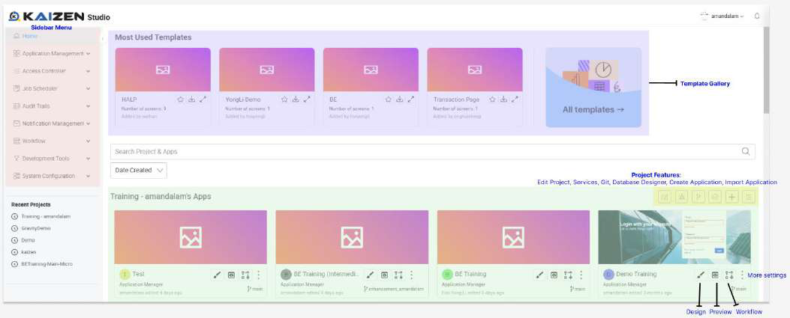

Note that not all the **Sidebar Menu Items** and **Project Features** will be accessible in your trainee account due to Identity and Access Management (IAM) access restrictions. In order to access the features, the respective roles need to be granted to your user account.

In a project scenario, our application offers predefined roles that can be assigned to users, such as **Project Manager**, **Developer**, **UI Designer**, **Internal Viewer**, and **External Viewer**. Each role is tailored with specific access levels, enabling precise control over features and   
functionalities for managing both applications and the overall project.

For more information on the IAM features, you may refer to Tutorial 28.

|  |
| --- |
|  |

App Designer

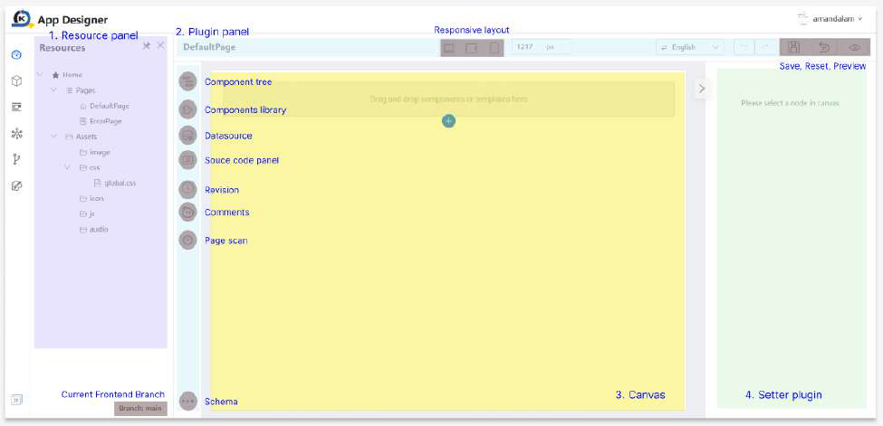

1. **Resource panel**: The Resource Panel is where you manage and access various pages related to your application.

2. **Plugin panel**: The Plugin Panel is a section that displays and allows you to manage the plugins or extensions integrated into the platform or software. Plugins enhance functionality or provide additional features.

● **Component Tree**: The Component Tree is a hierarchical view that represents the structure of the components within your project. It visually organizes and displays the relationships between different elements.

● **Components Library**: The Components Library is a collection of pre-built components that you can easily drag and drop into your application.

● **Datasource**: Datasource refers to the data connection or repository from which your application retrieves information such as API.

● **Source code panel**: The Source Code Panel is where you can view and edit the underlying source code of your project. It provides direct access to the code for users who prefer or need to work at the code level.

● **Revision**: The Revision feature allows you to track changes made to your project over time. It provides a version history, making it easy to revert to a previous state if needed.

● **Comments**: Comments are annotations or notes that you can add to your application. They provide explanations, insights, or instructions for yourself or collaborators.

● **Page scan**: Page Scan is a tool that analyzes and checks your project or application for potential issues, errors, or improvements. It helps ensure the quality and performance of your work.

● **Libraries**: Libraries are collections of reusable code or resources that can be imported into your project. They save time and effort by providing pre-built functionalities.

● **Schema**: Schema defines the structure and organization of your data in JSON format. It outlines the relationships, constraints, and rules governing how data is stored and accessed.

● **Responsive layout**: Responsive Layout refers to the design approach that ensures your project adapts and looks good on various devices and screen sizes, providing a consistent user experience.

● **Save Draft, Publish, Reset, Preview**: Save allows you to save your project progress, Reset reverts changes, and Preview enables you to see how your project will appear or function before finalizing.

● **Page Lock**: Mechanism designed to control and manage collaborative editing in a shared project environment. This ensures that critical or in-progress work on a page is not unintentionally modified or overwritten by others, providing a conflict-free editing process.

3. **Canvas**: The Canvas is the visual workspace where you design and arrange the elements of your project. It's the area where you create and build.

● **Component operation**: Component Operation involves managing and manipulating individual elements or components within your project, such as copying, locking, or deleting them.

4. **Setter plugin**: A Setter Plugin is a tool or extension that allows you to configure or set specific properties or attributes of components within your project.

We will now explore the fundamental concepts behind some key features of the App Designer listed above. These will be used heavily during the creation of your application screens. To

demonstrate these features in action, we have prepared a shared project that all trainees can access - **TrainingFoundation**.

|  |
| --- |
|  |

This setup allows you to observe how these features behave in a collaborative environment, particularly when actions are performed by other project members. You will also gain insight into how these actions affect visibility and interaction from your perspective.

**Save Draft**

The Save Draft feature allows you to save your project progress in KAIZEN app designer if you wish to save the progress without finalizing the design. In the below steps, we will guide you through the save draft function in KAIZEN designer.

● First, we will amend the text below and save the draft.

|  |
| --- |
|  |

|  |
| --- |
|  |

● After which, you may click on the revision button and you can see that a draft has been saved in revision.

● We also have an auto-save mechanism every 15 minutes in the app designer. This time period can be configured at system level depending on project needs.

|  |
| --- |
|  |

● Now, when you close the KAIZEN App Designer and re-open the same application again, or navigate to another page and back to this same page, it will prompt open draft revision dialog if there is a draft saved on this page.

|  |
| --- |
|  |

○ Click “Yes” if you wish to open the draft saved previously. It will open the page that we saved previously in draft.

○ Click “No” if you wish to open the page from the latest revision.

● Do take note that when you save a draft, it is stored privately in your account’s application. This means that only you have access to it, and other users cannot view or edit your saved work.

● Revision history from another account differs, where the draft will not be visible to another user.

|  |
| --- |
|  |

● However, if you wish to save your changes and visible to other users, you have to **publish** the page.

**Publish Page**

The Publish Page feature allows you to save your finalized page in KAIZEN app designer. Once published, your page becomes visible to other users. This means that team members,   
collaborators, or any designated user can view and interact with your content. It transforms your private draft into a shared resource. In the below steps, we will guide you through the publish function in KAIZEN designer.

● First, let's try to amend the text below and publish the page.

|  |
| --- |
|  |

|  |
| --- |
|  |

● Click on the revision button, and you can see a new revision history is updated.

|  |
| --- |
|  |

● Now, close the KAIZEN App Designer and re-open the same application again. It will not prompt open draft revision dialog anymore as currently there is no draft saved in the application.

● When you publish the page, it will be visible to other users in the project. This means that other users can view or continue editing your work which has been published. The revision history from another account will be the same.

**Preview Page**

The Preview Page feature allows you to see how your page will look and function.The preview feature provides a real-time view of your page, showing exactly how it will appear to end-users.

Besides, you also can test the functionality of your page, including buttons, links, forms, and other interactive elements. This helps you identify and fix any issues before making the page live.

|  |
| --- |
|  |

|  |
| --- |
|  |

Note that once you click on the preview button, you will be prompted to **select the navigator roles** in which you want to preview. This functionality aids in the configuration of necessary privileges and roles during the design stage to restrict the **access of pages** through the **navigator menus** in the application. However, in this training tutorial, we will not need to indicate or choose the user domain or role name. Simply click on ‘Confirm’ to skip this selection and your application preview without any access restrictions.

|  |
| --- |
|  |

For example, you may configure at application level by clicking on this icon for more settings. This is where you can configure the relevant privileges > roles > navigator for your application pages. We will cover more on navigator in Practical 9.2and more on privileges and roles in Tutorial 28on IAM.

**Page Lock**

The Page Lock feature is a mechanism designed to control and manage collaborative editing in a shared project environment.This feature ensures that critical or in-progress work on a page is not unintentionally modified or overwritten by others, maintaining the integrity of the content.

When a page is locked, it becomes restricted for other users. This means no other users can make significant changes and publish the page until it has been unlocked by either the user who locked the page initially or the project manager.

|  |
| --- |
|  |

● In the shared **TrainingFoundation** project, we have locked the Login page to illustrate how this feature functions.

|  |
| --- |
|  |

● You can view the locked page and experience first hand what happens when they try to perform certain actions.

|  |
| --- |
|  |

● Notice that if you make changes then **preview** or **publish** the page, it will be restricted.

|  |
| --- |
|  |

**Reset**   
The Reset feature will reset your page to an empty page, allowing the user to remove all the components added in the page with a reset button.

Note that you will **not** be able to undo this change!

|  |
| --- |
|  |

|  |
| --- |
|  |

**Tutorial 1: Creating a responsive Login page**

This tutorial covers the following Learning Objectives:

● Understand how to design a basic responsive login page using KAIZEN ● Experience the benefits of KAIZEN for rapid development.

A login page is the entry point for user authentication, ensuring secure access to your application. In this tutorial, we will create a login page using KAIZEN

|  |
| --- |
|  |

In KAIZEN Studio, you will see a Training Project which has been created with your trainee username. An empty application, ‘Designer Training’ has also been created for you to design and create your application following the tutorials below.

You can start editing the Designer Training App by clicking on the highlighted icon as shown in the image below.

|  |
| --- |
|  |

Since we are creating a Login page, change the Name and Page ID of the ‘DefaultPage’ to ‘LoginPage’ and click **Save**.

|  |  |  |  |
| --- | --- | --- | --- |
| |  | | --- | |  | | |  | | --- | |  | |

You will see a success message pop up:

|  |
| --- |
|  |

Practical 1.1: Add Background Image

● **Download** image url: [Tutorial1-Background.png](https://drive.google.com/open?id=1G__sWbwErHLWLV4NzkSCybmF88BJwfba)  
● **Upload** the image asset in the resources panel by clicking on **+** icon

|  |
| --- |
|  |

● Click **Save**

|  |
| --- |
|  |

● Select **Page** from the **Component Tree** and navigate to **Styles** tab ○ Step 1: Click on **Component Tree**  
○ Step 2: Click on **Page**   
○ Step 3: Click on **Styles**   
○ Step 4: Scroll down to **Background section**

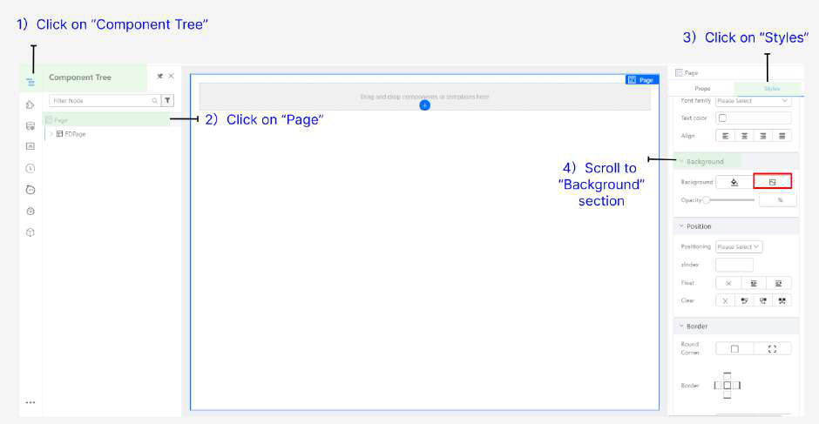

● **Click** on the image upload icon

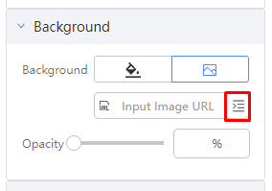

● **Select** on the background uploaded earlier and click **Confirm**

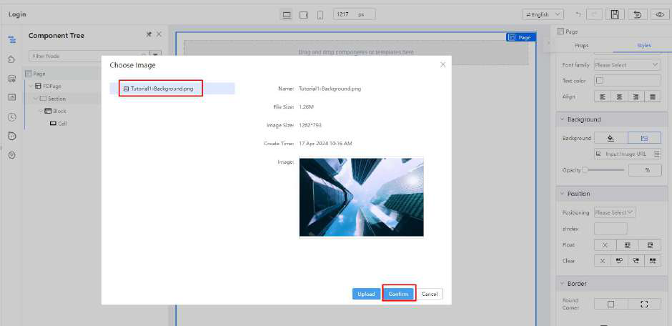

● **Set** the background-size (Size) as **Cover**

|  |
| --- |
|  |

● **Set** the Repeat Display as **No-repeat**

|  |
| --- |
|  |

● **The resulting** styles will be as follows:

|  |
| --- |
| **Styles**  height: 100%;  background-image:  url(/gateway/console/api/v1/asset/designertraining/assets/image/Tutorial1-Background.png?branchName=main);  background-size: cover;  background-repeat: no-repeat; |

Expected result will look like:

|  |
| --- |
|  |

Practical 1.2: Create Responsive Layout

● Click on the empty **Cell** and navigate to the breadcrumb at the top right corner of your page. Click to select the parent component **Block** to be selected instead.

|  |
| --- |
|  |

|  |
| --- |
|  |

● In order to design this login page to be responsive and adapt to smaller screen sizes, we will be utilising the Block component to design the left and right panel of the page. For more information, you may refer to Tutorial 13.

● With the **Block** component selected, hover on the middle white dot for the Cut icon to appear, click on it to vertically cut your block into two.

|  |
| --- |
|  |

|  |
| --- |
|  |

● Click on **Components Libraries**  
● Drag a **Box** component to each cell shown in screenshot below

|  |
| --- |
|  |

● Select the **Cell (Outer layer of Box)** by **clicking** on the containing area

|  |
| --- |
|  |

● **Set** the following properties

|  |
| --- |
| **Props**  Horizontal alignment: “center” |

|  |
| --- |
|  |

● Set the same for the cell on the right so achieve the following

|  |
| --- |
|  |

● Select the first **Box (Left)**, and set

|  |
| --- |
| **Props**  Justify:“flex-start” Align:“flex-start” |

|  |
| --- |
|  |

● In the same **Box**, and set the **Styles**

|  |
| --- |
| **Styles**  width: 65%;  height: 100%;  margin-top: 50px; |

The height of the box is set to 100% so that it is relative. Since it is empty with no child components inside it yet, it is expected for the box to currently look empty as follows.

|  |
| --- |
|  |

● Select the second **Box (Red-highlighted)**

|  |
| --- |
|  |

● Set the **Styles** to the following:

|  |
| --- |
| **Styles**  margin-top: 50px;  width: 70%;  height: 100%;  background-color: #ffffff;  border-radius: 10px; |

|  |
| --- |
|  |

The following sections (**Layout**, **Background**, **Border**) are to be edited:

|  |
| --- |
|  |

Similar to the box on the left, due to the relative height configured in percentage, the expected result will be:

|  |
| --- |
|  |

You will still be able to select your respective **Box** components under the left and right **Block** components via the **Component Tree**.

|  |
| --- |
|  |

Practical 1.3: Add 4 Text components

● Ensure that the left **Box** component is selected ● In the **Component Library**  
 ○ **Search** for keyword “**text**”,   
 ○ Drag one **Text** Component into **Box (left)**

|  |  |
| --- | --- |
|  |  |

● **Set** the following properties and styles

|  |
| --- |
| **Props**  Text: EduService  **Styles**  margin-top: 10%;  font-size: 50px;  line-height: 50px;  color: #3c89fc;  font-weight: 700;  -webkit-text-stroke: 2px white; |

|  |
| --- |
|  |

● Expected result will be:

|  |
| --- |
|  |

● Add three additional text components and set the following properties and styles:

|  |  |
| --- | --- |
| Second text | **Props**  Text: Your One-stop Portal for Education Administration  **Styles** |

|  |  |
| --- | --- |
|  | font-size: 15px;  color: #ffffff; |
| Third text | **Props**  Text: Login with your account  **Styles**  margin-top: 35%;  font-size: 28px;  font-weight: 600;  font-family: Helvetica;  color: #ffffff; |
| Fourth text | **Props**  Text: Empowering Minds, Shaping Futures!  **Styles**  font-size: 20px;  font-family: Helvetica;  font-style: italic;  color: #c8d8ff; |

● Your completed left box should look like this:

|  |
| --- |
|  |

Practical 1.4: Add Form Template ● In the **Component Library:**  
 ○ **Search** for “**Form Template**” ○ Drag the component into right **Box**

|  |
| --- |
|  |

|  |
| --- |
|  |

○ Set the **Styles of** Form Template

|  |
| --- |
| **Styles**  margin-top: 10%;  width: 90%;  height: 100%;  font-weight: 600; |

|  |
| --- |
|  |

● **Select** the first **Form Item** by clicking on the **label “Email”**

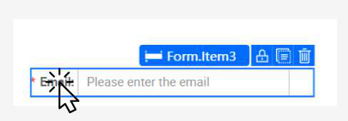

● **Set** the properties to

|  |  |  |
| --- | --- | --- |
| **Props**  Size: Large  Label Position: Top   |  |  | | --- | --- | |  |  | |

● **Select** the **Form Item (label** “**Password**” **)** and set

|  |  |  |
| --- | --- | --- |
| **Props**  Size: Large  Label Position: Top   |  |  | | --- | --- | |  |  | |

● **Delete** the **Reset** button by clicking on trash icon

|  |
| --- |
|  |

|  |
| --- |
|  |

● **Select** the last form.item by clicking on the containing area (**Beside Submit button**)

|  |
| --- |
|  |

● **Set** the last form item with the following:

|  |
| --- |
| **Props**  Label: Don't have an account? Sign up  Size: Large  Label Alignment: Left  Layout   Col Span: 24  Label Column   Span: 18   Offset: 0  Wrapper Column   Span: 6   Offset: 0  **Styles**  text-align: right; |

|  |  |  |
| --- | --- | --- |
| |  | | --- | |  | |  | |

● **Set** the last form item (Submit button) with the following:

|  |
| --- |
| **Props**  Label: Login  **Styles**  background-color: #1352f1; |

|  |
| --- |
|  |

|  |
| --- |
|  |

The expected result will be:

|  |
| --- |
|  |

This page is also designed to be mobile responsive and adapts to smaller screen sizes. You may toggle between the screen sizes using the **responsive layout** at the top of the page here.

|  |
| --- |
|  |

Since we have used blocks to design the two left and right segments of this login page, when toggled to mobile view, the blocks automatically stack in a user-friendly interface as follows.

|  |
| --- |
|  |

For more information on mobile responsive features, refer to Practical 10.2.

For more information on the process of structuring the screen layout to ensure flexibility and for it to adapt to varying screen sizes, refer to Tutorial 13.

**Tutorial 2: Creating the Landing Page**

This tutorial covers the following Learning Objectives:

● Understand how to design and build an effective landing page using KAIZEN.

● Learn how to structure the landing page to provide intuitive navigation and a welcoming user experience.

● Explore how KAIZEN simplifies the process of customizing the landing page, including adding images, text, and buttons.

In this tutorial, we will walk you through the steps to design and build an effective landing page using KAIZEN. You'll learn how to structure the page to ensure intuitive navigation and create a welcoming user experience. Additionally, we’ll explore how KAIZEN makes customizing the landing page easy, allowing you to add images, text, and buttons seamlessly.

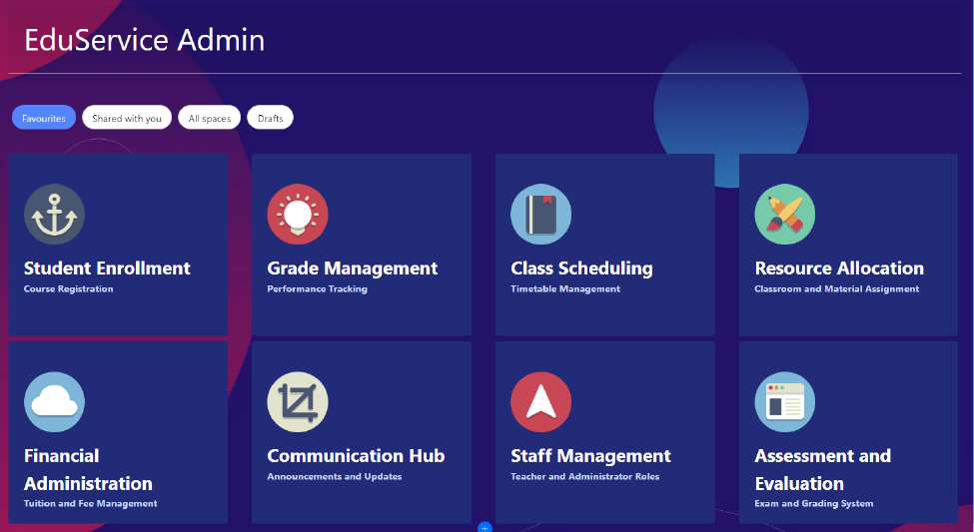

In order to create a new page, click on ‘Create Page’ of your application’s Pages and indicate your page details accordingly before clicking **Save**.

|  |
| --- |
|  |

|  |
| --- |
|  |

|  |
| --- |
|  |

Practical 2.1: Create Initial Layout  
 ● Click **Add Block Below** (**2 times**) to add 2 more block

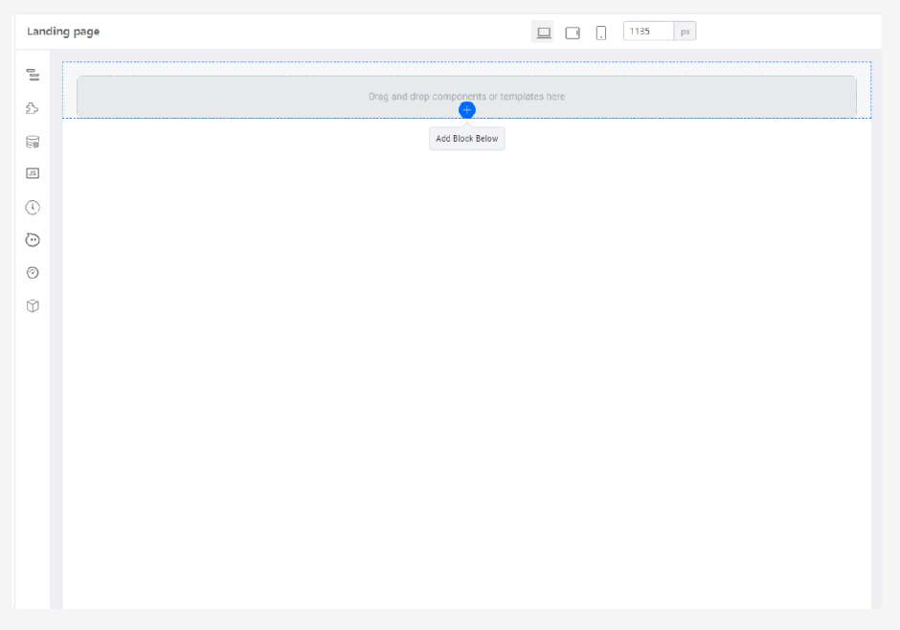

The expected result will be:

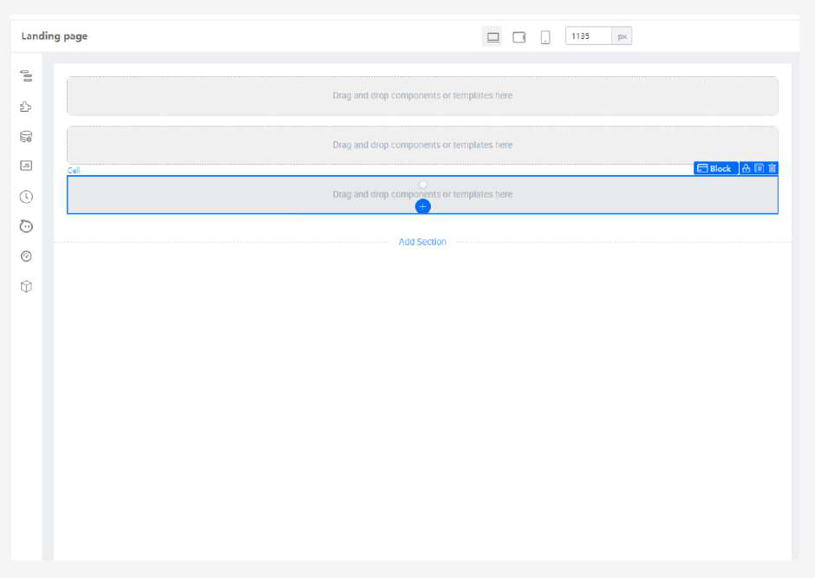

Practical 2.2: Create heading  
 ● In the **first top Cell**, add a **Text** component

|  |
| --- |
|  |

● **Set** the properties and styles to

|  |
| --- |
| **Props**  Text: EduService Admin  **Styles**  margin-top: 15px;  margin-left: 25px;  font-size: 50px;  color: #ffffff; |

The expected result will be:

|  |
| --- |
|  |

● Add a **Divider (**in the **first top Cell,** below the ‘EduService Admin’ text**)**

|  |
| --- |
|  |

● Delete the text “Delimiter” from the Divider’s label

|  |
| --- |
|  |

Practical 2.3: Add Image Background to root page

● **Download** image url: [Tutorial2-Background.png](https://drive.google.com/open?id=126MN02HvFv--x-CVDYqlxl_01SYP2BMF)● **Upload** the image asset in the resources panel

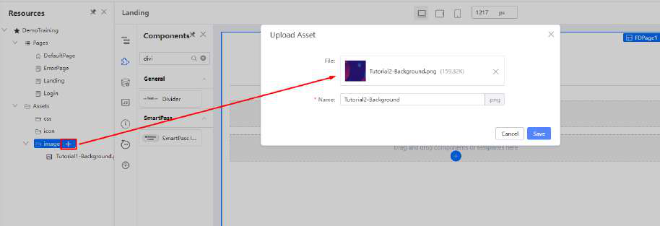

● Select **Page** (you can do via either of the following): ○ Select **Page** from the **Component Tree** OR ○ Via the **navigation** above the Prop and Style tabs

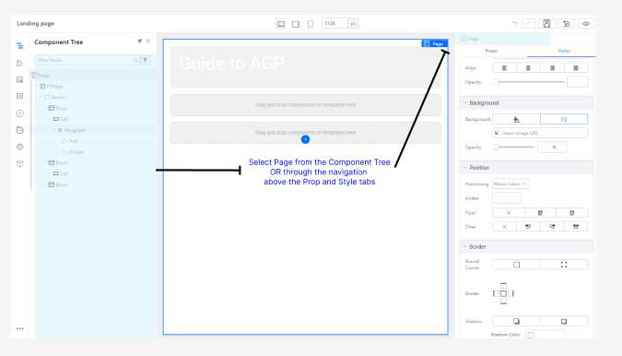

● **Click** on the image upload icon



● **Select** on the background uploaded earlier and click **Confirm**

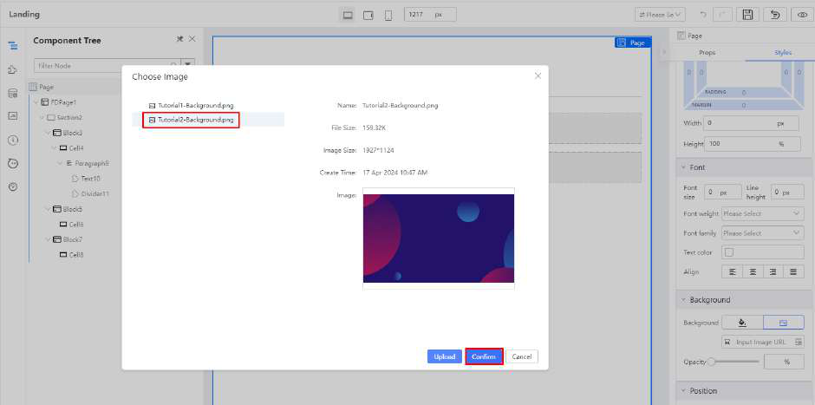

● **Set** the following styles

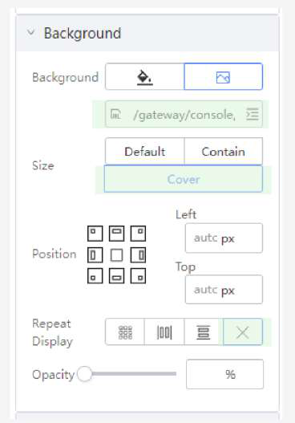

The resulting styles will be as follows:

|  |
| --- |
| **Styles**  height: 100%;  background-image:  url(/gateway/console/api/v1/asset/DemoTraining/assets/image/Tutorial2-Background.png?branchName=main);  background-size: cover;  background-repeat: no-repeat; |

The expected result will be:

|  |
| --- |
|  |

Practical 2.4: Add Button Group

● In **Component Library:**  
 ○ **Search** for **“Button Group”**

|  |
| --- |
|  |

○ Drag into **Block** (second block as shown in screenshot below) ○ **Set** the Button Group with the following property

|  |
| --- |
| **Prop**  Button size: Large |

|  |
| --- |
|  |

● Select the **first Button** and set

|  |
| --- |
| **Props**  Content: Favourites  **Styles**  margin: 0 5px 0 5px;  border-radius: 30px; |

|  |
| --- |
|  |

● Select the **second Button** and set

|  |
| --- |
| **Props**  Content: Shared with you  **Styles**  margin: 0 5px 0 5px;  border-radius: 30px; |

|  |
| --- |
|  |

● Click **Duplicate (2 times**) to duplicate 2 more buttons

|  |
| --- |
|  |

● **Set** the third button with the following property:

|  |
| --- |
| **Props**  Content: All spaces |

● **Set** the fourth button with the following property:

|  |
| --- |
| **Props**  Content: Drafts |

The expected result will be:

|  |
| --- |
|  |

Practical 2.5: Create responsive card

In this practical, we will guide you through creating a simple, responsive card component. A responsive card adapts to different screen sizes, providing a clean and readable layout for your content on mobile, tablet, and desktop devices.

● In **Component Library**:   
 ○ **Search** for “**Card”**

|  |
| --- |
|  |

○ Drag into **Cell (Last cell shown in screenshot below)**

|  |
| --- |
|  |

● **Set** the Card with the following

|  |
| --- |
| **Props**  Title: (Empty)  **Styles**  height: 300px;  background-color: #222B78;  min-width: 23%;  margin-bottom: 5px;  margin-right: 5px;  width: 300px; |

|  |
| --- |
|  |

● In **Component Library**:   
 ○ **Search** the “**Picture**” component

|  |
| --- |
|  |

○ Drag it into the **Card** component (**Blue background as shown in screenshot**  **below**)

|  |
| --- |
|  |

● **Set** the Picture component with the following:

|  |
| --- |
| **Styles**  width: 100px;  height: 100px;  margin-left: 25px;  margin-top: 50px; |

|  |
| --- |
|  |

● In **Components Library**:   
 ○ **Search** for **Box** component

|  |
| --- |
|  |

○ Drag a **Box** below the Picture component

|  |
| --- |
|  |

● **Set** the **Box** with the following:

|  |
| --- |
| **Props**  Justify: flex-start  Align: flex-start  **Styles**  padding-left: 25px;  padding-bottom: 50px;  width: 100%; |

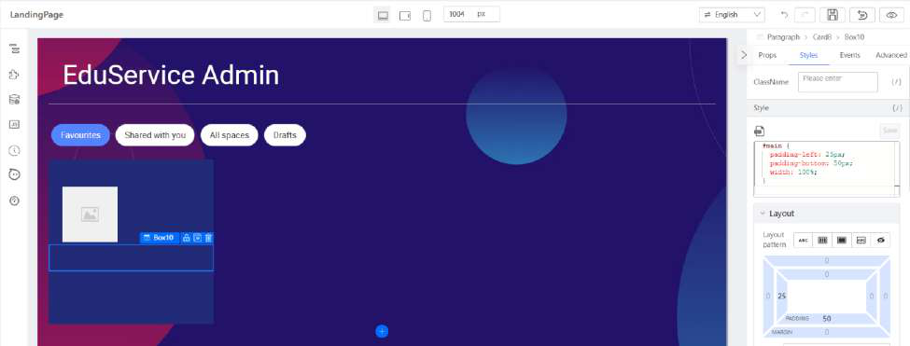

● Drag **Text** component (**2 times**) into the **Box (illustrated below)**

|  |
| --- |
|  |

● Set the **first Text** with the following:

|  |
| --- |
| **Props**  Strong: true  **Styles**  font-size: 30px;  text-align: left;  color: #ffffff;  margin-top: 15px; |

|  |
| --- |
|  |

● Set the **second Text** with the following:

|  |
| --- |
| **Props**  Strong: true  **Styles**  color: #c6d6ff;  font-size: 16px; |

|  |
| --- |
|  |

● **Download** these 8 images from this folder: [Tutorial2-images](https://drive.google.com/open?id=1hfo1MvEC7bRPmBxXauyvfNkA8fYgVUT6)● **Upload** these images into asset in the resources panel

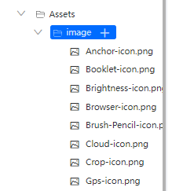

● **Download** [card-json-data.txt,](https://drive.google.com/open?id=10Q8fuMikEJh5WWOrf3fmQLsjMe8NqrUR) edit all the image path to **your app id** as located here.

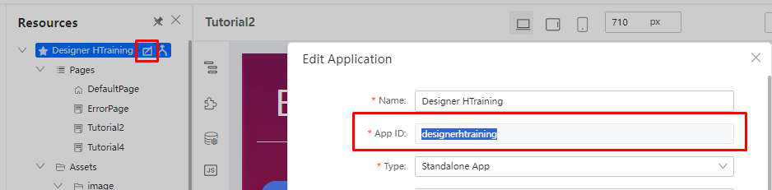

● **Edit** the image path   
E.g   
/gateway/console/api/v1/asset/{yourapp-id}/assets/image/Anchor-icon.png?branchName=main

|  |
| --- |
|  |

● Select the **Card component** and navigate to **Advanced** (**Top Right Corner**) tab

|  |
| --- |
|  |

● **Click** on **Bind data**

|  |
| --- |
|  |

● In the pop-up, **update** the data with the following value (**card-json-data.txt below**):

|  |
| --- |
|  |

The expected result will be:

|  |
| --- |
|  |

● Select **Picture component** by **clicking** on it

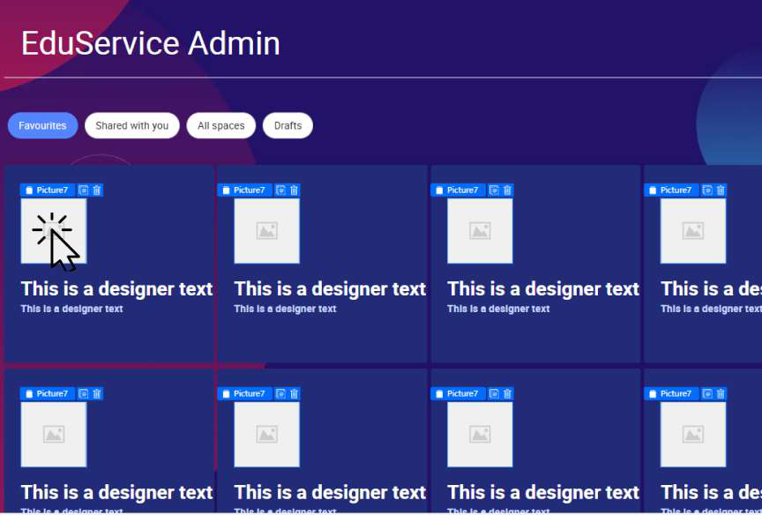

|  |  |
| --- | --- |
| ● Under **Image** property, click on **Switch Setter icon** |  |

|  |
| --- |
|  |

● In the dropdown, select **Variable Input** to bind data:

|  |
| --- |
|  |

|  |
| --- |
|  |

● In the popup box, update the value “**this.item.imageUrl**” under **Bind variables**

|  |
| --- |
| **Props**  Image (**Variable binding**): this.item.imageUrl |

|  |
| --- |
|  |

● Click **Confirm** to update the value

|  |
| --- |
|  |

The expected result will be:

|  |
| --- |
|  |

● Select the **Heading Textbox** and click on **Variable Binding**

|  |
| --- |
|  |

|  |
| --- |
|  |

● Set the following property

|  |  |  |  |  |
| --- | --- | --- | --- | --- |
| **Props**  Text (**Variable binding**): this.item.heading   |  |  | | --- | --- | |  | | |  |  | |

● Select the sub-heading Textbox and set the following:

|  |
| --- |
|  |

|  |  |  |
| --- | --- | --- |
| **Props**  Text (**Variable binding**): this.item.subHeading   |  | | --- | |  |  |  | | --- | |  | |

The expected result will be:

|  |
| --- |
|  |

● **Click** on the Container Area and ensure **Cell** is selected

|  |
| --- |
|  |

● **Set** the following properties

|  |
| --- |
| **Props**  Horizontal alignment: space-around |

|  |
| --- |
|  |

The expected result will be:

|  |
| --- |
|  |

**Tutorial 3: Creating the Listing Page (Optional)**

This tutorial covers the following Learning Objectives:

● Understand how to design and implement a basic listing page using KAIZEN, utilizing the table component to display data effectively.

● Learn how to structure and customize the table to organize and present information in a clear and user-friendly manner.

In this tutorial, we will guide you through the process of building a listing page using KAIZEN. By utilizing the table component, you will learn how to effectively display and organize data in a table. This tutorial emphasizes creating a user-friendly, dynamic listing page that allows users to view and interact with large sets of data efficiently.

|  |
| --- |
|  |

Practical 3.1: Create Initial Layout  
● Create a new page   
● Click “Add Block Below” 3 times to add 3 more blocks

|  |
| --- |
|  |

The expected result will be:

|  |
| --- |
|  |

Practical 3.2: Create Heading and Breadcrumb   
 ● Select “Page Header” from “Component Library” and drag into the first block

|  |
| --- |
|  |

● Set the following

|  |
| --- |
| **Props**  Title: Course Listing  Breadcrumb: Dashboard, Course Listing |

|  |
| --- |
|  |

Practical 3.3: Create Search form ● Select the second Cell and set the following:

|  |
| --- |
| **Styles**  background-color: #ffffff;  margin-bottom: 15px;  box-shadow: 5px 5px 5px 0px #c0c0c0; |

|  |
| --- |
|  |

● Select “Form Template” from “Component Library” and drag into the second “Cell”

|  |
| --- |
|  |

● Select the first “Form Item” by clicking on the label

|  |
| --- |
|  |

● In the first form item, set the following:

|  |  |
| --- | --- |
| **Props**  Label: Course Name:  Size: Large  Mandatory validation: false  Layout   Col Span: 8  Label Column   Span: 3  Wrapper Column   Span: 6  Name: (Empty)  **Styles**  font-weight: 600;   |  | | --- | |  | |

|  |
| --- |
|  |

● In the Input, set the following:

|  |
| --- |
| **Props**  Placeholder: Please enter the course name |

|  |
| --- |
|  |

● Remove the Password Form.Item

|  |
| --- |
|  |

● Remove the associated Cell

|  |
| --- |
|  |

● Click “Duplicate” 3 more times. Please take note to copy the Cell item, not the Form item.

|  |
| --- |
|  |

● Remove the second “Input’”

|  |
| --- |
|  |

● Replace the Input with a “Select” component

|  |
| --- |
|  |

● Set the Form.Item and Select component to the following:

|  |
| --- |
| **Form.Item**  **Props**  Label: Category:  **Select**  **Props**  Placeholder: All  Datasource: Online, In Person, Full time, All |

|  |
| --- |
|  |

● Delete Input and replace it with a rating component

|  |
| --- |
|  |

● Set the Form.Item and Rating component to the following:

|  |
| --- |
| **Form.Item**  **Props**  Label: Rating (&up):  **Rating**  **Props**  Current value: 3 |

|  |
| --- |
|  |

● Update Form.Item property and replace the fourth “Input” with a “3 Columns” component

|  |
| --- |
| **Form.Item**  **Props**  Label: Course Fee: |

|  |
| --- |
|  |

● In the “3 Columns” component, insert a “Number Input” to the first and third column. Delete the “Form Item” Label and set the Size to Large.

|  |
| --- |
|  |

|  |
| --- |
|  |

● Add a “Text” component to the second column. Similarly, click on its “Form Item” parent component and delete the Label.

|  |
| --- |
|  |

|  |
| --- |
|  |

|  |
| --- |
|  |

|  |
| --- |
|  |

● Set the Text component to the following:

|  |
| --- |
| **Text**  **Props**  Text: to  **Styles**  font-size: 16px; |

|  |
| --- |
|  |

● Set the Column (With Number Input) to the following

|  |
| --- |
| **Props**  Span: Empty  Fixed span: 4 |

|  |
| --- |
|  |

● Set the Column (With text) to the following:

|  |  |  |  |  |  |  |  |  |
| --- | --- | --- | --- | --- | --- | --- | --- | --- |
| **Props**  Span: Empty  Fixed span: 3  Align: Center  **Styles**  text-align: center;   |  |  |  | | --- | --- | --- | |  | | | |  |  |  | |  |  | |

● Set the Column (Last number input) to the following:

|  |
| --- |
| **Props**  Span: Empty  Fixed span: 4 |

|  |
| --- |
|  |

● Click on last form.item (Containing area)

|  |
| --- |
|  |

● In the Form.Item (With Submit Button), set the following:

|  |  |  |
| --- | --- | --- |
| **Props**  Size: Large  Wrapper Column   Span: 0   Offset: 3  **Styles**  margin-top : -10px;   |  | | --- | |  |  |  | | --- | |  | |

● Set the “Reset” button label with the following

|  |
| --- |
| **Props**  Label: Clear |

|  |
| --- |
|  |

Practical 3.4: Create List header  
● Drag a “Button” to the third “Block”

|  |
| --- |
|  |

● Set the following

|  |
| --- |
| **Props**  Content: Create New Course  **Styles**  height: 50px;  font-size: 20px; |

|  |
| --- |
|  |

● Drag a “Box” beside the Button

|  |
| --- |
|  |

● Set the Box with the following:

|  |
| --- |
| **Props**  Direction: Row  Justify: flex-start  **Styles**  background-color: #5584ff;  padding-top: 10px;  padding-left: 10px;  padding-bottom: 10px;  padding-right: 10px;  width: 100%; |

|  |
| --- |
|  |

● Drag a “Text” component into the “Box”

|  |
| --- |
|  |

● Set the Text with following:

|  |
| --- |
| **Props**  Text: Course Listing  **Styles**  font-size: 24px;  color: #ffffff; |

|  |
| --- |
|  |

Practical 3.5: Create Table  
 ● Add “Table” to the last “Block”

|  |
| --- |
|  |

● In “Table” properties, set the following

|  |
| --- |
| **Props**  Pagination configuration  ‘Show pagination: false  Style and theme   ‘Show header’: false   ‘Fixed header’: true   ‘Max body height’: 800  Action bar   delete “Add” and “Edit”  Action column   delete “Edit” and “Preserve”  **Styles**  height: 100%;  width: 100%; |

|  |
| --- |
|  |

The expected result will be:

|  |
| --- |
|  |

● In “Table” properties, under Data Column, set the following properties to all data columns

|  |  |  |
| --- | --- | --- |
| **Name** | **Age** | **Responsibility** |
| Width: 700  Data type: None  Render:  enabled,index,record | Width: 200  Data type: None  Render:  enabled,index,record | Width: 200  Data type: None  Render:  enabled,index,record |

Example with the “Age” Data Column:

|  |
| --- |
|  |

|  |
| --- |
| **Props**  Direction: Row  Justify: flex-start  Align: center  Spacing: 45 |

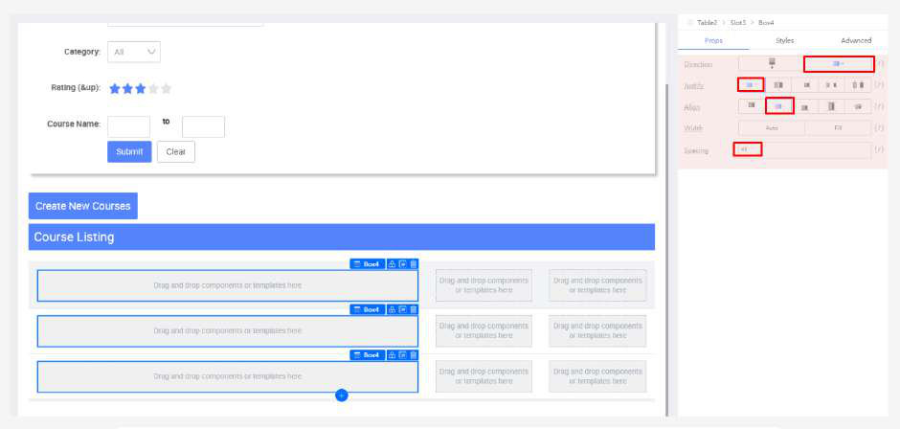

● Add a “Picture” to the table first column ‘Box’

|  |
| --- |
|  |

● Set the following styles

|  |
| --- |
| **Styles**  width: 350px;  height: 200px;  border-radius: 30px; |

|  |
| --- |
|  |

● Add a “Box” to the first column beside Picture

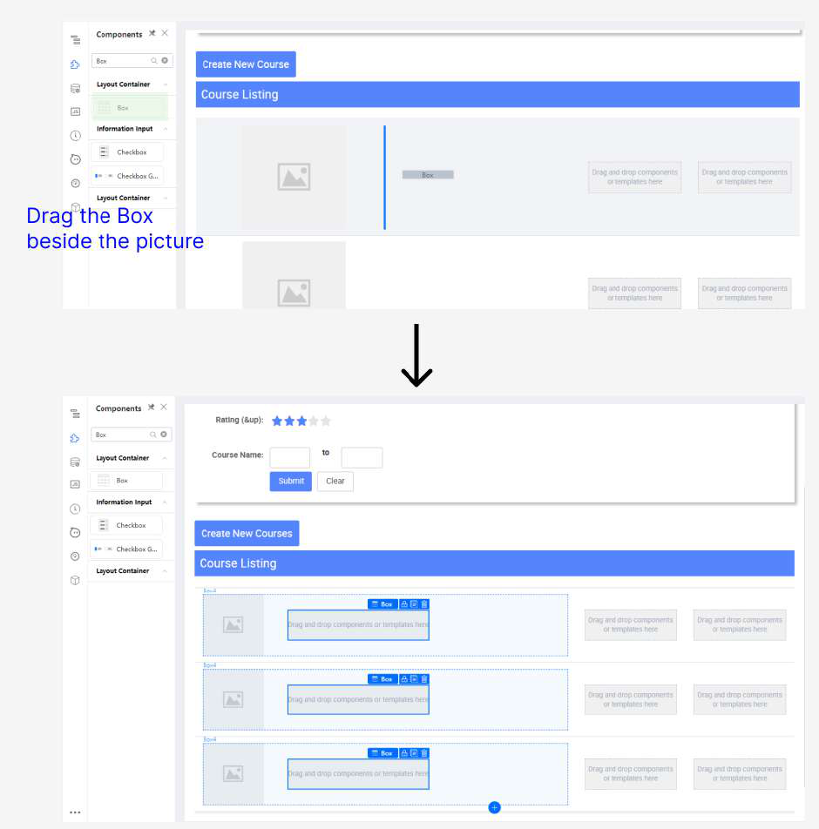

● Set the following styles

|  |
| --- |
| **Props**  Justify: flex-start  Align: flex-start  Spacing: 25 |

|  |
| --- |
|  |

● Add a “Text” to the “Box” from the previous step

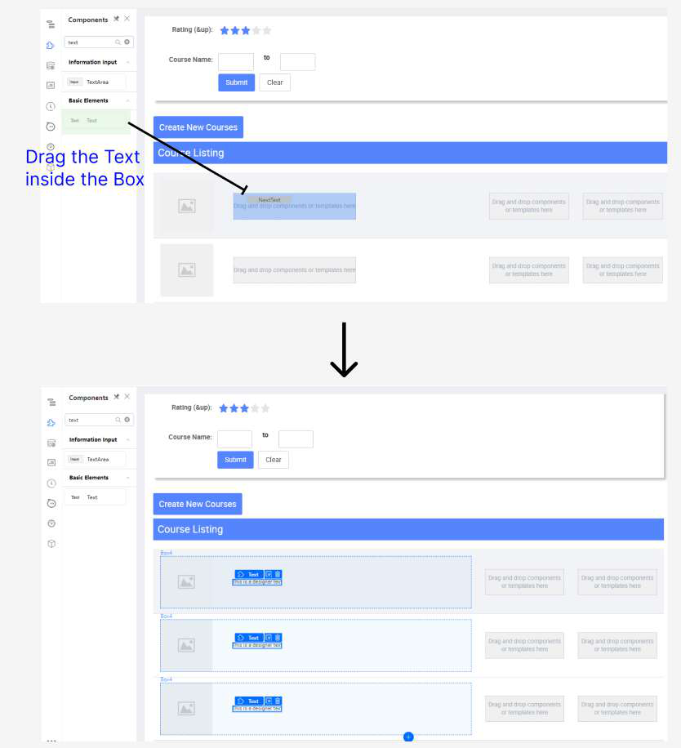

● Set the following to the “Text” component

|  |
| --- |
| **Props**  Strong: true  **Styles**  font-size: 30px; |

|  |
| --- |
|  |

● Add a second “Text” to the “Box

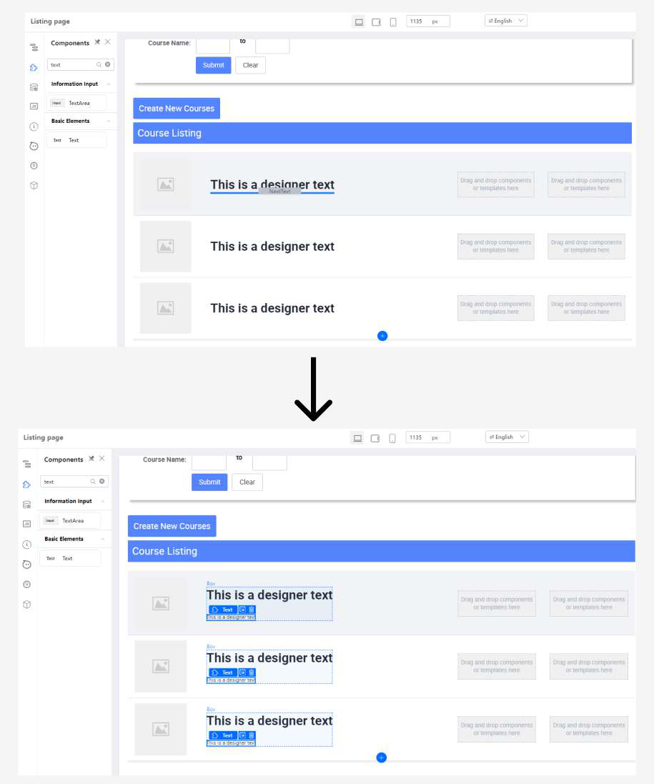

● Set the following for the second “Text”

|  |
| --- |
| **Styles**  font-size: 24px; |

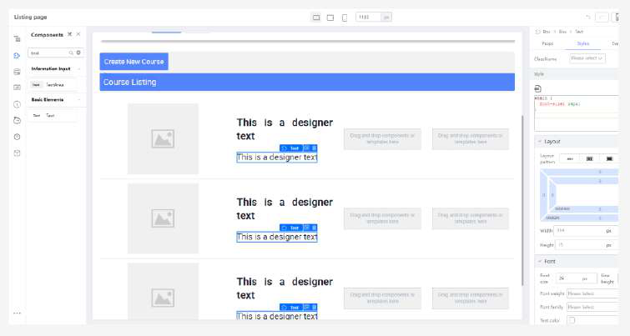

● Add another “Box” below the “Text” component

|  |
| --- |
|  |

● Set the following

|  |  |  |
| --- | --- | --- |
| **Props**  Direction: Row  Justify: flex-start  Align: center  Width: Fill  Spacing: 25  **Styles**  height: 25px;  width: 100%;   |  | | --- | |  |  |  | | --- | |  | |

● Add a **Rating** component to the “Box” inserted in previous step

|  |
| --- |
|  |

● Add a “Text” beside Rating and set the following

|  |
| --- |
| **Styles**  font-size: 16px; |

|  |
| --- |
|  |

● Add another “Text” beside Rating and set the following

|  |
| --- |
| **Props**  Highlight: true  Underline: true  Strong: true  **Styles**  font-size: 16px; |

|  |
| --- |
|  |

● Add a “Card” to the second column

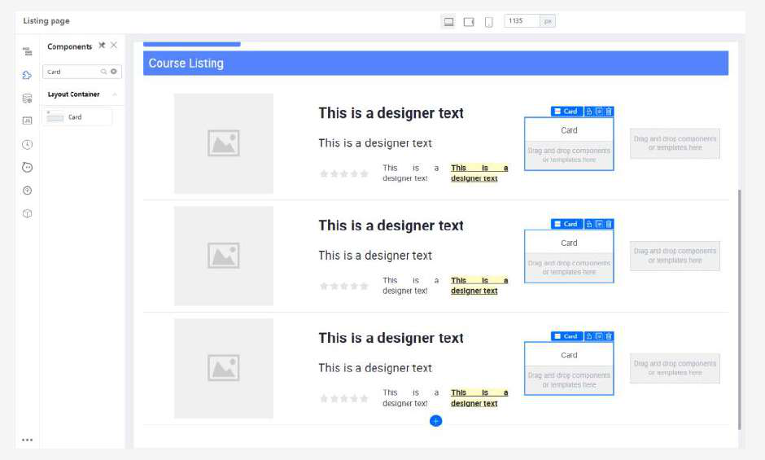

● Set the Card with the following

|  |
| --- |
| **Props**  Has border: true  Title: (Empty)  **Styles**  min-width: 50%;  height: 100%;  border-color: #479eea;  border-width: 2px;  padding-left: 25px;  padding-right: 25px;  text-align: center;  display: flex;  flex-direction: column;  justify-content: center;  align-items: center;  border-radius: 13px;  padding-bottom: 15px;  padding-top: 15px; |

The expected result will be:

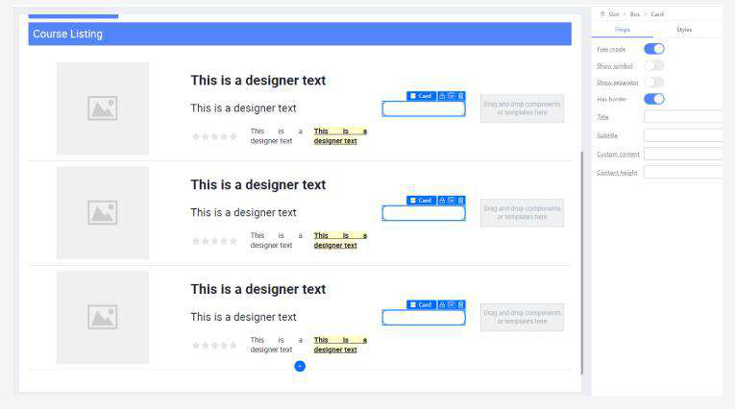

● Add a “Text” and set the following

|  |
| --- |
| **Props**  Text: Course Fee  **Styles**  font-size: 20px; |

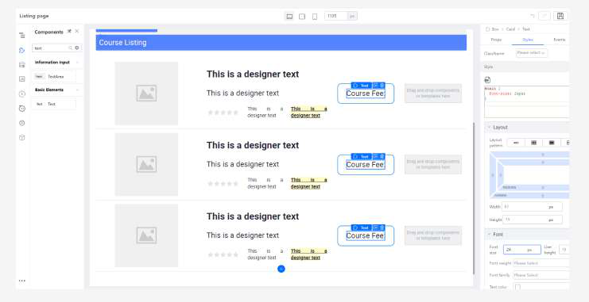

● Add a second Text and set the following

|  |
| --- |
| **Styles**  color: #479eea;  font-size: 25px; |

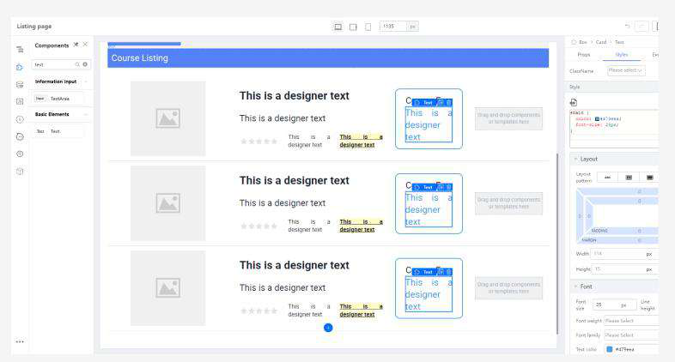

● Add a Button to the last column

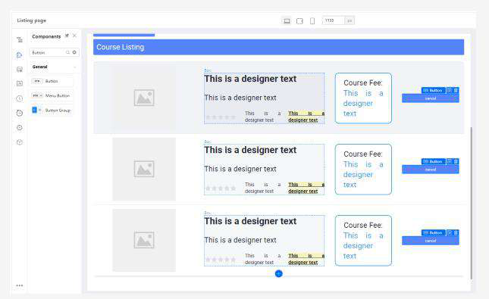

● Set the following:

|  |
| --- |
| **Props**  Content: View Courses  **Styles**  border-radius: 10px;  height: 50px;  font-size: 20px;  width: 150px; |

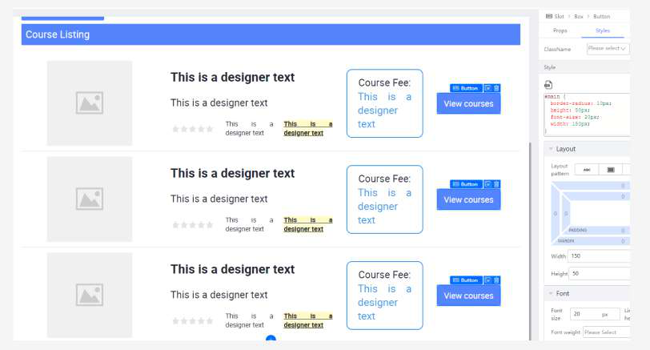

● Edit the table datasource with the following json data:

|  |
| --- |
|  |

[listing-table-json.txt](https://drive.google.com/open?id=19FJ2cU9TAWDSU9dP7gqZdR6e7fMhyvWs)   
Note: Remember to change the appID path on the courseImage   
Upload these images to Asset->images: [elearning-education-internet-lessons-online.jpg,](https://drive.google.com/open?id=1oWhTEP8A8Fb7gMwMxC73A23-i8OXCYxc)[data-analysis.jpeg,](https://drive.google.com/open?id=1T9d-ClUKCr0_n9IVJEMW5bip7D_z_13y) [Teachable.png](https://drive.google.com/open?id=1eO6f-zbVxpbs9PPaeekgAgi9oP4eOmJp)

|  |
| --- |
|  |

● In the Picture, select “Variable Input” in Switch Setter and set the following to bind variable

|  |
| --- |
| **Props**  Image (Variable binding): this.record.courseImage |

|  |  |
| --- | --- |
|  | |
|

The expected result will be:

|  |
| --- |
|  |

● Based on the numbers in the image below, variable bind these values to the following component in their **Props** tab:

|  |  |  |
| --- | --- | --- |
| No. | Field | Value to variable bind |
| **1** | **Text** | this.record.title |
| **2** | **Text** | this.record.subTitle |
| **3** | **Current Value** | this.record.rating |
| **4** | **Text** | this.record.ratingsDescription |
| **5** | **Text** | this.record.courseType |
| **6** | **Text** | this.record.courseFee |



The expected result will be:

|  |
| --- |
|  |

**Tutorial 4: Creating a Form with Steps**

This tutorial covers the following Learning Objectives:

● Understand how to design a multi-step form using KAIZEN.

● Learn how to break down complex forms into manageable steps for a smoother user experience.

● Explore how KAIZEN simplifies form creation by providing step-by-step navigation and validation between steps.

In this tutorial, you will learn how to design and build a multi-step form using KAIZEN. By breaking down a complex form into smaller, more manageable steps, you'll create a smoother and more engaging user experience. KAIZEN’s tools will guide you through adding step-by-step navigation, validation, and data handling, ensuring that users can easily complete the form without confusion.

There will be 4 Forms in total:

**Course Info**

|  |
| --- |
|  |

**Instructor Particulars**

|  |
| --- |
|  |

**Class Location**

|  |
| --- |
|  |

and **Class Schedule**.

|  |
| --- |
|  |

Introduction: Form Fields   
**Forms** are components that accept inputs from various Form fields and then, through user interaction (usually a button press), submit the field information from the form to the backend for processing.

Previously, we encountered forms in Tutorial 1. A refresher on what the form looked like:

|  |
| --- |
|  |

As you can see, the form contains an Email Field, a Password Field and a Login Button. The Email Field is known as an **Input Field**, which accepts open-ended values of text you type from the keyboard. The Password field is a special Input Field that does what the Email field does, but also masks the input so that others cannot see what is being typed on screen. Finally, the **Login button** submits the values that the user keyed in for each field, possibly to an Authentication Server.

While this is sufficient for a Login Form, modern web languages also support a multitude of other form fields, like radio buttons, dropdown selects, date pickers and more. Fortunately, Kaizen supports a good number of these.

In order to access them in the Kaizen App Designer, you can go to the Component Library and search for them.

We will get to use them when we get to the practicals later on.

Introduction: Form Validation

**Validation (or Form Control)** is a set of formatting rules defined for the browser to check. These validation rules usually act as an input format sanity check or as the first layer of defense against user-submitted dirty data, by allowing the browser to know when to warn and restrict the user before submission. The users are usually then allowed to change their inputs based on the warnings given by the browser.

You can see this in action, if you ever played around with the Login Form above, and tried to submit without any values typed into the form:

|  |
| --- |
|  |

This is because the Form Template that is in App Designer’s Component Library has Mandatory Validation enabled by default for both its form fields. Mandatory Validation on means that the field in question has to have a value in it for the form to treat it as a valid submission.

Of course, Mandatory Validation is the simplest validation. There are other more complex validation types that might find more use in more complex form fields. In Kaizen’s App Designer, the Validations can be found in the Props tab for a Form.Item component.

|  |
| --- |
|  |

Practical 4.1: Setting up the Form   
4.1.1 Creating the Form skeleton   
Before the Tutorial begins, please do the following steps. This is to set up the form for the rest of the Practicals. Most of these should be familiar if you have done the Tutorials before, but still, try and closely follow the following steps:   
 ● **Create** a new **Form Page**.

|  |
| --- |
|  |

|  |
| --- |
|  |

● **Click** on **Add Block Below** at the bottom.

|  |
| --- |
|  |

● **Search** for **Steps component**

|  |
| --- |
|  |

● Drag the **Steps component** to the top empty Cell.

|  |
| --- |
|  |

● **Search** for **Form Template component**

|  |
| --- |
|  |

● Drag the **Form Template component** to the bottom empty Cell.

|  |
| --- |
|  |

● **Select** Form component, under **Properties (Props)** of **Form Component,** set the following:

|  |
| --- |
|  |

|  |
| --- |
|  |

● **Search** for **Form Item component**

|  |
| --- |
|  |

● Drag the **Form Item component** above the Email field.

|  |
| --- |
|  |

● **Clear** the **Label** field

|  |
| --- |
|  |

● **Change** the **Wrapper column’s Offset** to **3**.

|  |
| --- |
|  |

● Drag a **Text component** to the top of the Form Template. **Change** the Styling and Properties of the text component to the following:

|  |
| --- |
|  |

|  |
| --- |
| **Props**  Text: Course Info  **Styles**  font-size: 24px;  font-weight: 600;  font-family: Arial; |

The expected output will be

|  |
| --- |
|  |

● **Click** on the Form Item containing area (as illustrated in the image below)

|  |
| --- |
|  |

● **Change** the **Wrapper column’s Offset** to **4**.

|  |
| --- |
|  |

● **Remove** the **Reset** button

|  |
| --- |
|  |

● **Click** on the Form Item containing area

|  |
| --- |
|  |

● Ensure **Cell** is **selected** (Note you also see a white circle, which is a split cell icon)

|  |
| --- |
|  |

● **Click** the **split cell** icon to split the cell into two

|  |
| --- |
|  |

|  |
| --- |
|  |

● **Select the Form Item** with the submit button on the left side and click **Duplicate**.

|  |
| --- |
|  |

● **Drag** the duplicated Form Item with the submit button to the right side.

|  |
| --- |
|  |

The expected output will be:

|  |
| --- |
|  |

● **Select** the **Form Item** on the **right (illustrated below)**

|  |
| --- |
|  |

● **Set** the properties of Form Item to below

|  |  |
| --- | --- |
|  | |
|

|  |
| --- |
| **Button’s Form.Item:**  **Props**  Size: Large  Layout  Label Column   Span: 0   Offset: 0  Wrapper Column   Span: 14   Offset: 10 |

|  |  |  |  |  |
| --- | --- | --- | --- | --- |
| |  |  | | --- | --- | |  | | |  |  | |

● **Select** the Submit button

|  |
| --- |
|  |

● Under Properties Label, change **Submit** to **Next**.

|  |
| --- |
|  |

|  |
| --- |
| **Button:**  **Props**  Label: Next |

You should expect to see something like this:

|  |
| --- |
|  |

● Style and configure the left button into a ‘Previous’ button.

Select the Form.Item. Under the Props tag, change Size to Large. Under Layout, change the Wrapper span to 14 and the offset to 5.

Select the Button. Under Content, change ‘Submit’ to ‘Previous’, Button Type to Secondary.

|  |
| --- |
|  |

|  |
| --- |
| **Button’s Form.Item:**  **Props**  Size: Large  Layout  Label Column   Span: 0   Offset: 0  Wrapper Column   Span: 14   Offset: 5  **Button:**  **Props**  Label: Previous  Button Type: Secondary |

And the button should look like this:

|  |
| --- |
|  |

● **Select** the Email **Form Item Label** by clicking on the label (illustrated below)

|  |
| --- |
|  |

● Change the Styling and Properties of the Email Form Item.

|  |  |  |  |  |  |  |  |  |  |  |
| --- | --- | --- | --- | --- | --- | --- | --- | --- | --- | --- |
| ○  ○  ○ | |  |  |  | | --- | --- | --- | |  | | | |  |  |  | |  | |  | |

|  |
| --- |
| **Email Form.Item Props**  Size: Large  (Advanced) Name: (Empty, clear the property ‘email’)  **Email Form.Item Styles**  font-weight: 500;  **Email Input Component Props**  Clear the Placeholder |

● **Select** the Input component

|  |
| --- |
|  |

● **Clear** the **Placeholder** under properties

|  |
| --- |
|  |

|  |
| --- |
| **Email Input Component Props**  Clear the Placeholder |

● **Select** the **Cell** containing area (illustrated below)

|  |
| --- |
|  |

● **Ensure** the **Cell** is selected

|  |
| --- |
|  |

● **Remove** the **Cell** containing Password Form Item

|  |
| --- |
|  |

● **Select** the **Form component** (illustrated below)

|  |
| --- |
|  |

● Under the Props tab, **click** on the **Field** - **Variable Binding** (looks like this {/}).

|  |
| --- |
|  |

● Under the Bind variables text area, key in **this.formField**. We will go more into this variable later. For now, just click the Confirm button after typing it in.

|  |
| --- |
|  |

● **Duplicate** the **Course InfoForm 3 times**. There should be 4 ‘Course Info’ Forms now.

|  |
| --- |
|  |

● Change the text in the bottom 3 Forms to ‘Instructor Particulars’, ‘Class Location’, ‘Class Schedule’ in order.

|  |
| --- |
|  |

● Change the Step sub-headers to their respective Step names: **Step 1: Course Info**   
**Step 2: Instructor Particulars**   
**Step 3: Class Location**   
**Step 4: Class Schedule**

|  |
| --- |
|  |

The expected output will be:

|  |
| --- |
|  |

4.1.2 Form Setup Complete

|  |
| --- |
|  |

4.1.3 The Source Code Panel   
Let’s bring over the code we will be using for today’s tutorial to the Source Code Panel: ● In the Kaizen App Designer, open the Source Code Panel on the left.

|  |
| --- |
|  |

● You should see the **Source Code Panel** appear on the left of the canvas:

|  |
| --- |
|  |

● **Click** on the gray button below to open a text file: ○ [Tutorial4-Code.txt](https://drive.google.com/open?id=1zm1N170lhxmiZ8HMmGo1Qhk2ZKxScK47)

|  |
| --- |
|  |

● **Copy** everything in this file to the Text Area in the Source Code Panel, like so:

|  |
| --- |
|  |

● **Click the Save button** on the top right of the Source Code Panel.

|  |
| --- |
|  |

In this tutorial, the Source Code Panel will be used to handle some of the more complex logic for the forms not covered by the UI. **If you are already familiar with JS and coding in general, you can skip to the next section (Practical 4.2)**.

Note that you will not be required to actually code. However, you will be required to do some uncommenting of the code. The following steps will guide you through the process:

● **Highlight** a section of a commented code (text in green). A commented section of code will not be executed by the application. Essentially, it will be ignored.

|  |
| --- |
|  |

● Press **Ctrl + /** to **uncomment** the code.

|  |
| --- |
|  |

There is an easy way to tell through the editor if the code is commented. If the text is **green**, it is commented. If the text is **not green**, it is not commented.

Make sure to **save** your changes.

|  |
| --- |
|  |

Practical 4.2: Form Fields and Form Validation   
4.2.1 Context   
The **1st Step: Course Info**, is a form for filling in the basic Course information for students to refer to. By the end of this Practical, this is the form you will be creating:

|  |
| --- |
|  |
|  |

Before we start: this Practical will only cover the ‘Course Info’ Form. Only work within this Form:

|  |
| --- |
|  |

4.2.2 Objective   
Learn about:   
 ● Creating a basic form   
 ● Mandatory, Length and Number Format validation 4.2.3 Basic Form Setup   
 ● **Select** the **Email Form Item**

|  |
| --- |
|  |

● **Duplicate** it **5 times**. You should now have 6 Form Items in this form, like so:

|  |  |
| --- | --- |
|  | |
|  |  |

● **Select** the first **Email Form Item** and change the **Label** to **Course Title**.

|  |
| --- |
|  |

● Then, with the Form Item still selected, change the **Name Property** to **courseTitle**

|  |
| --- |
|  |

● Now, perform the same steps for each of the **next 5 Form Items** but with the following info instead

|  |  |
| --- | --- |
| Form Item **Label** | Form Item **Name Property** |
| Course Code | courseCode |
| Enrollment Type | enrollmentType |
| Subject Type | subjectType |
| Course Fee | courseFee |
| Description | description |

After entering the info, the form should now look something like this:

|  |
| --- |
|  |

● **Ctrl + Click** the **Enrollment Type**, **Subject Type** and **Description** Input Components. ○ Press the **Delete/Backspace** key to **delete** them.

|  |
| --- |
|  |

The expected output will be:

|  |
| --- |
|  |

● In the Component Library, **search** the **Select component**

|  |
| --- |
|  |

● **Drag** the Select Component to the now-empty **Enrollment Type** and **Subject Type**  Form Item.

|  |
| --- |
|  |

|  |
| --- |
|  |

● **Ctrl + Click** both Select components and In the Styles tab, change their **width** to **100%.**

|  |
| --- |
|  |

● **Click** on the **Enrollment Type Select Component.** Under the Props tab, change the 3 Labels under **Datasource** to:   
 ● Part-time   
 ● Full-time   
 ● Online/Remote

|  |
| --- |
|  |

● **Click** on the **Subject Type Select Component**. Under the Props tab, change the Labels under **Datasource** to:   
 ● Accounting   
 ● Business   
 ● Computing   
 ● Design   
 ● Education

|  |
| --- |
|  |

● **Click** the **pencil icon**🖉 beside **Design** and **Education**. Fill in the values for **Design**  and **Education** to **4**and**5**respectively.

|  |
| --- |
|  |

|  |
| --- |
|  |

|  |
| --- |
|  |

● **Click** on the **Input Component** in Course Fee

|  |
| --- |
|  |

● **Add** a **$ sign** in **Text before** field

|  |
| --- |
|  |

● From the Component Library, **drag** a **TextArea** Component to the now-empty Description Form Item.

|  |
| --- |
|  |

4.2.4 Course Info Form Validation   
 ● **Select** the **Course Code** Form Item. Under Props > Validation, click on **Length**  **Validation.**

|  |
| --- |
|  |

● **Set** the Length to **4**.

|  |
| --- |
|  |

● Under Props > Validation, **click** on **Format Validation**.

|  |
| --- |
|  |

● **Click** on the **Number** Button (This ensures Course Code can only of type number)

|  |
| --- |
|  |

● **Select** the **Course Fee** Form Item

|  |
| --- |
|  |

● **Set** the **Course Fee** Form Item Validation. **Format Validation**: **Number**

|  |
| --- |
|  |

● Under Mandatory Validation

|  |
| --- |
|  |

● **Turn off** ‘Description’ Form Item Mandatory Validation.

|  |
| --- |
|  |

4.2.5 Form Completion   
Once you are done with everything, the first form should look like this:

|  |
| --- |
|  |

Practical 4.3: Create the ‘Instructor Particulars’ Form

4.3.1 Context

The **2nd Step: Instructor Particulars**, is a form for filling in the Instructor Personal Particulars for the system to record and verify.

Before we start: this Practical will only cover the ‘Instructor Particulars’ Form. Only work within this Form:

|  |
| --- |
|  |

4.3.2 Objective

● Draw the page in the above figure using the concepts that you learnt in**: Form Fields**  **and Form Validation**.

4.3.3 Requirements

|  |  |  |  |  |
| --- | --- | --- | --- | --- |
| **Label Name** | **Name Property** | **Form Field Type** | **Validation** | **Remarks** |
| Salutation | salutation | Select | Mandatory | Options: Mr, Mrs, Ms, Dr |
| Name | name | Input | Mandatory |  |
| NRIC | nric | Input | Mandatory, **SG NRIC** Format |  |
| Email | email | Input | Mandatory,  **Email** Format |  |
| Contact No. | contactNo | Input | Mandatory, **SG Tel** Format |  |

4.3.4 Hints   
 ● For this exercise, there is no need to do complex regex validations. Click and look through all the Validations - you might find what you are looking for inside.

● Do not forget your Property Names in the Form.Items!

4.3.5 Expected Result

|  |
| --- |
|  |
|  |

Practical 4.4: ‘Class Location’ Form

4.4.1 Context

The **3rd Step: Class Location**, is a form for filling in the Address where the classes for the course will take place.

Before we start: this Practical will only cover the ‘Class Location’ Form. Only work within this Form:

|  |
| --- |
|  |

4.4.2 Objective

Learn about:

● Creating 2 fields in one Form Item   
● Validation of both fields individually   
● Using Regular Expression Validation   
● Conditional Form Fields

4.4.3 Requirements

|  |  |  |  |  |
| --- | --- | --- | --- | --- |
| **Label Name** | **Name Property** | **Form Field Type** | **Validation** | **Remarks** |
| Postal Code | postalCode | Input | Mandatory,  Length validation: 6 digits  Numbers only |  |
| Address | address | Input | Mandatory |  |
| Floor / Unit No. |  | Input |  | **Refer to 4.4.4** |

Note that for the **highlighted part in yellow** in the table, you should just have the Floor / Unit

No. Form field ready. You will be taught how to create the 2 inputs in the next section.

For now, with the info above, you should have something like this:

|  |
| --- |
|  |

4.4.4 Creating a Field with 2 inputs

Sometimes you will need to create a form field with 2 fields. The example we used in this scenario is a floor/unit no (eg #02-16) field.

Here is the revised table with the Floor and Unit No. separate.

|  |  |  |  |  |
| --- | --- | --- | --- | --- |
| **Label Name** | **Name Property** | **Form Field Type** | **Validation** | **Remarks** |
| Postal Code | postalCode | Input | Mandatory,  Length  validation: 6  digits  Numbers only |  |
| Address | address | Input | Mandatory |  |
| Floor / Unit No. | |  | | --- | | floorNo | | Input | Mandatory.  Must be number. Max length 2. | Must be in the same row or  form item |
| unitNo | Input | Mandatory.  2-3 numbers at the start and an optional  uppercase letter at the end. |

It is possible to handle this in the Designer by using the 2 Columns or 3 Columns Component. ● **Remove** the **Input component** within the Floor / Unit No. Form Item.

|  |
| --- |
|  |

● **Drag** a **3 Columns** Component to the Floor / Unit No Form Item.

|  |
| --- |
|  |

● **Drag** a **Form Item Component** each for the left and right columns. **Drag** a **Text**  **Component** into the Center column.

|  |
| --- |
|  |

● Drag **Input Components** into the left and right Form Items.

|  |
| --- |
|  |

● **Ctrl +Click** to select both Form Item Components.

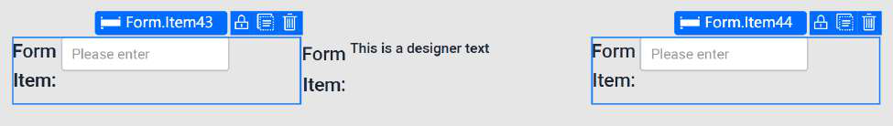

● **Change** their Styles to Large.

|  |
| --- |
|  |

● **Select** the **left Form Item**. **Clear** its **Label** and change its Property Name to **floorNo**  **Select** the **right Form Item**. **Clear** its **Label** and change its Property Name to **unitNo**

|  |  |
| --- | --- |
| floorNo | unitNo |
| |  | | --- | |  | | |  | | --- | |  | |
| |  | | --- | |  | | |  | | --- | |  | |

● **Delete** the **Label** of the center Form Item component

|  |
| --- |
|  |

4.4.5 Styling for the Inputs

● **Ctrl + Select** both Input Components. **Delete** their **Placeholders**. In Styles, change their **width** to **80px**.

|  |
| --- |
|  |

● **Change** the center **Text** Component to be a Dash (ie. ‘**-**’). Change **Font Size** to **h4**.

|  |
| --- |
|  |

● **Select** the **Row Component** inside the Floor / Unit No Form.Item.

|  |
| --- |
|  |

|  |
| --- |
|  |

● **Change** the width of the row to **200px.**

|  |
| --- |
|  |

● **Select** the Center Column Component.

|  |  |
| --- | --- |
|  | |
|

● **Add** a left padding of about 35px. The dash should be roughly aligned with the input boxes like this:

|  |
| --- |
|  |

|  |
| --- |
|  |

4.4.6 Validation for both input fields   
 ● Select the left Form Item and **add Mandatory** and Number Validation.

|  |
| --- |
|  |

● Select the right Form Item and **add Mandatory** and Regex Validation with this value: /^\d{2,3}[A-Z]?$/

|  |  |
| --- | --- |
|  | |
|  |  |

|  |
| --- |
|  |

● Add an Error message for this Regex Validation with this value:

unitNo is 2-3 digits + optional A-Z

Go into preview mode and click Next to see that both fields are now being validated

correctly.

4.4.8 Form Completion   
The final form should look something like this:

|  |
| --- |
|  |

Practical 4.5: Class Schedule Form

4.5.1 Context

The **4th Step: Class Schedule**, is a form for filling in the start and end date which the classes will take place and also the schedule every week for this date period.

Before we start: this Practical will only cover the ‘Class Schedule’ Form. Only work within this Form:

|  |
| --- |
|  |

4.5.2 Objective

Learn about:

● Custom Validation for the DatePicker to ensure Start Date is always after End Date ● Doing a simple dynamic row adder

4.5.3 Requirements

|  |  |  |  |  |
| --- | --- | --- | --- | --- |
| **Label Name** | **Name Property** | **Form Field Type** | **Validation** | **Remarks** |
| Start Date | startDate | DatePicker | Mandatory. This value must be  before End Date. |  |
| End Date | endDate | DatePicker | Mandatory. This value must be  after Start Date. |  |
| Weekly  Schedule |  | Table | Non-Mandatory | **Refer to 4.5.5** for more info on how to do. |

For the Weekly Schedule:

● Each schedule contains the **Day** of the week, **Start Time** and **End Time**.

● The user must be able to create new rows representing a new schedule.

|  |
| --- |
|  |

4.5.4 Custom Date Validation   
 ● **Open** the **Source Code Panel** and **uncomment lines 7 - 8.**

|  |
| --- |
|  |

● **Uncomment** the section **under (lines 39 - 57)**. Then click the **Save** button.

|  |
| --- |
|  |

● **Select** the **Start Date Form Item**. **Variable Bind** the validation state to **this.state.startError**

|  |
| --- |
|  |

|  |
| --- |
|  |

● **Select** the **End Date Form Item**. **Variable Bind** the validation state to **this.state.endError**

|  |
| --- |
|  |

|  |
| --- |
|  |

● **Ctrl + Click** toselect both the Form Items of Start Date and End Date.

|  |
| --- |
|  |

● Go to the Props tab, and click on **Custom validation**. Then, click on the **Bind Function**  button.

|  |
| --- |
|  |

|  |
| --- |
|  |

● Under Select event, click on Event, then click on **checkDates**. You should get something like this before clicking on the Confirm button:

|  |
| --- |
|  |

● Go to Preview and check if the validation is working as intended by selecting the dates for both datepickers and deliberately choosing invalid values.

|  |
| --- |
|  |
|  |

4.5.5 Creating the Form field that can add new Rows ● **Delete** the **DatePicker component** under **Weekly Schedule** field

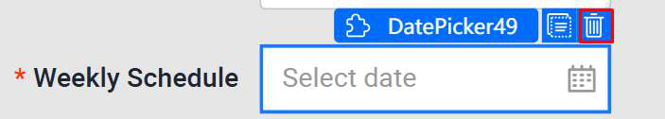

● **Remove** the **Mandatory Validation**

|  |
| --- |
|  |

● Drag a Table Component to the Weekly Schedule Form Item.

|  |
| --- |
|  |

● **Select** the **Table Component**. Under the Props tab, ○ **Turn off pagination**.

○ **Remove** the **‘Add’** and **‘Edit’** entries in the **Action Bar**.

○ **Remove** the **‘Edit’** and **‘Preserve’** entries in the **Action Column**.

|  |
| --- |
|  |

● **Add** another **Cell** below the Weekly Schedule Table **Form Item**.

|  |
| --- |
|  |
|  |

● Then, drag a Button Component into it.

|  |
| --- |
|  |

● In the Props Tab for the button’s Form Item, change the following ○ **Clear** its **Label**  
○ **Size: Large**  
○ **Wrapper Column offset** to **4** so that it aligns with the table. ○ Change the button’s text to **Add Schedule.**

|  |  |
| --- | --- |
|  | |
|  |  |

● Add a + icon to the button

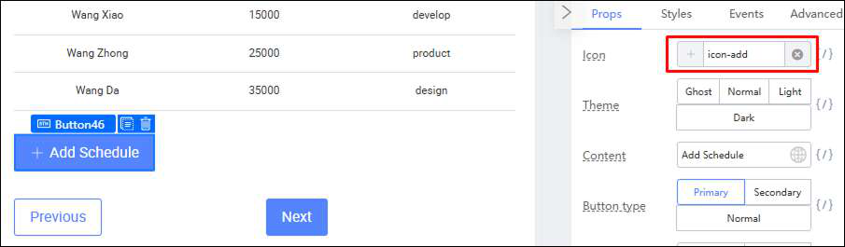

● Select the Table Component again. Change the Data Columns to **‘Day’**, ‘**Start Time**’ and ‘**End Time**’.

|  |
| --- |
|  |

● Edit each column by clicking on the pen icon on the left of each label. Change the Data Keys of Day, Start Time and End Time to **‘day’**, **‘start’** and **‘end’** respectively. Set all their Data Types to **‘None’**.

○ Repeat the above steps for **Start Time** and **End Time**

|  |
| --- |
|  |

● Drag a **Select** Component into the Date Column. Drag a **Timepicker** Component into the Start Time and End Time Columns.

|  |
| --- |
|  |

● **Select** one of the Select Components in the Day Column and **add the following**  **Options**  
 ○ Monday’, ‘Tuesday’, ‘Wednesday’, ‘Thursday’, ‘Friday’, ‘Saturday’ and ‘Sunday’.

|  |
| --- |
|  |

● **Select** the Timepickers in the **Start Time** and **End Time** columns. Under the Props tab, ○ Set the **Format** to **HH:mm**  
○ In the Styles tab, set the **width** of the Timepickers to **150px**.

|  |
| --- |
|  |

|  |
| --- |
|  |

● Open the Source Code Panel and uncomment lines 9 - 13.

|  |
| --- |
|  |

● Uncomment the section under /** 4.5.5 **/ (lines 61 - 69). Then click the Save button.

|  |
| --- |
|  |

● **Select** the Weekly Schedule **Table Component.** Click on Variable Binding in Data Source.

|  |
| --- |
|  |

● Click on **State Attribute** under Variable List, then click on **weekly**. Then click the **Confirm** button.

|  |
| --- |
|  |

● **Click** on the **Add Schedule button**. Go to the **Events** tab, and click on the ‘**Component**  **native event**’ button.

|  |
| --- |
|  |

● **Select** the **onClick** event from the dropdown.

|  |
| --- |
|  |

● Under ‘Select event’, click on **Event**, then click on **onClick_AddSchedule**. Then Click the **Confirm** button.

|  |
| --- |
|  |

You can now add extra schedules!

|  |
| --- |
|  |

4.5.6 Form Completion   
Your finished Form 4 should look like this:

|  |
| --- |
|  |

Practical 4.6: Cascade Dropdown   
4.6.1 Context   
Recall the 1st form, Course Info. There were 2 Select dropdown fields in that form: ● Enrollment Type - which is values like Part-time, Full-time and Online/Remote.

● Subject Type - The subject of the course (eg. Business, Computing etc.)   
Now, let’s say there was a change in requirements: the Part-time, Full-time and Online/Remote courses can only have certain subject types. What we will need to do is to implement some conditional logic to handle that.

4.6.2 Requirements   
In the 1st Form, Course Info,   
 ● The Select dropdown from Enrollment Type should populate a different set of values of Subject Type:

|  |  |
| --- | --- |
| Enrollment Type | Subject Type |
| Part-time | Accounting, Business, Computing |
| Full-time | Accounting, Business, Computing, Design, Education |
| Online/Remote | Computing, Education |

4.6.3 Adding the Logic   
 ● Open the Source Code Panel and **uncomment lines 14 - 25.**

|  |
| --- |
|  |

● **Uncomment** the section under /** 4.6.3 **/ (lines 76 - 81). Then click the Save button.

|  |
| --- |
|  |

● Click on the Select Component of the **Enrollment Type** Form Item. In the **Events** tab, click on the **Component native event** button and then click **onChange** from the dropdown.

|  |
| --- |
|  |

● Under Select event, click on **Event**, then click on **onChange_EnrollmentType**. Once done, click on the **Confirm** button.

|  |
| --- |
|  |

● Click on the Select Component of the Subject Type Form Item. Click on the **Switch**  **Setter** on the top right of the **Datasource** panel.

|  |
| --- |
|  |

● **Select** the **Variable Input** from the dropdown.

|  |
| --- |
|  |

● Click on the “Please input expression” box and select **this.state.subjectTypeArray**

|  |
| --- |
|  |

You can now click preview and check out the result: Part-time:

|  |
| --- |
|  |

Full-time:

|  |
| --- |
|  |

Online/Remote:

|  |
| --- |
|  |

Practical 4.7: Setting field values using Form Variables (Optional)

4.7.1 Context

Before we go to the next Practical, let’s say now that we want to enhance this form a little bit.

Maybe the Form can also, in practice, take in the personal particulars of this instructor with MyInfo. Of course, we are not going to actually connect to MyInfo to get actual data - that’s the job of the backend developers.

But we can still populate the form in the Kaizen App Designer, sort of like a proof-of-concept for the actual form. We can do this by using a function of the Next.Field library, called setValue().

4.7.2 Requirements

Add the following to the 2nd Form: Instructor Particulars.

● A button at the top of the form, that when clicked, populates all the fields (except Salutation) with fixed data.

4.7.3 Adding the ‘MyInfo’ Button

● Scroll to the Instructor Particulars Form.

● **Add** a button to the top of the Form below the title. Remove the Form Item Label. Under

the button’s Form Item Styles tab, Shift button to the right.

|  |  |
| --- | --- |
|  | |
|  |  |

● **Download** the sample MyInfo button image here [MyinfoBtn.png](https://drive.google.com/file/d/1jNByKAa486sqVOXNVu5nFwOw3DPH825P/view?usp=drive_link)

● **Upload** the MyInfoBtn.png image to your assets -> image

● Under the button’s Styles tab, change the button background image to MyInfo.

|  |  |
| --- | --- |
|  | |
|  |  |

|  |
| --- |
| **Button Style**   background-image:  url(/gateway/console/api/v1/asset/designerTraining/assets/image/MyinfoBtn.png?b ranchName=main);   background-size: contain;   width: 150px;   height: 55px;   background-repeat: no-repeat; |

● Go to the Button’s Props tab and set the Theme to ‘Ghost’. Remove ‘cancel’ from the

Content field.

|  |
| --- |
|  |

|  |
| --- |
| **Button Props**  Theme: Ghost  Content: (Clear this field) |

4.7.4 Adding the logic   
 ● **Uncomment** the section under /** 4.7.4 **/ (lines 85 - 90). Then click the Save button.

|  |
| --- |
|  |

● With the MyInfo button selected, go to **Events** tab and click **Component native event**

and select **‘onClick’** in the dropdown.

|  |  |
| --- | --- |
|  | |
|  |  |

● Select **Event** under ‘Select Event’ and type in **retrieveSingPassMyInfo** under ‘Event

Name’. Click the ‘Ok’ button.

|  |
| --- |
|  |

● Preview and check if the fields are populated correctly by clicking on the MyInfo button.

|  |
| --- |
|  |

Practical 4.8: Binding it all together

Now that we have done the content, we are finally going to make the Step Form itself work.

4.8.1 Adding the code

● Uncomment the section under /** 4.8.1 **/ (lines 94 - 103, 106 - 113). Then click the

Save button.

|  |
| --- |
|  |

4.8.2 Bind currentStep variable to Step Component   
 ● **Select** the **Steps Component** at the top. Bind the variable **this.state.currentStep** to the Step Component.

|  |
| --- |
|  |

|  |
| --- |
|  |

4.8.3 OnClick Events for the Next buttons   
 ● **Select** all the **Previous Buttons** in the Forms and **disable** them.

|  |
| --- |
|  |

● **Select** the **Next Button** in the **Course InfoForm** and go to the **Events** tab. Bind **onClick** to the **onClick_Next** event.

|  |
| --- |
|  |

|  |
| --- |
|  |

● Do the same for the ‘Instructor Particulars’ (2nd Form) and ‘Class Location’ Forms (3rd Form).

● For the ‘Class Schedule’ Form (4th Form), change the Label of the Next button to ‘Submit’.

|  |
| --- |
|  |

4.8.4 Set conditions for the Forms to be visible   
 ● Select the **Course Info Form**. In the **Advanced** tab, click on the top-right for the **‘Visible’** field and select **Variable Input**.

|  |
| --- |
|  |

● Type this in the Bind Variables box:

|  |
| --- |
| **this.state.currentStep == 0 || this.state.showAll** |

|  |
| --- |
|  |

Then click the ‘Confirm’ button.

● For ‘Instructor Particulars’ Form bind this:

|  |
| --- |
| **this.state.currentStep == 1 || this.state.showAll** |

to the ‘Visible’ Property in the Advanced tab.

|  |
| --- |
|  |

● For ‘Class Location’ Form bind this:

|  |
| --- |
| **this.state.currentStep == 2 || this.state.showAll** |

to the ‘Visible’ Property in the Advanced tab.

|  |
| --- |
|  |

● For ‘Class Schedule’ Form bind this:

|  |
| --- |
| **this.state.currentStep == 3 || this.state.showAll** |

to the ‘Visible’ Property in the Advanced tab.

|  |
| --- |
|  |

Note: If you ever want to view all the forms again later, you can simply set the showAll state variable (line 13) to true.

|  |
| --- |
|  |

Practical 4.9: Modal Dialog Box

When we do a Submit, we might want a popup to appear asking if the user would want to confirm their submission before sending the information to the database. We can use a Modal dialog box for this purpose.

4.9.1 Steps for Creating a Modal Dialog

● **Drag** a **Dialog** Component to the Designer. Anywhere in the workspace will do.

|  |
| --- |
|  |

● Change the Title to ‘**Form Submission**’ and **add** a **Text Component** to the Cell in the middle of the Modal Dialog box. Change the Text to ‘**Confirm your Submission?**’.

|  |
| --- |
|  |

● Click on the Dialog Component and under the Props Tab, change the blue button’s Label (Help) to ‘Confirm’ under the Dialog Component’s Prop tab.

|  |
| --- |
|  |

|  |
| --- |
|  |

● Go to the **Advanced** Tab and change the **refId** to **confirm-dialog-box**

|  |
| --- |
|  |

4.9.2 Adding the logic for the Modal Dialog   
 ● Open the Source Code Panel and **uncomment lines 118 - 123 and 127 - 129**. And click **Save**.

|  |
| --- |
|  |

● Select the Dialog Component (Under Component Tree)

|  |
| --- |
|  |

● Under the **Events** tab and click on the **Component native event** button.

|  |
| --- |
|  |

● **Select** the **onOk** event from the dropdown that appears.

|  |
| --- |
|  |

● Under **Event** and then click **‘OnClick_ConfirmSubmit’**.

|  |
| --- |
|  |

● Go to the Props tab for this Dialog Component. For the ‘Visible’ field, click on the Variable Binding {/}.

|  |
| --- |
|  |

● Under Bind Variables, enter the following: **this.state.confirmVisible**. Once done, click Confirm.

|  |
| --- |
|  |

● Select the Submit button on the ‘Class Schedule’ Form, and go to the Events tab. Click on the ‘Component native event’ button.

○ Temporary changes the **showAll** flag to **true**

|  |
| --- |
|  |

|  |
| --- |
|  |

● Select **‘onClick’** in the dropdown that appears.

|  |
| --- |
|  |

● Under ‘Select event’, click on **‘Event’**, and then click on **‘onClick_Submit’**.

|  |
| --- |
|  |

● Now go back to your Source Code Panel, change back the flag to false

|  |
| --- |
|  |

● Change your **OnClick_ConfirmSubmit** function to navigate back to your course listing page, by changing the navigateTo in utils1function to use the correct App ID and Page ID.

If you have not completed tutorial 3 in creating your course listing page, you may navigate to your landing page instead for now.

|  |
| --- |
|  |

|  |  |  |  |
| --- | --- | --- | --- |
| Having trouble finding the **App ID** and **Page ID**?  ● You can find the **App ID** under resources. Click on the App, then click on Edit Application.   |  | | --- | |  |   ● Similarly, you can find the **Page ID** under resources as well. All you have to do is to hover over your page created in Day 2 and you will get the Page ID. You may also click on edit page to view the Page ID.   |  | | --- | |  |  |  | | --- | |  | |

And Finally…

Let’s go through the form together. Click Preview.

Step 1: Course Info

|  |
| --- |
|  |

Step 2: Instructor Particulars

|  |
| --- |
|  |

Step 3: Class Schedule

|  |
| --- |
|  |

Step 4: Class Location

|  |
| --- |
|  |

Form Submission: Redirect back to Course Listing

|  |
| --- |
|  |
|  |

Additional Information

1. **Utils functions summary**

**Data Storage Utilities**

○ this.utils.dataStore: Stores and retrieves data for page references. ■ Methods: getData(key), setData(key, value), clearData(). ○ this.utils.context: Passes data between pages.

■ Methods: getDataMap(object), setData(object, key, data), getData(object, key).

**Third-Party Libraries**

○ this.utils.FileSaver: Uses the **file-saver** library for file operations. ○ this.utils.dateFormat: Uses the **dateformat** library for formatting dates.

**Navigation Utilities**

○ this.utils.navigateTo(appId, pageId, data, object): Navigates to a specific page within an app (object should be this).

○ this.utils.navigateToCurrAppPages(pageId, data, object): Navigates within the current app pages.

○ this.utils.getNavigatedData(key, object): Retrieves data passed between pages.

**Security and Role Management**

○ this.utils.RSAUtil: Encrypts passwords.

■ Methods: convertJwkToPem(jwk), encrypt(text, pubKey, keyFormat).

○ this.utils.RolesUtils: Manages user roles for filtering navigators in preview mode.

■ Methods: delete(role, userDomain), set(role, userDomain), getRoles(), clear(), saveRoles(roles, userDomain).

**Utility Functions**

○ this.utils.getUrlParams(): Retrieves URL parameters.

○ this.utils.hasSuperAdminPrivilege(): Checks if the current user is a super admin.

○ this.utils.getAssetsUrl(assetsName, fileName): Retrieves asset file URLs.

○ this.utils.handleProfile: Used to do virtual login with profile in preview, only work in preview and will not generate in runtime.

■Methods: handleProfile(data: {   
userDomainCode: string; userAccountId: string; vault: string }).

**Note:**\* indicates different implementations between **designer mode** and **runtime mode**.

**Tutorial 5: Tables, Sorting and Pagination**

This tutorial covers the following Learning Objectives:

● Understand how to create and structure tables in KAIZEN to display data effectively. ● Learn how to implement client-side sorting functionality to allow users to organize data by different columns.

● Explore how to add client-side pagination to tables to manage large data sets efficiently.

● Discover how KAIZEN simplifies the integration of sorting and pagination features to enhance user interaction.

In this tutorial, you will learn how to create and manage tables in KAIZEN to display data clearly and efficiently. We’ll guide you through implementing sorting and pagination features, allowing users to interact with and organize large sets of data easily. By the end of this tutorial, you'll be able to enhance your application’s data presentation with dynamic, user-friendly tables.

For this example, we will be doing a registered course list table, containing the Course Name, Course Code, Subject, Enrollment Type, Duration, Schedule, Price and the number of Students enrolled.

|  |
| --- |
|  |

Practical 5.1: The Table Component

The Table Component is a template that you can use to create tables for your projects with relative ease. You can find it in the Component Library as a component called ‘Table’. Simply drag it out into the design space as you would any other component and should work.

5.1.1 Setting up the Table Component   
 ● Create a new Course Table Page.

● From the Component Library, **drag** out the **Table Component** into the Cell in the Design space.

|  |
| --- |
|  |

● Under Props:   
○ **Remove** the **Add** and **Edit** buttons by deleting them under the **Action Bar**○ **Delete** the **Edit** and **Preserve** links under the **Action Column** as well

|  |
| --- |
|  |

● Under Styles, change the width of the Table to 100%.

|  |
| --- |
|  |

● Go to the Props tab and go to **Style and theme**. ○ **Turn on** the **Fixed Header** switch and then ○ **Set** the **Max body height** to **800px.**

|  |
| --- |
|  |

5.1.2 Setting the Table Headers

The configuration for changing the headers are located in the Props tab of the Table itself under **Data Column**. You can change these values and it will reflect on the Design space. Add and/or remove the headers accordingly with the buttons in the Data Column menu.

|  |
| --- |
|  |

Recall that we will need to add headers for:

● Course Name   
● Course Code   
● Subject   
● Enrollment Type   
● Duration   
● Schedule   
● Price   
● Students

You should have something like this:

|  |
| --- |
|  |

5.1.3 Adding a Static Dataset to the Table   
Now that the table is set up, it is time to add the content to each row for testing.

The Table Component parses JSON and uses it to generate the data it displays on the rows. Each Key in a JSON object will correspond to the header in the table and each Value in a JSON object will be the row value.

|  |
| --- |
|  |

We can add the row values through 3 different ways under the Props tab > Data Column of the Table Component:   
 a) Click on the ‘**Edit Data**’ button. Modify the **JSON** accordingly.

b) **Add the JSON** data into the **Source Code Panel** in the Designer, then variable bind it.

c) **Retrieve** the data from an **external datasource**, like a backend server, then apply **variable binding** to it.

For today, we will only be covering (b) in detail:   
 ● **Open** the **Source Code Panel**. **Copy** the entire file from below: [Tutorial5-code.txt](https://drive.google.com/open?id=1sTSZpHOZwoJQ-EyzMPJot-SHdeWUgzEH)  
 ● Click **Save** on the top-right of the Source Code Panel.

|  |
| --- |
|  |

● Select the Table Component and under Props tab > Data Column, click on the Variable Binding (the {/}) for Data Source.

|  |
| --- |
|  |

● Under the Variable List, select **State Attribute** > **table**. Click on **Confirm**

|  |
| --- |
|  |

Notice the data in the table has changed.

|  |
| --- |
|  |

You can see that the headers are there, but the data it is displaying doesn’t look right.

Let’s figure out what’s wrong:   
● Select the Table Component and under Props tab > Data Column, Click on the Edit button on the ‘Course Name’ header.

|  |
| --- |
|  |

Look at the **Data Key** field. This field takes the values of the key in a JSON object to put in the Table. So, this field must have exactly the same name as whatever the key is in our dataset.

Let’s examine one of the entries in the data we put in the Source Code Panel earlier:

|  |
| --- |
| **{**    **"id": "1",**    **"name": "Financial Reporting and Analysis",**   **"code": 4156,**    **"subject": "Accounting",**    **"enrollment-type": "Full-time",**    **"duration": "4 months",**    **"schedule-type": "weekly",**    **"price": 22000,**    **"student-no": 1325**  **}** |

We can see that the key, ‘name’, in this JSON, corresponds with ‘name’ in our own ‘Course Name Header. So that explains why the Table has those rows under ‘Course Name’ populated even though we have not done anything yet.

Now that we have figured it out, all that’s left to do is to change the rest of the headers.

● On Props tab > Data Column, edit each header’s Data Key:

|  |  |
| --- | --- |
| Header Title | Data Key |
| Course Name | name |
| Course Code | code |
| Subject | subject |
| Enrollment Type | enrollment-type |
| Duration | duration |
| Schedule | schedule-type |
| Price | price |
| Students | student-no |

|  |
| --- |
|  |

Once done, you should have a table like this:

|  |
| --- |
|  |

Practical 5.2: Table Sorting & Pagination   
Now that we have the table set up, it's time to look at some other features we can add to this table, namely table sorting and pagination.

5.2.1 Setup   
 ● **Open** the Source Code Panel. **Uncomment** the lines **253 - 273**.

|  |
| --- |
|  |

The code block that you uncommented is for table sorting.

5.2.2 Sorting

In order to sort a table, we will first need to determine which data columns will be sortable and then set them as such in the Designer.

● The 4 columns that will be sortable are:   
 ○ **Course Name**  
 ○ **Duration**   
 ○ **Price**   
 ○ **Students**   
● Under **Data Column**, **Click** on the **Edit** button beside the **Course Name** header.

|  |
| --- |
|  |

● Enable **Allow Sorting**.

● **Repeat** the same steps for **Duration**, **Price** and **Students**

Note in the Table in the Designer’s display area has changed the column to have an up/down arrow beside the headers you have changed. Clicking on it does nothing for now. We will need to do some event binding.

● Under the **Events** tab, **click** on the **Component native event** button.

|  |
| --- |
|  |

● In the dropdown, **select** the **onSort** event.

|  |
| --- |
|  |

● In the popup, select **Event**, click on **onSort**. Then click on the **Confirm** button.

|  |
| --- |
|  |

We should now be able to sort by clicking on the headers in each column.

5.2.3 Pagination

Something you probably noticed is that the table is only displaying 10 entries even though the dataset has 22 entries in total. That’s because the Table and the code placed in the Source Code Panel has catered for pages in the table. However, there is no way to navigate the pages or change the page size. Let’s change this.

● Open the Source Code Panel. Uncomment lines 277 - 282

|  |
| --- |
|  |

● Under the **Pagination Configuration**, click on the **Variable Binding** for field **Current**  **Page**

|  |
| --- |
|  |

● Under Variable List, Select ‘State attribute’ then select **‘currentPage’**.

|  |
| --- |
|  |

● Still under the Pagination Settings, click on the Variable Binding for ‘Total records’.

|  |
| --- |
|  |

● Under Variable List, Select ‘State attribute’ then select **‘dataCount’**.

|  |
| --- |
|  |

● Still under the Pagination Settings, click on the Variable Binding for ‘Show page size’.

|  |
| --- |
|  |

● Under Variable List, Select ‘State attribute’ then select **‘pageSize’**.

|  |
| --- |
|  |

● In the **OnChange** field, click on the **Bind Function** button.

|  |
| --- |
|  |

● Under **Event**, click on the **onPageChange** event.

|  |
| --- |
|  |

In **Preview** mode, now you can click on the pages at the bottom-right of the table and each page should display each page set of data correctly.

|  |
| --- |
|  |

5.2.4 Page Sizing   
Let’s continue to add a Page Size feature.

● **Open** the **Source Code Panel**. **Uncomment** lines **286 - 293.**

|  |
| --- |
|  |

● In the **Selector** type field, choose **‘Dropdown’**.

|  |
| --- |
|  |

● Page size list should be ‘5,10,20’

● In the OnPageSizeChange field, click on the ‘Bind Function’ button.

|  |
| --- |
|  |

● Under **‘Select** event’, Click on **‘Event’**, then click on ‘OnPageSizeChange’.

|  |
| --- |
|  |

● Click on the **‘Confirm’** button.

These are the options you should have:

|  |
| --- |
|  |

Now you can Preview to check all the changes that we added.

Practical 5.3: Download functionality (Optional)

Sometimes there is a need for the user to download files or data from your end. It is possible to do this with the Designer’s Source Code Panel. In this Practical, we will add a button that allows users to download the JSON data of the table we did in the previous Practical.

5.3.1 Add a download button   
 ● Add a block to the bottom of the table.

|  |
| --- |
|  |

● Drag a Button Component to Cell.

|  |
| --- |
|  |

● Do some styling for the button and rename it to ‘Download Data as JSON’.

|  |
| --- |
|  |

5.3.2 Add the download code   
 ● Open the Source Code Panel. Uncomment the lines 297 - 301.

|  |
| --- |
|  |

5.3.3 Event bind the download button   
 ● Click on the Button Component and go to the Events tab and click on the ‘Component native event’ button. In the dropdown, click on ‘OnClick’.

|  |
| --- |
|  |

● Under ‘Select event’, Click on ‘Event’, then click on ‘OnClick_Download’.

|  |
| --- |
|  |

● Click on the ‘Ok’ button.

Now, whenever you click on the Download button, you will start downloading a JSON file with the table’s data.

|  |
| --- |
|  |

**Tutorial 6: Charts and Graphs**

This tutorial covers the following Learning Objectives:

● Understand how to integrate and display various types of charts and graphs in KAIZEN. ● Learn how to visualize data effectively using different chart types like bar and pie charts. ● Explore how to bind data dynamically to charts for real-time updates.

In this tutorial, you will learn how to create and display charts and graphs in KAIZEN to visualize data effectively. We’ll guide you through selecting the right chart types and binding them to dynamic data, enabling real-time updates. By the end of this tutorial, you'll be able to enhance your application with informative and interactive visualizations that help users interpret data quickly and easily.

Practical 6.1: Adding Graph Components

6.1.1 Setup Steps

● From the Component Library, drag a Cell Component to the top of the Table in the Course Table Page that you have created from Tutorial 5.

|  |
| --- |
|  |

● Drag a Tab Component into the Cell Component.

|  |
| --- |
|  |

● Rename the tabs (and remove any extra) so that there are only these 2 tabs: ‘Price Comparison’ and ‘Enrollment’.

|  |
| --- |
|  |

Once you are done, you should have something like this:

|  |
| --- |
|  |

6.1.2 Adding a Bar Graph   
 ● Select the ‘Price Comparison’ tab in the Tab Component.

● From the Component Library, search for ‘chart’ and drag a Bar Chart Component (aka Column Component) into the Price Comparison Tab.

|  |
| --- |
|  |

6.1.3 Sending Data to the Graph   
 ● Select the Column Component and under the Props Tab, click on Variable Binding.

|  |
| --- |
|  |

● Under ‘Variable List’, Select ‘State attribute’, then select ‘data’.

|  |
| --- |
|  |

● Click the ‘Confirm’ button.

Note the graph has disappeared.

● Change the ‘x-axis label’ to **price** and the ‘y-axis label’ to **name**.

|  |
| --- |
|  |

● With the Bar Chart Component still selected, go to the Styles tab and change the Height to 600px.

If you click on Preview, you can hover over each column to see their specific x-axis labels.

6.1.4 Adding a Pie Chart

● Select the ‘Enrollment’ tab in the Tab Component.

● From the Component Library, search for ‘chart’ and drag a Pie Chart Component into the Enrollment Tab.

|  |
| --- |
|  |

6.1.5 Sending Data to the Graph

● Select the Pie Chart Component and under the Props Tab, click on Variable Binding.

|  |
| --- |
|  |

● Under ‘Variable List’, Select ‘State attribute’, then select ‘data’.

|  |
| --- |
|  |

● Click the ‘Confirm’ button.

Note the graph has disappeared.

● Change the ‘Value field name’ to **student-no** and the ‘Category field name’ to **name**.

|  |
| --- |
|  |

● With the Pie Chart Component still selected, go to the Styles tab and change the Height to 600px.

If you click on Preview, you can hover over each column to see their specific category names. You can also hover over each item in the legend to highlight their position in the pie chart.

|  |
| --- |
|  |

In the Legend, you can also click on an item to deselect it and prevent it from showing up in the Pie Chart.

**Tutorial 7: Using External JS Libraries**

This tutorial covers the following Learning Objectives:

● Understand how to integrate external JavaScript libraries into your KAIZEN application.

● Learn how to enhance application functionality by leveraging popular libraries like uuid.js, and others.

● Explore the process of importing and utilizing external libraries to extend the capabilities of your application.

In this tutorial, you will learn how to integrate external JavaScript libraries into your KAIZEN application to enhance its functionality. We’ll guide you through the process of importing and using libraries like uuid.js to add features such as advanced data transformation and interactivity. By the end of this tutorial, you’ll be equipped to extend your application’s capabilities by seamlessly integrating third-party JavaScript libraries.

Practical 7.1: Importing a UUID JS Library (Demonstration)

We will be returning to the Step Form page we created before to demonstrate how to use this feature.

Let’s say, now, the Instructor has to submit a special Registration code that was provided to them before to confirm their identity. This Registration code will be in a UUIDv4 format. When working on the form, we would like to generate the UUID to make it more convenient for ourselves.

However, by default, the Kaizen App Designer does not have a library to generate UUIDs. Fortunately, Kaizen is capable of supporting external JS libraries to help with this.

7.1.1 Setup Steps

● Go to the 2nd Step (Open the Source Code Panel and change the “currentStep” to 1, then save the Source Code).

● Duplicate the Cell of the Contact No Form Item.

|  |
| --- |
|  |

● Select the duplicated form item and change the Label to ‘Registration No’ and Property Name to ‘registrationNo’.

|  |
| --- |
|  |

● Select the Registration No Form Item and select Default for the Format Validation.

|  |
| --- |
|  |

7.1.2 Adding the Library   
 ● Select the **Libraries** option from the left sidebar. Click on the ‘Install’ button.

|  |
| --- |
|  |

● Fill in the info for the ‘Add Library’ form:

|  |
| --- |
|  |

|  |
| --- |
| **Package: uuid**  **Version: 8.3.1**  **URL: https://unpkg.com/uuid@8.3.1/dist/umd/uuid.min.js Library: uuid** |

● Click on the ‘Save’ button.   
● Reload the Page.

With the uuid library installed, we can now use it in our Source Code. You can look at the possible functions here:[https://www.npmjs.com/package/uuid/v/8.3.1.](https://www.npmjs.com/package/uuid/v/8.3.1)

7.1.3 Using the library

● Before using the library, make sure that Tutorial 4.7.3 Adding the ‘MyInfo’ Button is done so there is the button to trigger the below method. If not, do proceed to create a button in the Instructor Particulars form component under the FormPage.

● In the Source Code Panel, add the following line in the retrieveSingPassMyInfo() function:

|  |
| --- |
|  |

|  |
| --- |
| **this.formField.setValue("registrationNo", uuid.v4());** |

● Preview and click on the MyInfo button to check if the UUID is generated correctly.

|  |
| --- |
|  |

**Tutorial 8: Theme Designer**

This tutorial covers the following Learning Objectives:

● Understand the purpose of the Theme Designer feature in KAIZEN   
● Customize application themes by modifying color schemes and layouts without advanced knowledge of CSS   
● Apply consistent branding across multiple applications using the Theme Designer ● Explore best practices for theme customization to enhance user interfaces

In modern application development, user interface (UI) and user experience (UX) are critical elements that influence how users interact with and perceive a product. KAIZEN streamline the development process by providing visual tools to design and deploy applications quickly. One of the key features in KAIZEN is the Theme Designer, which allows developers and administrators to customize the look and feel of applications without the need for in-depth front-end coding expertise.

In this tutorial, we'll explore how the Theme Designer enables customization of UI elements, helping users maintain consistent branding and visual appeal across multiple applications. This flexibility allows teams to create cohesive user experiences while reducing development time and effort.

Practical 8.1: Customize new theme

This tutorial will guide you through the customization of application themes using the KAIZEN Theme Designer, enabling you to maintain consistent branding and improve UI/UX with minimal coding.

● Open your browser, go to the Theme Designer URL, and log in using your credentials.

URL: <https://kaizen-daas.toppanecquaria.com/theme-editor/#/login>Username: <username>   
Password: <password>

|  |
| --- |
|  |

● After login, you will see a list of themes available and published history panel   
 ○ Edit: Users can further customize their selected theme by clicking the **Edit** button ○ Publish History: Users can access the **Publish History** feature to view the previously published versions of the selected theme.

○ Setting: Additional setting to edit/export/delete theme.

○ Create (+): User can start to create a customize theme   
○ Import: You can click the **Import** button to bring existing themes into the designer

|  |  |
| --- | --- |
|  | |
|  |  |

Now, let's start to create new project for our new theme:

|  |
| --- |
|  |

● Click on **Create Theme**, and follow the naming convention @tecq/ to ensure proper integration.

○ **Theme Name:** For standard name convention, The theme name must start with @tecq/<username>. This is required for now as all js libraries integration ○ **Version:** We can add a version number to control and track updates. The recommended format should be Major.Minor.Patch (1.0.0).

○ **Inherit:** For the Inherit option, you can choose which theme you can copy from. So the new theme will be created based on the inherited theme.

|  |
| --- |
|  |

For the inherit option, we can either inherit from the KAIZEN default theme or inherit from the customized theme.

For this case we will inherit from @tecq/ali-orange-24.10.1.

Configure as per the above with your theme name prefixed with your username   
‘@tecq/<username>’ (E.g. @tecq/amandalam). After configure, click on the **Save** button to save your theme.

|  |
| --- |
| ● Once the theme is created, you may access it by clicking on the design icon . |

|  |
| --- |
|  |

Before we go any further, let’s take a brief aside to talk about the components of the Theme Designer.

**Header Pane:**

The Header Pane serves as a central control point for theme management, offering users the ability to **save** or **publish** their theme customizations.

|  |
| --- |
|  |

● **Save Functionality**: Users can save their theme progress at any point, ensuring that any adjustments made to colors, layouts, fonts, or other design elements are securely stored. This allows users to work incrementally without the risk of losing their changes. ● **Publish Functionality**: Once the theme is finalized, users can use the **Publish** feature to make their customized theme live across KAIZEN App Designer . This function ensures that all users or viewers will see and apply the newly updated theme.

**Designer Pane:**

The Designer Pane plays a crucial role in offering **real-time visibility** to the changes users apply while customizing their theme or design elements.As users make adjustments—whether it's altering the layout, modifying colors, or changing fonts—these changes are instantly reflected in the Designer Pane. This real-time feedback allows users to see how their design evolves without needing to reload or switch views, ensuring a smooth and uninterrupted workflow.

**Component Pane:**

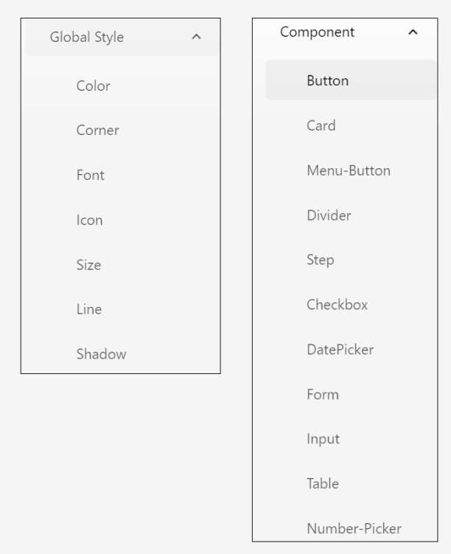

Global Styles   
Global styles are settings that apply to the entire application or design system, ensuring consistency and scalability. They are used to configure the styling of your components.

Component   
Components are individual, reusable UI elements that follow the global style guidelines. They are building blocks of the interface and can be customized with predefined properties.

**Token Configuration Pane:**   
Once user click on the color, user will see the token Token Configuration Pane on the right hand panel.This pane enables users to adjust a wide range of design properties, such as borders, padding, text size, and colors for specific UI components (in this case, a button). It allows for detailed and precise styling adjustments, ensuring components align with the overall design language of the theme.

|  |
| --- |
|  |

|  |
| --- |
|  |

● Let's try to **design a new theme**. We will first customize a new color scheme for your brand.

● Click on Global Style > Color, you can see 3 available color codes for **Brand**, let’s edit the second **color brand1-6** code. The color selection will appear once you click the color code.

|  |
| --- |
|  |

● Let's try to edit **color-brand1-6** code with this hex color **#7F3618**.

|  |
| --- |
|  |

● Once finished the **color-brand1-6** will immediately change its color display as below.

|  |
| --- |
|  |

● Next, you can **apply this new color code to Components**. When you click on the

"Button" menu under the "Component" section, you will immediately see the effects for

the "Active" color states for buttons

|  |
| --- |
|  |

|  |
| --- |
|  |

**Description of Token Configuration**

|  |  |  |
| --- | --- | --- |
| Menu | Section | Usage |
| **bounding** | border width | Thickness of the border |
| height | Height of the border |
| x | Padding of the border |
| **text** | size | Size of the text |
| **normal** | corner | Style of the corner |
| **Statement -**  **normal,hover,active** | background | Background color |
|  | border color | Border color |
|  | border style | Border style |
|  | shadow | Shadow style |
|  | text | Text color |

● Once complete, click on **Save** to store your personalized theme.

|  |
| --- |
|  |

|  |  |
| --- | --- |
|  | |
|  |  |

● This button here is to publish the theme to the Nexus repository, Note that publishing a theme to a Nexus repository does indeed take some processing time, typically around **5-10 minutes**. In the interest of time, we will skip this step for the training.

|  |
| --- |
|  |

● Once the theme is published, you will be able to start applying the published theme in the app Designer. Once a theme is published, it becomes publicly accessible and can be viewed and used globally.

Practical 8.2 Apply theme to your application

● We have pre-created a theme to be applied onto your Designer Training application. First, login to [KAIZEN](https://kaizen.toppanecquaria.com/#/login) and access the App Designer of your application. Navigate to the Course Table page.

|  |
| --- |
|  |

● Click on the theme design button and select the @tecq/ali-orange theme to apply, then click **Ok**.

|  |
| --- |
|  |

● The page will be reloaded for the changes to take effect. After that, you will see the colour and style of the components of your application has changed according to this newly applied theme.

|  |
| --- |
|  |

|  |
| --- |
|  |

|  |
| --- |
|  |

Additional Information

**Export**

You can click export theme if you wish to share the theme design.

|  |
| --- |
|  |

**Import**

You also click on the import button to import existing themes into the designer.

|  |
| --- |
|  |
|  |

**Tutorial 9: Preview Mode**

Practical 9.1: Preview Mode and Collaborative Commenting

This practical covers the following Learning Objectives:

● Learn how to enable preview mode in your application for testing and review purposes. ● Understand how to implement collaborative commenting to allow team members to provide feedback on the application.

● Enhance team collaboration by providing a seamless workflow for reviewing and improving your application before publishing.

In this practical, you will learn how to enable preview mode in your application, allowing you and your team to test and review changes in real-time before finalizing them. Additionally, we will guide you through implementing collaborative commenting, so team members can easily provide feedback and suggestions. This feature enhances collaboration and ensures that all stakeholders can participate in the review process to improve the application before it goes live.

● Navigating back to the shared project that all trainees can access - **TrainingFoundation,** click on the ‘Preview’ button the application.

|  |
| --- |
|  |

● In preview mode, click on the Comments icon near the sidebar.

|  |
| --- |
|  |

● Select a component, and type the comment in the comment box.

○ Note that you can toggle the visibility of your comment to either “Visible to Public” or “Visible to Internal” by clicking on the text below the comment box. This is useful in the event that a project member wants to leave a comment to internal team members, which should not be visible to the customers when they preview this page.

|  |
| --- |
|  |

● Navigating back to this page in the App Designer, click on the Comments icon to bring up the list of comments relating to this page. You will be able to access and see the comments added by all users.

|  |  |
| --- | --- |
|  |  |

Practical 9.2: Navigator Creation / Page Linking

This practical covers the following Learning Objectives:

● Learn how to create and organize navigators within your application.

● Explore how to enhance user experience by designing intuitive and easy-to-use navigation menus.

● Learn how to create a custom navigator and menu within your application. ● Customize the user experience by creating tailored navigation flows.

● Understand how to link pages efficiently to ensure smooth navigation for users.

In this practical, you will learn how to create navigators for your application, enabling users to easily navigate between pages. We’ll guide you through the process of linking pages effectively, ensuring that the navigation is intuitive and user-friendly. By the end of this tutorial, you will be able to design and implement an organized, seamless navigation system that improves the overall user experience within your application.

9.2.1 Navigator Creation   
 ● Navigate back to your own project and application.

● Click on **Navigator** to edit the setting

|  |
| --- |
|  |

|  |
| --- |
| **User Domain: Default domain**  **Name: Landing page**  **Parent: (Empty)**  **Path: /landing**  **Target: Landing Page**  **Open Method: Current Tab**  **Priority: 1**  **Icon: List** |

|  |
| --- |
|  |

● Now, when you preview your application, you will be able to see your newly created navigator, which brings you to the Landing Page upon click.

|  |
| --- |
|  |

9.2.2 Customize Navigator Menu   
After creating your Navigator Menu, you will learn how to customize the navigators and menus for your application, providing a personalized user experience.

|  |
| --- |
|  |

● Preview your application.

● Click on the Setting icon in order to start customizing your navigator menu. We will now proceed to edit the menu color.

|  |
| --- |
|  |

● In the settings, note that there are many CSS properties to change navigator menus

|  |
| --- |
|  |

● Change the Navigation Mode to ‘Top Menu Layout’

|  |
| --- |
|  |

● Edit “Menu Item Hover Font Color” to change menu color on hover

|  |
| --- |
|  |

|  |
| --- |
|  |

● Click on “Save To Application”. This will save your changes across all pages to your entire application. If you only want to customize at page level, you can click on “Save To Page” instead.

|  |
| --- |
|  |

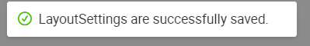

9.2.3 Page Linking   
Once all your pages and Navigator Menus are created, we can connect them to ensure a seamless experience by binding the onClick event.

● In your Login Page, bind the onClick event.

|  |
| --- |
|  |

|  |
| --- |
|  |

● Add the following code in the JS Source Code Panel.

The **navigateTo** function takes in two parameters, the “App ID” and “Page ID”. Replace with your application IDs accordingly.

|  |
| --- |
| **onClick(){**    **this.utils.navigateToCurrAppPages('Page ID'); }** |

|  |
| --- |
|  |

● Save your changes and try to login in preview mode! Your page should navigate over to the landing page successfully.

Practical 9.3: Page Tagging for External Review (Demonstration)

This practical covers the following Learning Objectives:

● Learn how to implement page tagging for external review, enabling stakeholders to view specific versions of your application.

● Understand how to manage and control which updates are visible to external reviewers while hiding upcoming revisions.

● Explore how to tag pages for review, ensuring customers can only view the current version and not unfinished updates.

In this practical, you will learn how to use page tagging for external review, which allows you to mark specific versions of your application for stakeholder review. By tagging pages, you ensure that external reviewers can only see the current version of the application, while any ongoing revisions remain hidden. This feature helps to maintain a clear and organized review process, ensuring that external feedback is based on a consistent, unaltered version of the product.

● We will be using the Designer Training application in our TrainingFoundation project. ● Under the revision history of each page, you can click on the button for external viewers to preview that particular published version. Subsequent versions with further   
 enhancements by the project team will not be visible to external viewers when they preview the application.

|  |
| --- |
|  |

|  |
| --- |
|  |

● We have assigned a customer user account with an external viewer role assigned for this application as seen to demonstrate this.

|  |  |
| --- | --- |
|  |  |
|  |

● Now as a customer, the customer will only be able to see this version tagged for them to review and not subsequent versions when previewing this application.

**Tutorial 10: Page Improvement**

Practical 10.1: Page Analysis with Page Scan (Demonstration)

This practical covers the following Learning Objectives:

● Understand how to perform a comprehensive page scan using the platform's built-in tool which analyzes web apps and web pages, collecting modern performance metrics and insights on developer best practices.

● Analyze key metrics such as Performance, Accessibility, Best Practices, SEO, and Progressive Web App (PWA) compliance to identify areas for improvement.

In this practical, you will learn how to use the platform's page scanning capabilities to evaluate your pages against industry-standard metrics, optimize them for better performance and accessibility, and ensure they meet the latest web development best practices.

● Select the “Page Scan” plugin and click ‘Analyze Page’.

|  |
| --- |
|  |

|  |
| --- |
|  |

● Upon scanning, you will also be able to download the report of the page scan which will also give you further insights such as recommended changes to your page.

Practical 10.2: Mobile Responsive UI (Demonstration)

This practical covers the following Learning Objectives:

● Learn to configure table rows to collapse for optimal display on smaller screen sizes. ● Explore adaptive design techniques to ensure usability across various device types.

In this practical, you will learn how to apply the collapse row feature to optimize table data presentation for small screens, which is one of the mobile responsive features provided.

● Navigate to the Course Table page and click on the ‘mobile’ view icon.

|  |
| --- |
|  |

● When you scroll down to the table, notice that its view is not user friendly when in mobile screen size as you need to navigate via horizontal scrolling.

|  |
| --- |
|  |

● Click on the table. In props, select ‘Collapse Row’ for responsive table type.

Notice that your table will now be collapsed on mobile view, which is a more intuitive and user friendly interface.

|  |  |
| --- | --- |
|  |  |

Practical 10.3: Translation using i18n (Demonstration)

This practical covers the following Learning Objectives:

● Learn how to add multi-language switching functionality to your application using i18n. ● Enhance user accessibility by supporting global audiences with multiple language options.

In this practical, you will learn how to integrate translation functionality into your application using the i18n standard. This feature allows users to switch between different languages seamlessly, making your application accessible to a wider, global audience. You’ll explore how to add and configure language files, making your product user-friendly across different regions.

|  |
| --- |
|  |

● In the TrainingFoundation project, the “Chinese” language has already been added into the application settings in Languages.

|  |
| --- |
|  |

● Each text’s Chinese translation has already been pre-filled as well.

|  |
| --- |
|  |

● Select “Chinese” in the dropdown

|  |
| --- |
|  |

● In Designer mode, note that language is switched to “Chinese”.

|  |
| --- |
|  |

● Similarly in Preview mode, note that the page’s language can also be switched to “Chinese”.

**Tutorial 11: Page Import From Template**

This tutorial covers the following Learning Objectives:

● Learn how to import pages from pre-designed templates to speed up application development.

● Understand how to customize imported templates to fit your specific application needs.

● Explore the benefits of using templates for consistency and efficiency in your design process.

In this practical, you will learn how to import pre-designed pages from templates, allowing you to quickly start building your application with a solid foundation. We’ll guide you through the process of customizing these templates to meet your project’s requirements, saving you time and effort in the design phase. By the end of this tutorial, you will be able to leverage templates to create consistent, professional-looking pages in your application while ensuring they align with your specific needs.

● Create an application from a template.

|  |
| --- |
|  |

● Select the CRUD Template and select its page.

|  |
| --- |
|  |

● Fill in the necessary details and click **Save.**

|  |
| --- |
|  |

● Just like that, your new page is created by using the selected template.

|  |
| --- |
|  |

**Tutorial 12: Main and Micro Applications**

This tutorial covers the following Learning Objectives:

● Understand how to set up and manage a main application and micro-application architecture.

● Learn the advantages of micro-application architecture for scalability and flexibility.

In this tutorial, you will learn how to set up a main application with micro-applications. Micro-application architecture allows you to split your application into smaller, more manageable components, which enhances scalability, flexibility, and performance—an ideal solution for rapidly evolving environments. This aligns with the micro-frontend framework.

● These two Main and Micro applications have been created for you. Your current Designer Training Application that you have been working on is a “Standalone” application type.

|  |
| --- |
|  |

● Generally, the Main application will contain the menu and it will load child Micro application(s). Note that one Main application can be tied to multiple micro applications.

|  |
| --- |
|  |

● Navigator should be done in the Main application. Refer back to Practical 9.2 for more details.

● Customization of global layout should be done in the Main application via ‘Save to Application’ function. Refer back to Practical 9.2for more details.

|  |
| --- |
|  |

● Customization of individual layout should be done in the Micro application via ‘Save to Page’ function. Refer back to Practical 9.2for more details.

|  |
| --- |
|  |

Practical 12.1 Export and Import Pages to Main/Micro Apps

(Optional)

This practical covers the following Learning Objectives:

● Understand how to export and import pages in the App Designer.

In this practical, you will learn how to export and import your pages for use. This will be required in development when you need to either duplicate your existing pages in your application for ease of development, or in the case of this tutorial, to import pages into other applications.

● In your Designer Training application, we will first export the login page and import it over to the **Main** application.

○ Export Login Page from your original Designer Training application

|  |
| --- |
|  |

○ Import into the Designer Training - Main application

|  |
| --- |
|  |

● Do the same for the rest of the pages and import it accordingly as follows. Ensure to save and publish your applications once all imports are done.

○ Designer Training - Main   
 ■ Login Page   
○ Designer Training - Micro   
 ■ Listing Page   
 ■ Landing Page   
 ■ Form Page   
 ■ Course Table

● Create the navigator in your main app to point to all 4 pages in the micro app.

|  |
| --- |
|  |

● Once you preview your main app, you will be able to navigate to the different pages via the menu bar.

|  |
| --- |
|  |

Practical 12.2 Add Action Page Type to Main App (Optional)

This practical covers the following Learning Objectives:

● Learn how to utilise the ‘Action’ type page in your applications.

In this practical, you will learn how to create a ‘logout’ button which will persist across all your application pages. In order to avoid having to duplicate global components that you want to persist on all pages (e.g. profile, logout, language toggle), you can create an ‘Action’ type page in your main application. In addition to action components, you can also create ‘Menu Header’ and ‘Footer’ type pages to persist the design of headers and footers across your application respectively.

|  |
| --- |
|  |

● There are a few types of pages you can create for different purposes. In previous tutorials, you have only been using the standard ‘Page’ type.

○ **Menu Header**: A navigation element used to group related pages under a common section in the application’s menu. It helps organize and structure the navigation for better usability.

○ **Footer**: A section that appears at the bottom of the application’s interface, typically used for displaying copyright information, quick links, or additional navigation options.

○ **Action**: A page type designed for action components that persist across all pages in the application, such as profile settings, logout, and language toggle.

These components remain accessible regardless of the user's navigation.

○ **Page**: The standard content page where users can design and display UI components, input forms, data tables, and other interactive elements. This is the primary type used for building application interfaces.

|  |
| --- |
|  |

● For this tutorial, create a new ‘Action’ page in your main app.

|  |
| --- |
|  |

● Drag a Button component into the page.

|  |
| --- |
|  |

● Set the button with the following styles and code. Save and publish your page changes.

|  |  |
| --- | --- |
|  | |
|

|  |
| --- |
| **Props**  Content: Logout  Button size: Large  **Styles**  background-color: #1352f1;  **Events**  Component native event: OnClick  onClick(){   this.utils.navigateTo('trainingFoundationMain', 'LoginPage'); } |

● In the Resource panel, click on the ‘edit’ icon of your main app.

|  |
| --- |
|  |

● Under Action, select the ‘Action’ page that you have just created and click ‘Save’.

|  |  |
| --- | --- |
|  | |
|

● In preview mode of your main app, notice that the ‘Logout’ button added now forms part of the page header.

|  |
| --- |
|  |

● Click on the Setting icon to customize your navigator menu. Select ‘Top Menu Layout’ for the Navigation Mode and click ‘Save To Application’.

|  |  |
| --- | --- |
|  |  |
|  |

● Now, the ‘Logout’ action button will appear at the top right across all pages.

|  |
| --- |
|  |

● However, you may not want your action buttons to appear on all pages. In this case, it would not make sense to have this button (or access to the other pages via the menu bar) on the first Login page. Hence, you can choose to customize your navigator menu further by disabling the layout for the login page and clicking on ‘Save To Page’.

|  |  |  |
| --- | --- | --- |
|  | | |
|  |  |  |
|  |  |
|  | | |

● Once you have logged in, you will be able to see the navigator menu and ‘Logout’ action button across all other pages.

|  |
| --- |
|  |

**Tutorial 13: Build screen skeleton**

This tutorial covers the following Learning Objectives:

● Learn how to build the skeleton structure of a screen within your application.

● Understand how to create a layout framework that can be easily customized and populated with content.

● Explore the process of designing a flexible and responsive screen skeleton that ensures scalability and consistency.

In this tutorial, you will learn how to build the basic framework, or skeleton, of a screen within your application. The screen skeleton serves as the foundation upon which you will add content and functionality. We will guide you through the process of structuring the layout, ensuring it is flexible and can easily adapt to different screen sizes. By the end of this tutorial, you’ll be able to create a consistent and scalable screen layout that forms the core of your application’s user interface.

**Key Concepts**

We will start by introducing the hierarchy structure of Section, Block and Cell (**Parent-Child relationship**).

● Section can contain Block   
● Block can contain Cell, but cannot contain Section ● Cell cannot contain Section and Block

**Hierarchy:**

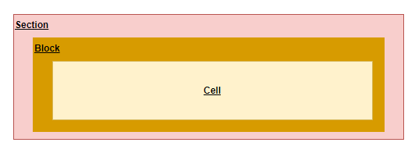

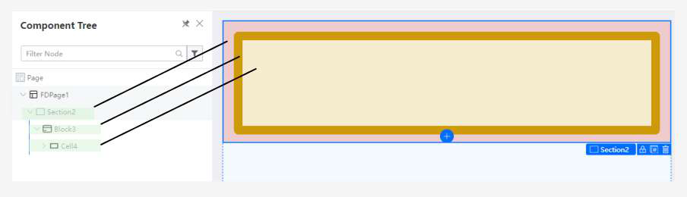

**Layout: Section vs Block**

**Section:**

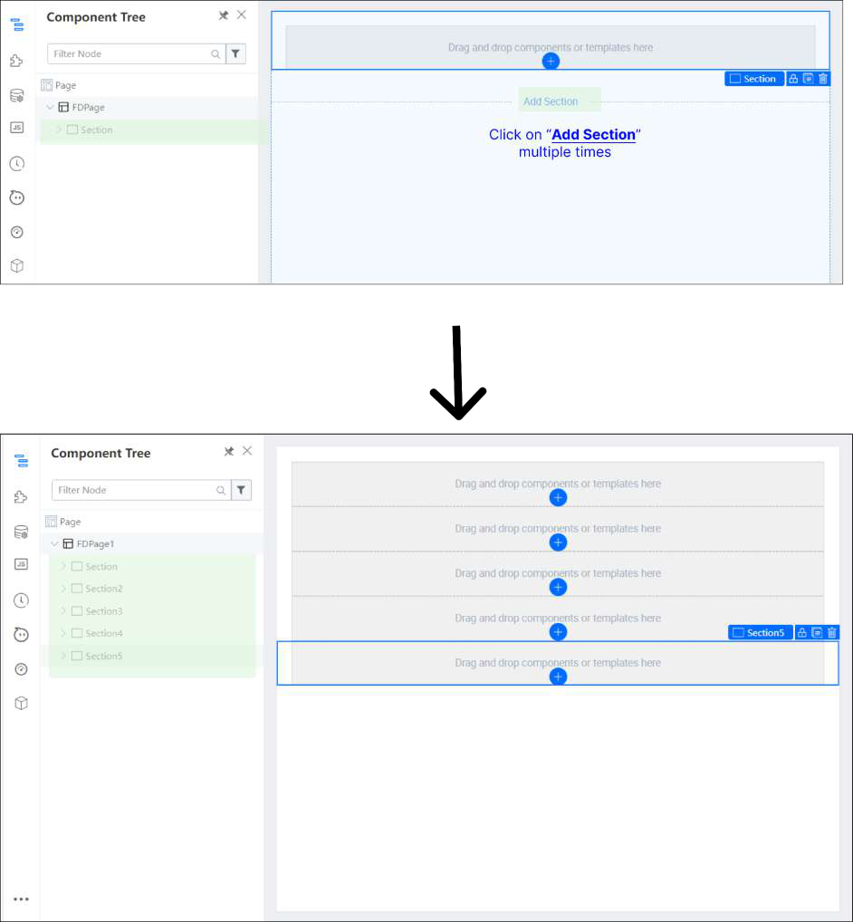

● **Organization**: Takes up the **entire width (100%)** and provides a clear and structured way to organize content. Each section can represent a distinct topic or category, making it easier for users to navigate and understand the layout.

● **Customization**: Sections allow for more **customization** options in terms of layout, styling, and functionality. You can apply **different designs, backgrounds, and behaviors to each section** as needed.

● **Scalability:** Sections offer scalability, allowing you to easily add or remove content sections without affecting the overall layout. This flexibility is particularly useful for websites or applications with dynamic or evolving content.

● **Readability:** By dividing content into sections, you can **improve readability and comprehension** for users. Clear demarcations between sections help users understand the flow of information and locate relevant content quickly.

**Block:**

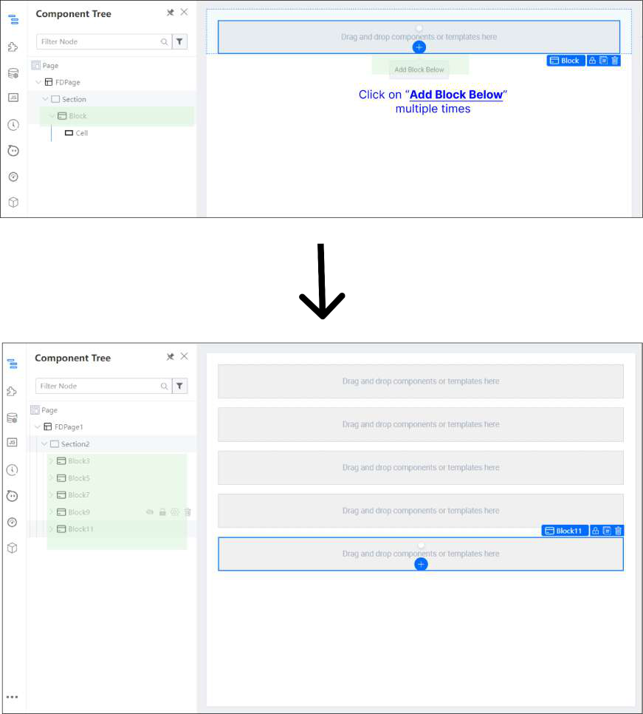

● **Granularity:** Using **multiple blocks** allows for a more granular approach to content management. Each block can represent a smaller unit of content or functionality, giving you finer control over the layout and presentation.

● **Flexibility:** Blocks offer **flexibility in arranging content** within a section. You can easily rearrange blocks or add new ones without restructuring the entire layout, providing greater adaptability to changing requirements or user preferences.

**Example (Using Section)**   
Using the [https://amazon.sg](https://amazon.sg/) website as an example, we will explain why it is preferable to use Sections over Blocks

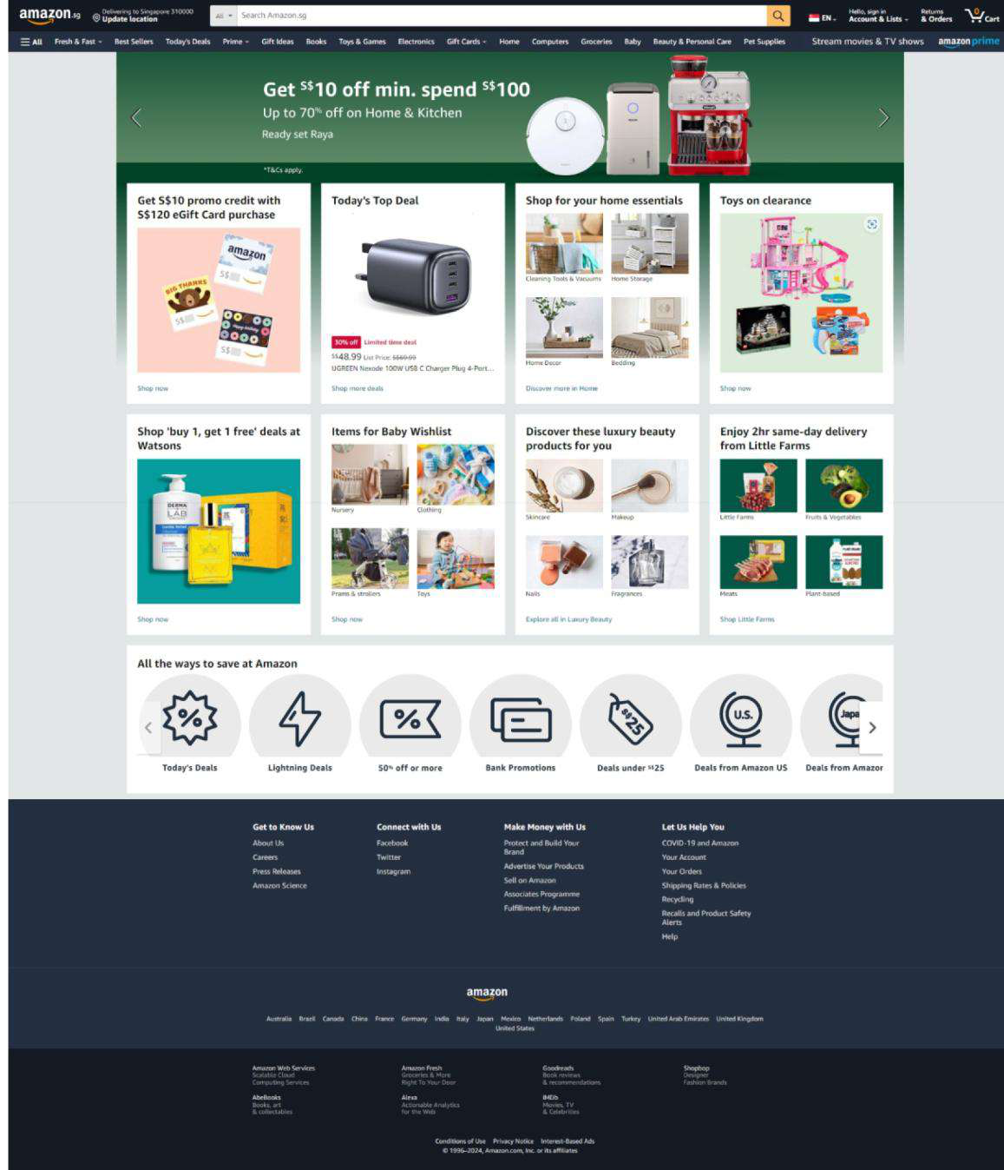

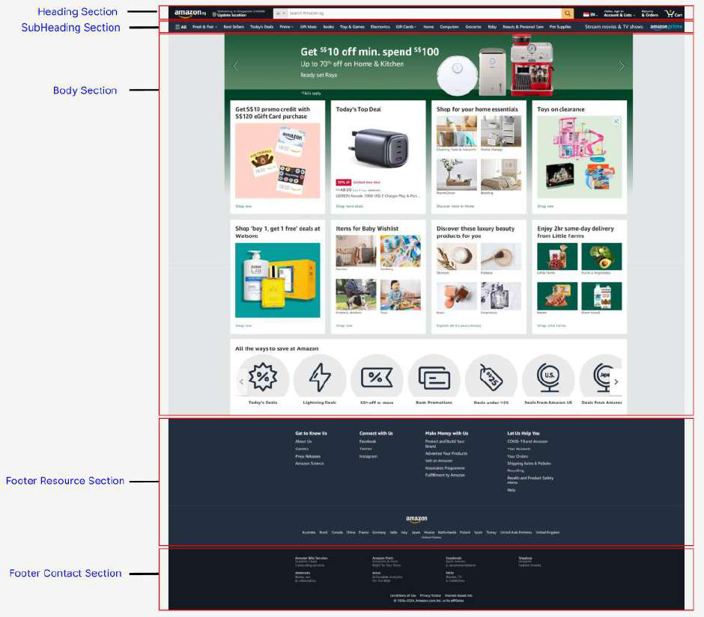

|  |
| --- |
|  |

Creating the skeleton of amazon.sg website in KAIZEN

|  |
| --- |
|  |

**Example (Using Block)**   
Using the Twitter (https://twitter.com) website as an example, we will explain why it is preferable to use Blocks over Sections

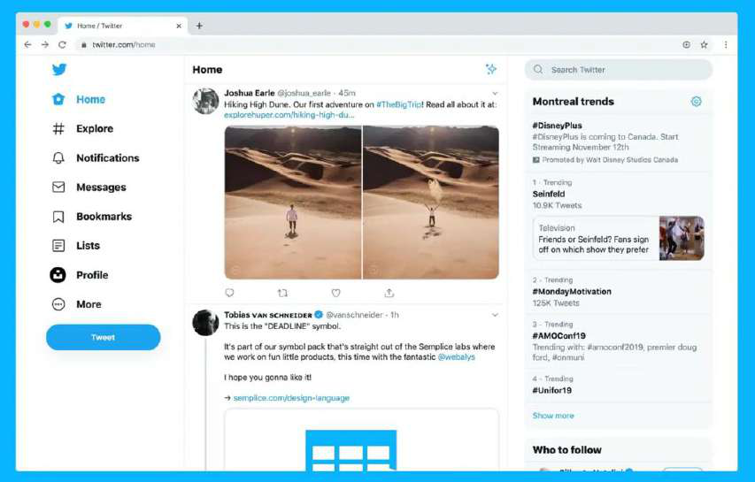

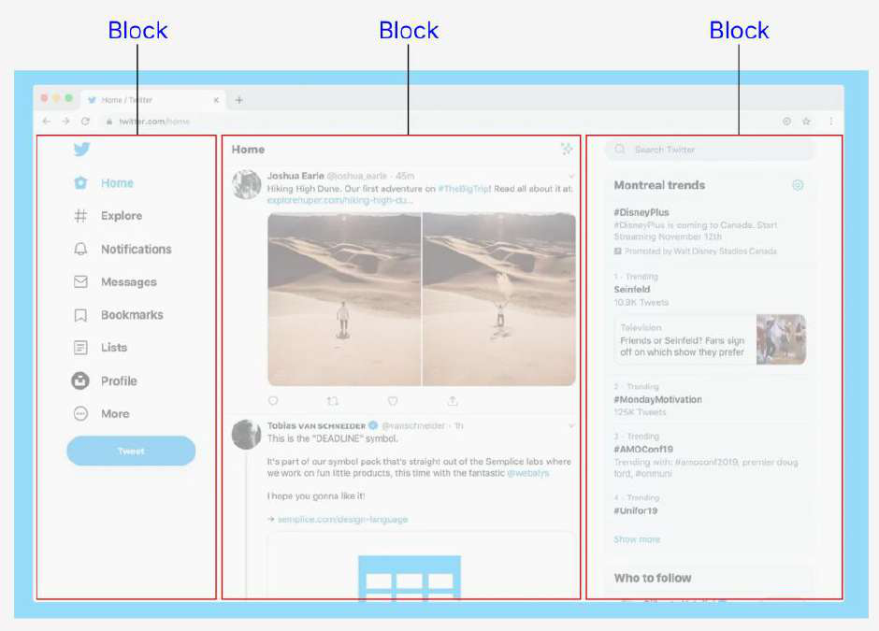

**Layout: Block vs Cell**

**Block:**

● Supports Vertical Cut option

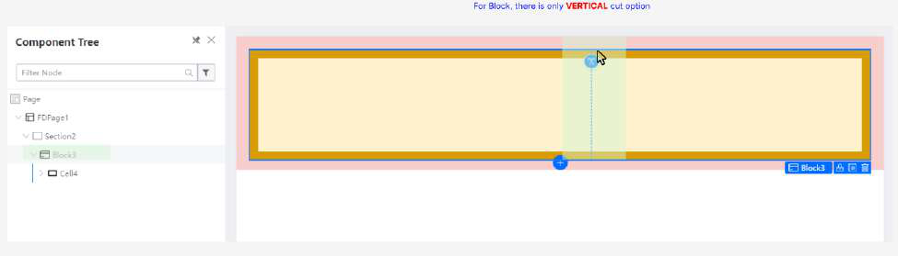

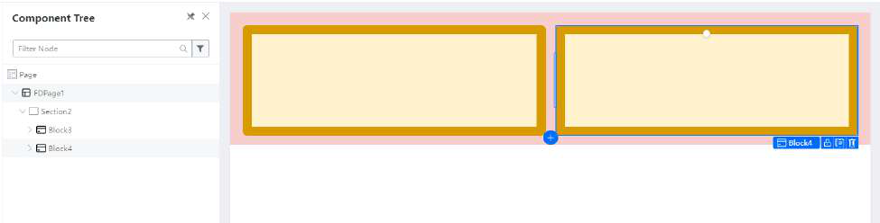

● Uses structured **grid layout**  through configuring “Col Span” property

|  |
| --- |
|  |

|  |
| --- |
|  |

● **Granularity:** Using **multiple blocks** allows for a more granular approach to content management. Each block can represent a smaller unit of content or functionality, giving you finer control over the layout and presentation.

● **Flexibility:** Blocks offer **flexibility in arranging content** within a section. You can easily rearrange blocks or add new ones without restructuring the entire layout, providing greater adaptability to changing requirements or user preferences.

**Cells:**

● Supports Vertical and Horizontal Cut option

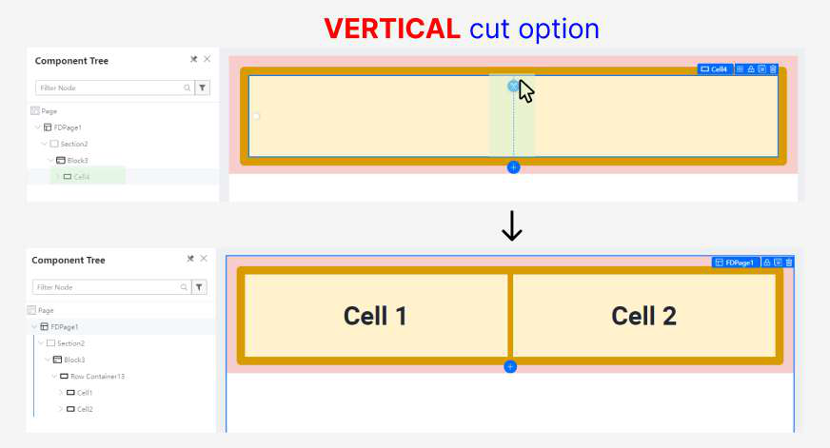

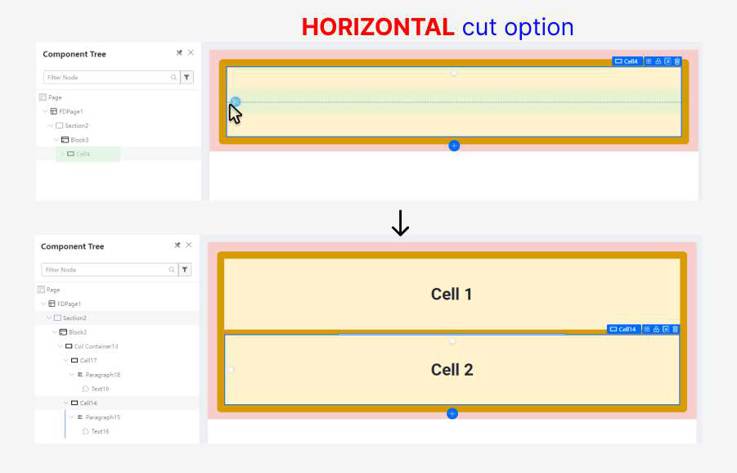

● Uses **flex layout**through adjusting the span (width)

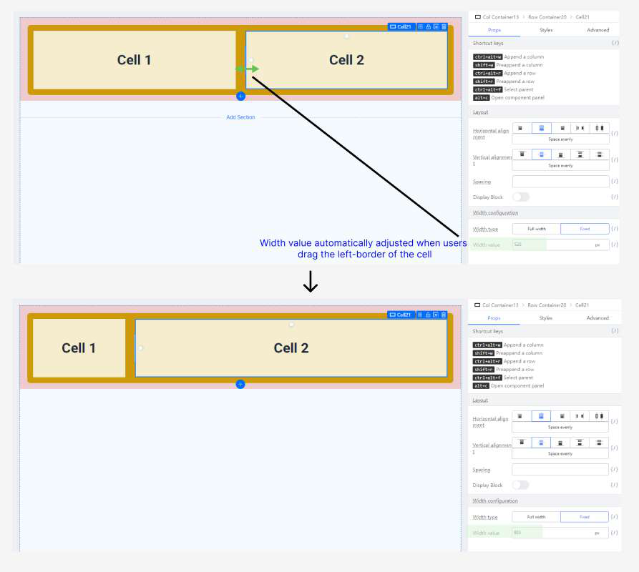

● **Modular Layouts**: Cells allow for modular design by segmenting content into smaller units within a Block.

● **Flexible Styling**: Provides flexibility in styling individual cells, including formatting, borders, padding, and other visual properties.

● **Tabular Data Presentation**: Ideal for presenting tabular data with rows and columns, enhancing readability and organization.

Block VS Cell   
In Desktop view, the layout structure for Block and Cell looks like this:

|  |
| --- |
|  |

In Mobile view, the layout structure looks like this:

|  |
| --- |
|  |

By default, using Block will have a responsive layout wrap behavior, while Cell does not.

Example: Webpage walkthrough example

We will use the following webpage as an example to walk you through the methodology when

creating page skeleton:

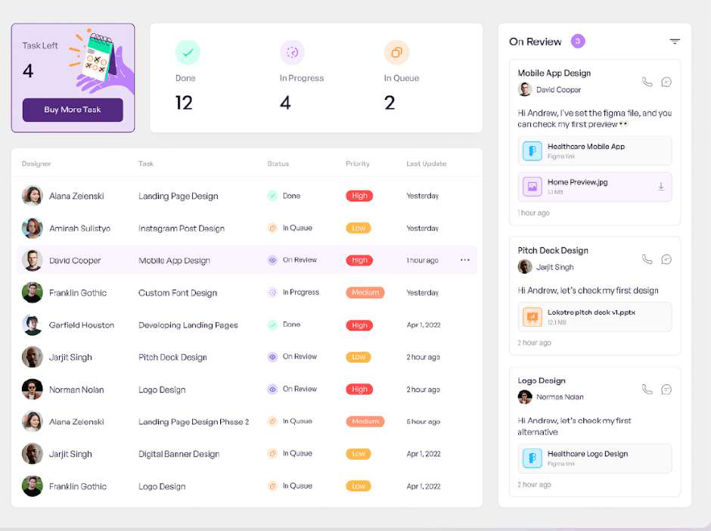

Step 1: Create layout   
*To illustrate the example clearer, I will apply background color to Section, Block and Cell

|  |
| --- |
|  |

|  |  |
| --- | --- |
| ● Cut Block into two  ● Set column span to 9 and 3 respectively   |  | | --- | |  | |

Step 2: Divide cell horizontally for left block

|  |
| --- |
| **Left Block** |

Step 3: Split cell into two

|  |
| --- |
| **Left Block** |

|  |
| --- |
| ● Cut the Cell horizontally  ● Apply a spacing of 25 between the cell |

|  |
| --- |
| ● Cut the Cell vertically ● Set the width to 30% |

|  |
| --- |
|  |

Step 4: Add a card component

|  |
| --- |
|  |

Step 5: Add 3 Card components

|  |
| --- |
|  |

Step 6: Add a table component

|  |
| --- |
|  |

|  |  |
| --- | --- |
| ● Add a Card component   |  | | --- | |  | |

|  |
| --- |
| ● Add 3 Card components |

|  |
| --- |
|  |

|  |
| --- |
| ● Add a table component |

Step 7: Add components to the right block

|  |
| --- |
| **Right Block** |

|  |
| --- |
| ● Add a Box component  ● Followed by 3 Card components |

** We have included few other examples below to demonstrate the drawing of screen skeleton

Example   
Building Screen skeleton examples

|  |
| --- |
|  |

|  |
| --- |
|  |

**Developer Materials**

In the upcoming tutorials, we will shift our focus to backend features that KAIZEN offers to support the development of backend services and APIs for your application. To explore these capabilities, we will use another application called “BETraining” which is designed to guide you through backend-centric functionalities.

**Prerequisites (in folde[rSoftware Installation)](https://drive.google.com/drive/folders/1IcjmECoOWnUZSkBtauOm-V06EVqaeGQL)**

For Windows:

1. **Node.js Version 18 (Preferably 18.20.4)**  
 ○ Download and install **[node-v18.20.4-x64.msi](https://drive.google.com/open?id=11BLqqEmRlK8wQbAb9bc1TS_zAV_f7Kty)**   
2. **Nginx**  
 ○ Download **[nginx.zip](https://drive.google.com/open?id=1PC7enXExHsHKHyVyjBtFOc6BayD94gaD)**[,](https://drive.google.com/open?id=1PC7enXExHsHKHyVyjBtFOc6BayD94gaD) unzip and place it in your C:\ drive (C:/nginx).

3. **Java**  
 ○ Download and install **[OpenJDK17U-jdk_x86-](https://drive.google.com/open?id=1cSr7im_9Etfq7bzhACACysjj4j9nCxFs)**  
 **[32_windows_hotspot_17.0.12_7.msi](https://drive.google.com/open?id=1cSr7im_9Etfq7bzhACACysjj4j9nCxFs)**   
4. **Maven**  
 ○ Download [apache-maven-3.9.9-bin.zip](https://drive.google.com/open?id=13v_r4Q41gowPxaGXXw5WwmaJkYR696hd)Maven Zip File and Extract   
 ○ Install via this guide from Step 2 onwards - [https://phoenixnap.com/kb/install-](https://phoenixnap.com/kb/install-maven-windows) [maven-windows](https://phoenixnap.com/kb/install-maven-windows)

For MacOS:   
 5. **Node.js Version 18 (Preferably 18.20.4)**  
 ○ Download this package [node-v18.20.4.pkg](https://drive.google.com/open?id=1WRRYOUE-LHkp_px31lXsDnXh20n6sCMR)   
 Or <https://nodejs.org/dist/v18.20.4/node-v18.20.4.pkg>  
 6. **Nginx**  
 ○ brew install nginx   
 7. **Java**  
 ○ Download and install   
 **[OpenJDK17U-jdk_x64_mac_hotspot_17.0.12_7.pkg](https://drive.google.com/open?id=1zzTxWINtiXlt97G8FMJXjF1lEbEmn4BK)**   
 8. **Maven**  
 ○ Download Maven: [apache-maven-3.9.9-bin.tar.gz](https://drive.google.com/open?id=1Vs_4KdAQ1-egL5cPMZl4ZnyNIKu8Riy2)   
 Or download from URL[https://dlcdn.apache.org/maven/maven-](https://dlcdn.apache.org/maven/maven-3/3.9.9/binaries/apache-maven-3.9.9-bin.tar.gz)  
 [3/3.9.9/binaries/apache-maven-3.9.9-bin.tar.gz](https://dlcdn.apache.org/maven/maven-3/3.9.9/binaries/apache-maven-3.9.9-bin.tar.gz)  
 ○ Open the Terminal where your file being downloaded and Run this command on terminal   
 $ tar -xvf apache-maven-3.9.9-bin.tar.gz   
 $ sudo mv apache-maven-3.9.9 /opt/

$ export M2_HOME=/opt/apache-maven-3.9.9 export PATH=$M2_HOME/bin:$PATH

$ mvn -version (make sure it is v3.9.9 and its using JDK 17)

**Architecture**   
A simple network architecture of the training environment is provided below.

|  |
| --- |
|  |

Full Diagram:   
[KAIZEN Deployment Architecture_v8.0(CloudDaaS)-KAIZEN Training.drawio.png](https://drive.google.com/open?id=1J4WEd_cbZbAmTFEz9FDUBfGyw5L7d7fL)

**Creation of Profile**

**Add** to create the “Training Environment Profile” in your App Designer. This will connect your application to the training environment which we have pre-created.

This is the runtime environment set up for this BETraining application, which we are connecting your application to via the App Designer profile feature directly.   
We will be going through more on the profile feature in Tutorial 23.

|  |
| --- |
|  |

|  |  |
| --- | --- |
| Name | Training Environment |
| Url | <https://kaizen-training.toppanecquaria.com/gwproxy> |
| User Domain | training_product |
| Account | <username> |
| Password | Password$1234 |

Ensure it is checked and **refresh the page**

|  |
| --- |
|  |

**Tutorial 14: Git Setup & Creation of New Branch**

This tutorial covers the following Learning Objectives:

● Understand how to set up Gitlab in KAIZEN for version control. ● Creation of new branch

In this tutorial, we’ll learn how to connect a project to a GitLab repository for efficient version control. This Git integration feature allows users to seamlessly connect their projects to a Git repository, enabling direct version control operations from within the application in KAIZEN. We will also learn how to initialize new repositories directly from KAIZEN. This integration enhances the CI/CD pipeline by automating the process of committing and pushing changes, thus improving efficiency and collaboration. Additionally, we will also learn how to create a new branch in order to work on feature enhancements or bug fixes in a project setting.

**Practical 14.1: Connect with Gitlab**

In this[GitLab](http://alb-kaizen-daasez-001-673358367.ap-southeast-1.elb.amazonaws.com/)environment, a group “KAIZEN-Training” has already been created for the purpose of this training. In addition, a sub-group has also been created for each trainee prefixed with your username ‘kaizen-training-<username>’ (E.g. kaizen-training-amandalam).

|  |
| --- |
|  |

Similarly, in your project’s context, you may create subgroups for different applications required in your project (E.g. FE internet portal, BE intranet portal), and each subgroup will then be initialized with your application repositories. After which, you may then connect to Git in KAIZEN by configuring the respective group.

Navigate back to your KAIZEN studio console, you will notice that the current branch for your application is on ‘main’. We will go through a later tutorial on Git Branch Management to allow you to push your changes onto your repositories.

|  |
| --- |
|  |

14.1.1 Generate Gitlab Personal Access Token

● Login to your gitlab account as follows and reset your password ○ **URL**: [http://alb-kaizen-daasez-001-673358367.ap-southeast-](http://alb-kaizen-daasez-001-673358367.ap-southeast-1.elb.amazonaws.com/) [1.elb.amazonaws.com/](http://alb-kaizen-daasez-001-673358367.ap-southeast-1.elb.amazonaws.com/)  
 ○ **Username**: <username>   
 ○ **Password**: ahdoh6shaechaip0seidu1ahnailoogaeF8Ainie● Navigate to your gitlab account profile, click **Edit Profile**

|  |
| --- |
|  |

● Click on **Access Tokens**

|  |
| --- |
|  |

● **Create** your personal access token   
○ **Token name:**access_token   
○ **Expiration date:** leave as default   
○ **scope:**api, read_api, read_repository, write_repository

|  |
| --- |
|  |

● **Copy** the generated token to store it for later use

|  |
| --- |
|  |

14.1.2 Connect to Git

● On the KAIZEN studio console, click on the Git button of your BE Training project and click **Connect**.

|  |
| --- |
|  |

● Select **Gitlab** as the service provider and click **Next**

|  |
| --- |
|  |

● Enter the following details to connect to Gitlab   
 ○ **URL**: [http://gitlab-http-svc.kaizen-devops.svc.cluster.local](http://gitlab-http-svc.kaizen-devops.svc.cluster.local/) ○ **Personal Access Token**: <token-string>   
 ○ **Group**: kaizen-training/kaizen-training-<username> ● Click on **Test Connect** to test your connection

|  |
| --- |
|  |

● The group to specify is the url path of your group and subsequent subgroups where you will be initializing your project.

● Note that if the “Separate BE Group” checkbox is selected, then “Group” will specify the group for your Frontend Repository and “BE Group” will be for your Backend Repository.

If it is not selected, then both FE and BE will be connected to the same Git group. This is to help aid in development such that you will not need to always re-connect to another group path in the event you want to push your code in your BE repository.

● Once successful, click on **Save** to connect.

|  |
| --- |
|  |

**Practical 14.2: Initialize Git Repository**

14.2.1 Frontend - Initialize Git Repository

● **Click** on the **Design icon** of your application. It will navigate to the **App designer** of your application

|  |
| --- |
|  |

● In the left panel area, click on the **Git icon**. Notice that you are already connected to Git. You may click on **Settings** to verify.

|  |
| --- |
|  |

● **Click** on the button **Initialize**

|  |
| --- |
|  |

● In the popup, input the following and click on **Initialize** to create the gitlab repository: ○ **Repository name:** fe-product

|  |
| --- |
|  |
|  |

|  |
| --- |
|  |
|  |

● Verify the following initialized frontend repositories in your gitlab project.

|  |
| --- |
|  |

● Currently, these initialized repositories are empty. In the later tutorial we will show you how you can generate and push your code into these defined repositories.

14.2.2 Backend - Initialize Git Repository   
**Backend - Create Service (Prerequisite)**

You may initialize your BE repository through the Service Designer after the creation of your microservice(s).

Let us first create an empty Product Service first so that the BE repository can be initialized. Note that a microservice for your application needs to be created first before you can initialize your BE Git repository. Not to worry as we will cover more details on the Service Designer tutorial below.

● Click **Services** to launch the user interface.

|  |
| --- |
|  |

● Select **Add Service** in the Service API Designer.

|  |
| --- |
|  |

● In the configuration panel, name your microservice to represent its function (e.g., "Product” for Product microservice). Click **Apply**.

|  |
| --- |
|  |

|  |
| --- |
|  |

|  |
| --- |
|  |

● In the Service Designer, the Product Service has a couple of features which we will explore further in later tutorials.

|  |
| --- |
|  |

● In your Service Designer, click on the **Git icon (Manage Branch)** on your Service.

|  |
| --- |
|  |

● Click **Initialize** toset upyour BE repository.

|  |
| --- |
|  |

|  |
| --- |
|  |

|  |
| --- |
|  |

● You should be able to see this newly created repository reflected on Git as well.

|  |
| --- |
|  |

● KAIZEN will create these 3 repositories under the defined group.

|  |  |
| --- | --- |
| Project Name | Description |
| fe-product | FE generated react code |
| fe-product-definition | FE screen pages which store the JSON Schema (JS definitions etc). This schema is rendered during runtime and on preview to load the page as well. |
| be-product | BE generated code |

**Note:**   
If you connect to git again with the repositories already present and initialized, clicking on the initialized button will not create new repositories. The success message will flag out accordingly that this repository with this name has already been initialized when connecting.

**Practical 14.3: Create and Switch to new branch**

In KAIZEN, frontend Git branch management is essential for maintaining an organized and efficient workflow. By creating separate branches for UI changes, such as theme updates, new features or bug fixes, developers can isolate modifications, avoid conflicts, and ensure smooth collaboration across teams. This approach supports parallel development, minimizes disruption to the main codebase, and allows for better testing and integration of frontend updates, ultimately enhancing project quality and stability.

14.3.1 Frontend Git Branch Management

● In your App Designer, click on the **Git icon** menu item on the left panel. Then, click on the **+** icon to create a new branch

|  |
| --- |
|  |

● In the pop-up window, enter the following details   
 ○ **Branch Name**: <username>_enhancement (e.g. amandalam_enhancement).

|  |
| --- |
|  |

This will create a new branch based on the current branch that you are on, in this case, ‘main’. You can then work on your feature enhancement and make the relevant changes to this newly created branch.

|  |
| --- |
|  |

You should be able to see this newly created branch reflected on Git as well.

● Navigate back to your application’s resources by clicking the **Resources** icon

|  |
| --- |
|  |

● In the app designer. You may switch to the new branch by clicking on your application’s current branch as shown below.

|  |
| --- |
|  |

Alternatively, you may also switch to the new branch by clicking the Git branch on your application from the studio console.

|  |
| --- |
|  |

Note that switching of branches on KAIZEN is a personal setting and is tied to individual users. Hence, if another project member switches branches, it will not be reflected on your application.

● Ensure that your ‘Training Environment’ profile is checked in the new branch as well.

|  |
| --- |
|  |

14.3.2 Backend Git Branch Management (Optional)

● Similarly for BE, we will proceed to create a new branch in the Service Designer. This will allow us to work on our new feature enhancements before merging into the main branch.

|  |
| --- |
|  |

|  |
| --- |
|  |
|  |

|  |
| --- |
|  |
|  |

● You should be able to see this newly created branch reflected on Git as well. ● Switch to the new branch from the service designer. Select the branch to switch to in the dropdown and click ‘Apply’.

|  |  |  |  |
| --- | --- | --- | --- |
|  | | | |
|
|  | |  |  |
|  | | |  |

**Tutorial 15: Master Code Integration**

This tutorial covers the following Learning Objectives:

● Understand how to integrate Master Code functionality within a low-code application. ● Learn to bind specific master codes, such as location codes, dynamically to different entities.

● Enhance application flexibility by allowing the dynamic assignment of master codes.

In this tutorial, you will learn how to integrate Master Code functionality into your application. Master Codes allow users to assign predefined codes to different entities, such as location or category codes. This integration improves the flexibility of your application, enabling dynamic assignment of codes that enhance data management and workflow precision.

**Practical 15.1: Integrating Master Code**

● *(Note)* Two Master Codes “Category” and “Location” were already created

|  |
| --- |
|  |

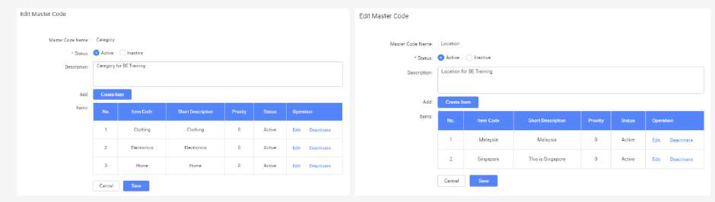

● In App Designer, **click** on **Page1 Table** page

|  |
| --- |
|  |

● **Click** on Category search field

|  |
| --- |
|  |

● *(Note)* Notice that the current values for this dropdown are static and hardcoded under **Datasource** section

|  |
| --- |
|  |

|  |
| --- |
| ● Click on the switch icon to switch to MasterCodeSetter in order to dynamically |

populate this field

|  |
| --- |
|  |

● Select **MasterCodeSetter**

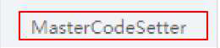

Note: MasterCodeSetter supports multiple components such as Select, Cascader, CascaderSelect, PhoneInput.

● In the dropdown, select **Category**

|  |
| --- |
|  |

● Similarly,select **Location** form search field. Under **Datasource**, click on **switch icon**  and change to **MasterCodeSetter**

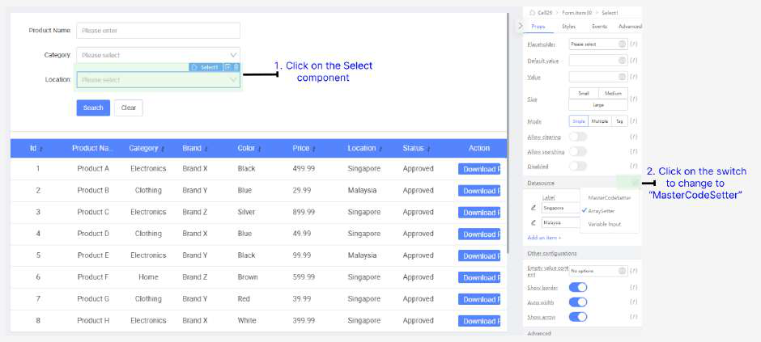

● In the dropdown, select **Location**

|  |
| --- |
|  |

● Preview the page

|  |
| --- |
|  |

● Perform the Searching function. Note that it still works as intended using Master Code values fetched dynamically, instead of hardcoded values

|  |
| --- |
|  |

**Practical 15.2: Multi language support(Optional)**

Master code feature has a multi-language support. This enhancement will allow users to view

and select master codes, such as location codes, in their preferred language, improving the

accessibility and usability of your application for a global audience.

● Master code translation to Chinese have already been created

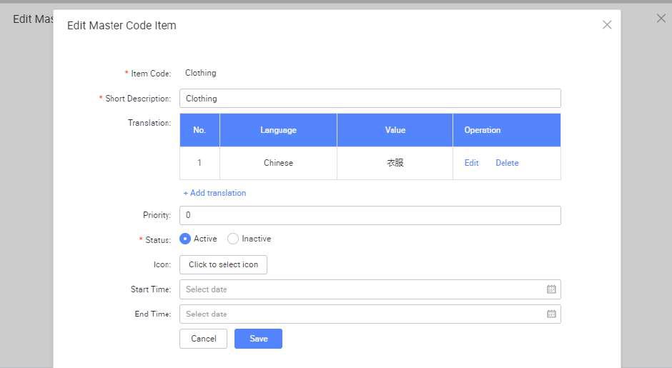

● Click on “Edit Application”. Note that multi-language support “Chinese” is enabled.

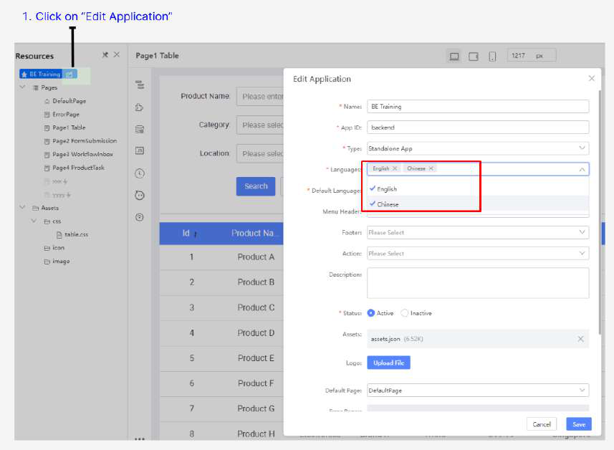

● Preview the page and select “Chinese” as the language

|  |
| --- |
|  |

● In the dropdown select, noted that master code is using chinese translation

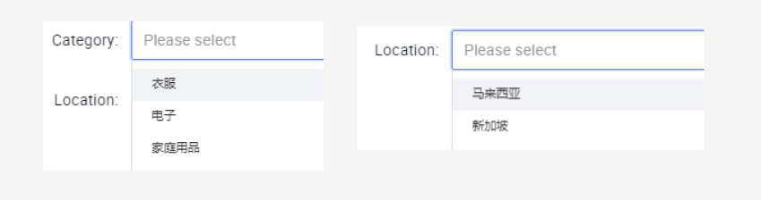

|  |
| --- |
|  |

**Tutorial 16: Custom Login Page Integration**

This tutorial covers the following Learning Objectives:

● Learn to integrate a custom login page for your application.

● Understand how to connect your custom login page with IAM (Identity and Access Management) service.

● Secure your application with enhanced authentication mechanisms.

In this tutorial, you will learn how to customize and integrate a login page into your application, backed by the IAM service in KAIZEN. This allows you to provide a secure and user-friendly login experience while ensuring that user authentication aligns with your organization’s identity management policies.

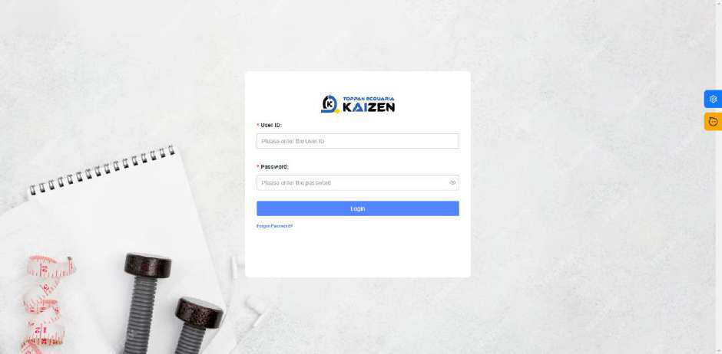

**Practical 16.1: Login Page Integration**

All necessary backend APIs for authentication have already been configured, allowing you to focus on designing and implementing the front-end aspects of the login page.

● **Update** the path with your **username** in the Source Code ○ betraining_amandalam

|  |
| --- |
|  |

**Tutorial 17: Database Designer**

This tutorial covers the following Learning Objectives:

● Understand how to create, modify, and manage database schemas using the Database Designer within the low-code platform.

● Learn to automate the generation of Database Access Objects (DAOs) by configuring them through the Database Designer.

● Effectively manage your database scripts within a centralized platform for improved organization and accessibility.

In this tutorial, you'll explore the Database Designer feature within KAIZEN, which allows you to design and manage your application's database with ease. Instead of manually writing SQL queries, the designer provides a user-friendly interface to create tables, define relationships, and structure your data model. This feature helps streamline database management and ensures that your data structure is aligned with your application's requirements.

**Practical 17.1: Setup Database and tables**

Each trainee is provided with a central PostgreSQL database for the practical. Ensure you have the correct database credentials (hostname, username, password, and database name) before proceeding.

Connect to the PostgreSQL Server

● In the studio console, go to your project and click **Database Designer** to launch the user interface

|  |
| --- |
|  |

● Click **Connections** and select **PostgreSQL**

|  |
| --- |
|  |

● Enter the following configuration details:   
○ **Host**: 172.20.0.141  
○ **Port**: Use the default PostgreSQL port (usually 5432) ○ **User**: <username>   
○ **Password**: tr@ining2025   
○ **Database**: trg_single

|  |
| --- |
|  |

● **Test** the connection. Once successful, click on **Save**

|  |
| --- |
|  |

Creating a New Table

● To create a table, right-click on the Tables section under the created schema and select **Create Table**.

|  |
| --- |
|  |

● In the right-panel section under **Basic**, enter the table name **product**

|  |
| --- |
|  |

● Under Column, click on **Add column** to add new columns

|  |
| --- |
|  |

● Define the following columns for the product table

|  |
| --- |
|  |

|  |  |
| --- | --- |
| **Column Name** | **Data Type** |
| id | SERIAL |
| name | VARCHAR |
| price | VARCHAR |
| category | VARCHAR |
| status | VARCHAR |
| brand | VARCHAR |
| color | VARCHAR |
| location | VARCHAR |
| pdf_data | BYTEA |

● Click **Save**

|  |
| --- |
|  |

|  |  |
| --- | --- |
| **Size** | **Additional**  **Constraint** |
| - | **Key**: Primary Key |
| 64 | **Nullable:** true |
| 64 | **Nullable:** true |
| 64 | **Nullable:** true |
| 64 | **Nullable:** true |
| 64 | **Nullable:** true |
| 64 | **Nullable:** true |
| 64 | **Nullable:** true |
| - | **Nullable:** true |

● Click **Run** in SQL preview

|  |
| --- |
|  |

|  |
| --- |
| CREATETABLE"product"( |

"id"SERIALNOTNULL,   
 "name"VARCHAR(64)NULL,   
 "price"VARCHAR(64)NULL,   
 "category"VARCHAR(64)NULL,   
 "status"VARCHAR(64)NULL,   
 "brand"VARCHAR(64)NULL,   
 "color"VARCHAR(64)NULL,   
 "location"VARCHAR(64)NULL,   
 "pdf_data"BYTEANULL,   
 PRIMARYKEY("id")   
);

● After creating the table, expand the Tables section under the schema to view the newly created table.

|  |
| --- |
|  |

Adding Rows to Table

In a development environment, it is often necessary to quickly add data to a PostgreSQL table

for testing purposes. There are two main ways to add data to a PostgreSQL table: manually

through the user interface or by running SQL scripts. Below are the steps for both approaches.

● Right-click on the table and select **Open Table**.

|  |
| --- |
|  |

● In the right panel, select **Add Row (+)**

|  |
| --- |
|  |

● Enter the following details to the new row for the first record ○ **id**: 1   
○ **name**: Product A   
○ **price**: 499.99   
○ **category**: Electronics   
○ **status**: Approved   
○ **brand**: Brand X   
○ **color**: Black   
○ **location**: Singapore   
○ **pdf_data**: <null>

|  |
| --- |
|  |

● Click **Submit** to save the new row

|  |
| --- |
|  |

● Alternatively, we can select the **Query console** to run SQL scripts. Right click on table and select **Query console**

|  |
| --- |
|  |

● Paste the SQL script below in the console and click **Run**

|  |
| --- |
|  |

|  |
| --- |
| INSERT INTO product (id, name, category, brand, color, status, price, location) |

VALUES   
(2, 'Product B', 'Clothing', 'Brand Y', 'Blue', 'Approved', '29.99', 'Singapore'), (3, 'Product C', 'Electronics', 'Brand Z', 'Silver', 'Approved', '899.99',   
'Singapore'),   
(4, 'Product D', 'Clothing', 'Brand X', 'Blue', 'Approved', '49.99', 'Singapore'), (5, 'Product E', 'Electronics', 'Brand Y', 'Black', 'Approved', '99.99', 'Singapore'), (6, 'Product F', 'Home', 'Brand Z', 'Brown', 'Approved', '599.99', 'Singapore'), (7, 'Product G', 'Clothing', 'Brand Y', 'Red', 'Approved', '39.99', 'Singapore'), (8, 'Product H', 'Electronics', 'Brand X', 'White', 'Approved', '399.99',   
'Singapore'),   
(9, 'Product I', 'Clothing', 'Brand Z', 'Gray', 'Approved', '59.99', 'Singapore'), (10, 'Product J', 'Electronics', 'Brand Y', 'Silver', 'Approved', '149.99',   
'Singapore'),   
(11, 'Product 404', 'Electronics', 'Brand Y', 'Silver', 'Approved', '149.99',   
'Singapore'),   
(12, 'Product 400', 'Electronics', 'Brand Y', 'Silver', 'Approved', '149.99',   
'Singapore'),   
(13, 'Product 500', 'Electronics', 'Brand Y', 'Silver', 'Approved', '149.99',   
'Singapore');



● Back to the Table tab, we click **Refresh** and see the updated list of rows in the table

|  |
| --- |
|  |

Benefits of Database designer

The Database Designer tool supports automatic generation of Data Access Objects (DAO) during code generation. This feature allows developers to quickly generate Java classes that map to database tables and handle CRUD operations, reducing the need for manual coding. We will explore this feature in greater detail in later tutorials.

In addition, the Database Designer also supports the automated creation of **Entity Relationship (ER) Diagram** and **Data Dictionary** for your application’s Databases.

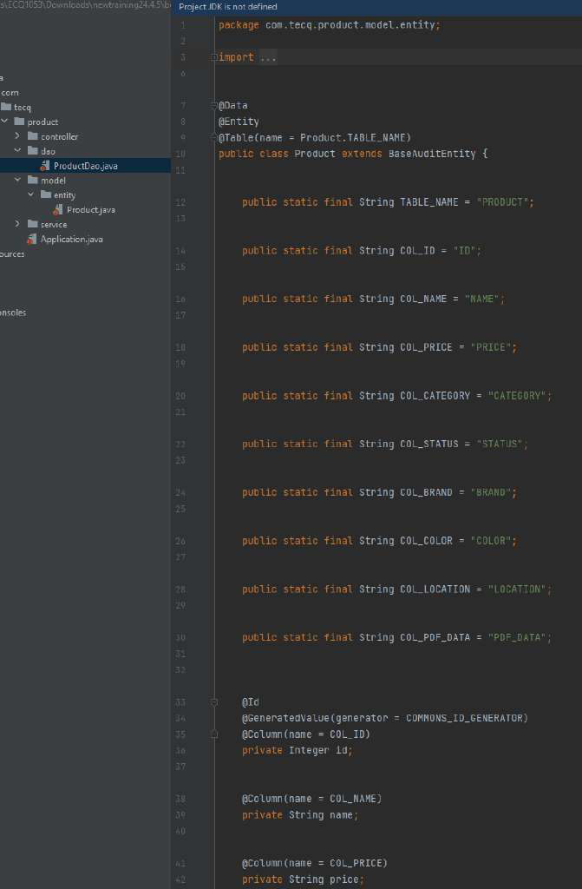

**Tutorial 18: Service / API Designer**

This tutorial covers the following Learning Objectives:

● Understand how to design and configure the service layer for APIs using the Service Designer feature within the low-code platform.

● Learn to define and manage essential API parameters and configurations using the API Designer.

● Gain insights into best practices for creating scalable and maintainable services and APIs to support application functionality.

In this tutorial, you'll explore the Service and API Designer features of KAIZEN, which allow you to build and configure the service layer for your applications seamlessly. The Service Designer enables you to design the architecture of your service layer, ensuring that it meets the requirements of your application. Meanwhile, the API Designer allows you to specify the necessary parameters and configurations for your APIs, ensuring effective communication between different components of your application. By mastering these tools, you will create robust and efficient service and API layers that enhance your application's performance and scalability.

**Practical 18.1: Creating Service and Controller**

The Service API Designer in development enables users to visually create and manage APIs with minimal coding effort. It simplifies the process of defining API endpoints, adding controllers, configuring datasource, and handling data types through an intuitive drag-and-drop interface. With built-in import/export features and code generation capabilities, the tool allows developers to efficiently design and integrate APIs into their applications. This feature streamlines API management, making it accessible to both technical and non-technical users, while ensuring that services are well-organized and maintainable.

Navigating the Service / API Designer

● Click **Services** to launch the user interface

|  |
| --- |
|  |

● Familiarize yourself with the interface layout

○ **Settings Panel (Left):** Contains options like add/import service, code generation, switching branch.

○ **Configuration Panel (Right):** For configuring controllers, datasources, and more.

|  |
| --- |
|  |

Adding a Service

The Service API Designer allows you to create and manage service (microservices), which serve as the backbone of a modular application architecture. Microservices enable scalable and independent components for handling different application functions. Microservices offer flexibility in development by breaking down a monolithic application into smaller, independent services that can be developed, deployed, and scaled individually. This ensures that each microservice focuses on a specific business capability, allowing for faster updates, better fault isolation, and easier scaling.

● In Tutorial 11, you would have already added an empty ‘Product’ microservice in order to initialize your Git Repository. Click on it in the Service API Designer to edit the service.

|  |
| --- |
|  |

● In the configuration panel, name your microservice to represent its function (e.g., "Product” for Product microservice").

○ **Name:** Product   
This is the name of the service being created. In this case, "Product" represents a microservice responsible for managing product-related functionalities in your application.

○ **(1st level) Package Path**: com.ecquaria.lowcode   
This specifies the root path at project level. Only project admin has the privilege to edit this value.

○ **(2nd level) Service Package Path**: product   
This specifies the base package path where all service-related components will reside. It organizes the project structure under product, ensuring that the service logic is well-organized.

○ **(3rd level)Controller Package:** controller (Default value: controller)   
The package where the controllers will be placed. Controllers handle incoming HTTP requests and route them to the appropriate service methods, providing endpoints for the API.

○ **(3rd level) Service Package:** service (Default value: service)   
This defines the location for service classes. The service layer contains business logic that performs operations related to the domain (e.g., product management), sitting between the controller and DAO layers.

○ **(3rd level) Model Package**: model (Default value: model)   
This package holds the data models or entities representing your domain objects. In this case, the Product model would define the structure of product data in the system.

○ **(3rd level)Dao Package:** dao (Default value: dao)   
DAO (Data Access Object) package contains classes that interact with the database, executing queries and managing persistence for your models (e.g., fetching or saving product data).

○ **(3rd level)Dao Package:** vo (Default value: vo)   
VO (Value Object) package represents a simple object that holds data and defines an attribute or a concept in the domain.

○ **Priority:** 0   
The priority defines the importance or order of this service relative to others. A lower number (like 0) could indicate higher priority, ensuring this service is loaded or accessed first when needed.

|  |
| --- |
|  |

Example of generated code structure based on the value entered:

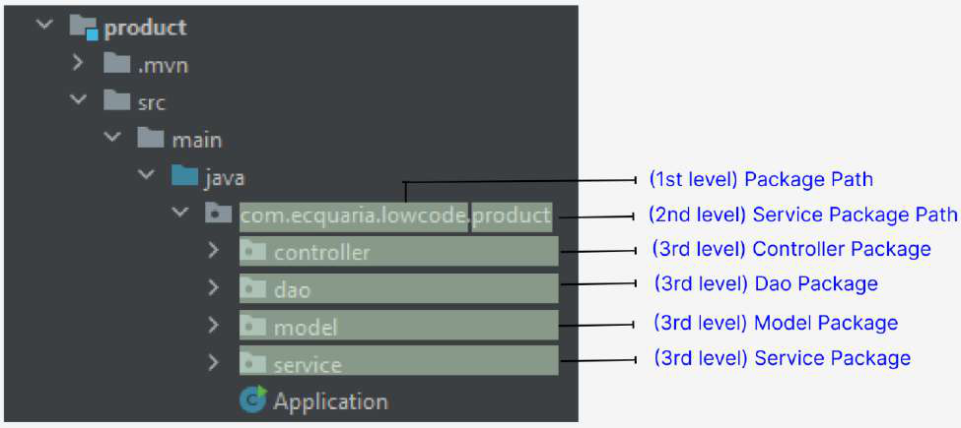

Note the **Package Path** value is specified when creating the project and the value can be edited. Only project admin can edit this value. For this training, the value of **com.ecquaria.lowcode** is being used.

|  |
| --- |
|  |

Adding a Database

Configuring a database is a crucial step to enable data storage and retrieval within the   
application. Integrating a new database configuration allows you to specify connection details, select tables, and set up data sources that your app can interact with directly. By configuring the database, your application can seamlessly manage and access data as part of its automated workflows and user interactions.

● Click **Add Database** to add database configuration

|  |
| --- |
|  |

● Enter the following configuration details and click **Save**:   
 ○ **Connection**: @172.20.0.141   
 ○ **Database**: trg_single   
 ○ **Schema**: <username>_schema (e.g. amandalam_schema)   
 ○ **Dao Package Path**: <BLANK> (Default)   
 ○ **Tables**: product   
 ■ Each of the tables in 'Assigned' will generate the DAO in the code. ■ Usually in a project setting, you might not want to generate the DAO for all the tables in your project database for this particular microservice. In this case, you will select the relevant ‘product’ database table created.

|  |
| --- |
|  |

● Click **Apply** to create the service

|  |
| --- |
|  |

Adding a Controller

Controllers in the Service API Designer act as an interface between the client (front end) and the service logic. They receive incoming requests, process them, and return appropriate responses. Controllers play a critical role in organizing API endpoints for different services. They manage the flow of data between the client and the service layer, ensuring that requests are routed correctly and data is processed efficiently. Properly structuring your controllers helps maintain clarity and scalability as your application grows.

● Click **Add Controller**

|  |
| --- |
|  |

● Enter the following:   
 ○ **Name**: ProductController   
 A descriptive name that reflects the functionality it controls (e.g.,   
 "ProductController" for product-related operations or "OrderController" for order- related tasks).

○ **(4th level) Controller Package:** <BLANK> (Default value: <BLANK>)   
The package where the controllers interface will be placed. Controllers handle incoming HTTP requests and route them to the appropriate service methods, providing endpoints for the API.

○ **(4th level)Service Package:** <BLANK> (Default value: <BLANK>)   
This defines the location for service classes. The service layer contains business logic that performs operations related to the domain (e.g., product management), sitting between the controller and DAO layers.

|  |
| --- |
|  |

|  |
| --- |
|  |

**For illustration purpose only**

In certain scenarios where we need complex application designs in controllers and services, adding a 4th layer controllers and services help make our code more maintainable. Below is an example of generated code output if 4th layer controller and service are specified in the configuration.

|  |
| --- |
|  |

Adding Datasource & Configure API Endpoints

In KAIZEN, adding a datasource and configuring API endpoints allows developers to quickly connect design interfaces with live APIs. This feature enables seamless interaction between the front-end design and back-end services, supporting various HTTP methods (e.g., GET, POST) to retrieve or send data. By integrating datasource into your project, you can bind the API to the design interface, ensuring real-time communication between the user interface and actual service APIs, streamlining development without requiring extensive manual coding.

● Select **Add Datasource** under controller

|  |
| --- |
|  |

● In the configuration panel, a list of configuration items are as follows:   
 ○ **Datasource ID**: A unique identifier for the datasource, used to reference it within your service.

○ **Identity**: A unique identifier, typically a key or ID, used to distinguish and manage the specific datasource connection.

○ **Location URL**: The endpoint URL where the API is hosted, used for sending requests.

○ **Version**: The version of the API being accessed, useful for managing compatibility.

○ **Params**: Parameters passed in the URL or body of the request, such as filters or identifiers.

○ **Query/Body**: Defines where the parameters are sent, either in the query string (URL) or request body.

○ **Encode Data**: Option to encode the data before sending it, typically used for secure or structured data formats like JSON.

○ **Response Type**: Specifies the format of the response data (e.g., JSON, Text) expected from the API.

○ **Method**: The HTTP method (e.g., GET, POST, PUT, DELETE) used to interact with the API.

○ **Timeout (ms)**: The maximum time in milliseconds to wait for a response before the request times out.

○ **Request Headers**: Key-value pairs sent with the API request, often used for authentication or content-type definitions.

○ **Add Function**: Allows the creation of custom functions to manipulate data or process the response after receiving it from the API.

|  |
| --- |
|  |

● Create a **getProducts** datasource as follows

|  |
| --- |
|  |

Note that **Params** allows toggling by clicking on **slash-icon (/)**  and **+Add**.We will explore other Params feature in later tutorial

|  |
| --- |
|  |

The details are as follows:

|  |  |
| --- | --- |
| **Field** | **Value** |
| **Datasource ID** | getProducts |

|  |  |
| --- | --- |
| **Identity** | getProducts |
| **Location URL** | /gateway/product/api/v1/betraining/products |
| **Version** | 1 |
| **Params** | pageNo: Single (Integer) |
|  | pageSize: Single (Integer) |
|  | name: Single (String) |
|  | category: Single (String) |
|  | location: Single (String) |
|  | sortBy: Single (String) |
|  | sortDir: Single (String) |
| **Query** | True |
| **Encode Data** | False |
| **Response Type** | <Default> |
| **Method** | GET |
| **Timeout (ms)** | 5000 |
| **Request Headers** | <Default> |
| **Add Function** | <Default> |

The **"Location URL"** parameter must follow the format /gateway/<service>/api/v1, where each segment plays a specific role in routing requests to the appropriate backend microservice:

● **/gateway/**: Serves as the main entry point, directing the request to the routing layer. ● **<service>**: This placeholder should be replaced with the unique name of the target microservice. It allows the gateway to identify and forward the request to the correct backend service.

● **/api/v1**: Specifies the API version to ensure backward compatibility and structured request handling.

This URL structure enables consistent routing within the microservice architecture, directing calls from the gateway to the designated backend services. Note that only requests formatted according to this convention will be correctly routed by the system

**Note**: The "Location URL" parameter currently does not support external API calls. Please ensure that all provided URLs are internal or self-hosted resources within the supported environment. External API functionality may be considered for future updates.

● Click **Apply** to add the datasource

|  |
| --- |
|  |

**Tutorial 19: Datasource API Binding**

This tutorial covers the following Learning Objectives:

● Understand how to bind datasources to APIs using HTTP GET and POST methods within a low-code platform.

● Learn to handle and process various data types, datasources during API binding.

●

In this tutorial, you'll discover the Datasource API Binding feature of KAIZEN, which allows you to seamlessly connect and interact with external datasources. This feature enables you to bind APIs through GET and POST methods, retrieve and send data in diverse formats, and configure datasources to suit your application needs. By mastering these capabilities, you'll create dynamic and responsive applications that effectively manage data from multiple sources, enhancing their functionality and scalability.

**Practical 19.1: Binding API to Table(GET)**

Binding an API to a frontend design enables seamless interaction between the user interface and backend services. This process allows developers to easily connect UI components to RESTful APIs, facilitating real-time data retrieval and manipulation with minimal coding. KAIZEN uses intuitive drag-and-drop interfaces, making it accessible for users with varying technical skills. This approach accelerates development, enhances maintainability, and allows teams to focus on business logic and user experience, leading to quicker deployment and improved application quality.

● Navigate to the App Designer page by clicking on the **Design** icon

|  |
| --- |
|  |

● Go to **Page1Table** page by clicking on the Resource panel

|  |
| --- |
|  |

|  |  |
| --- | --- |
| ● Click **Preview** | to enter the preview page, click **Confirm** using default roles |

|  |
| --- |
|  |

● Explore the client-side feature (Searching, Sorting, Pagination)

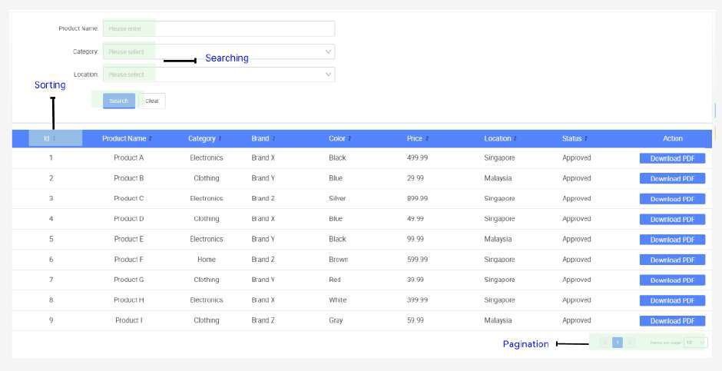

● Select **Datasource** and click **Create**

|  |
| --- |
|  |

● In the pop-up window, select **getProducts** and click **Next**

|  |
| --- |
|  |

● In the datasource configuration panel, click the **V** icon and select **Expression**

|  |
| --- |
|  |

It will change the text box to javascript expression, allowing values to be evaluated dynamically

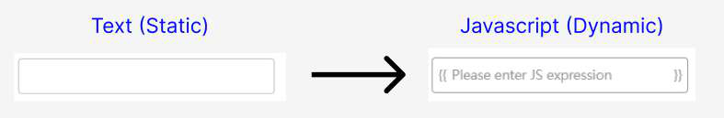

● Ensure all other fields are changed to **Expression**

|  |
| --- |
|  |

● Enter the following details for the datasource configuration and click **Create**:

|  |  |
| --- | --- |
| pageNo | this.state.currentPage |
| name | this.state.name |
| pageSize | this.state.pageSize |
| sortBy | this.state.sortBy |
| location | this.state.location |
| category | this.state.category |
| sortDir | this.state.sortDir |

|  |
| --- |
|  |

● Locate the **loadTable()** function in **Source Code Panel**

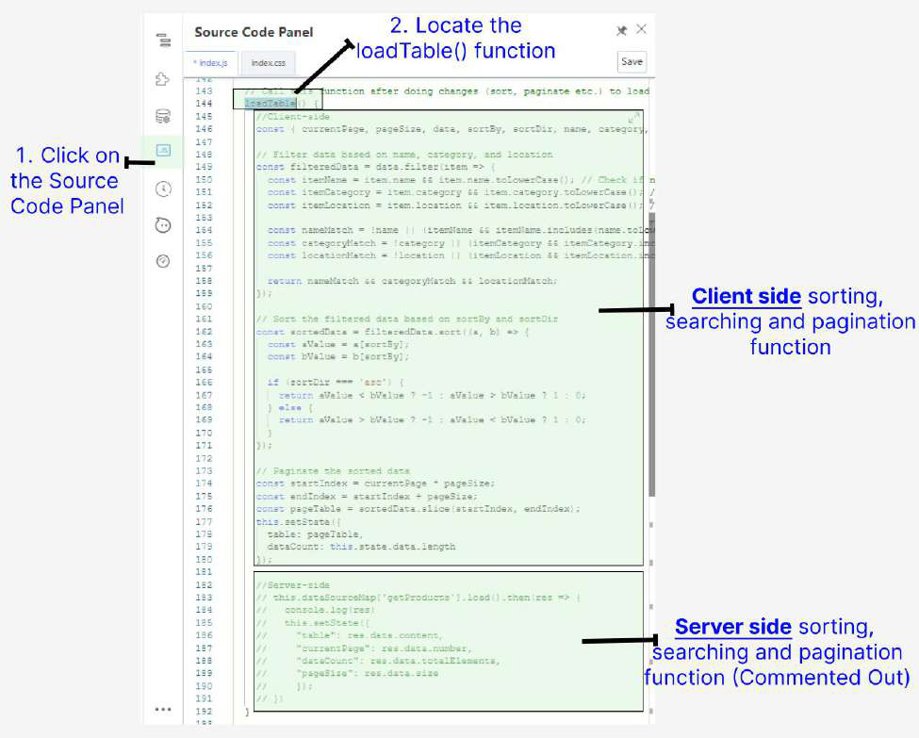

● Comment out Client-side code and Uncomment Server-side code and click **Save**  ○ Shortcut key: **Ctrl + /**

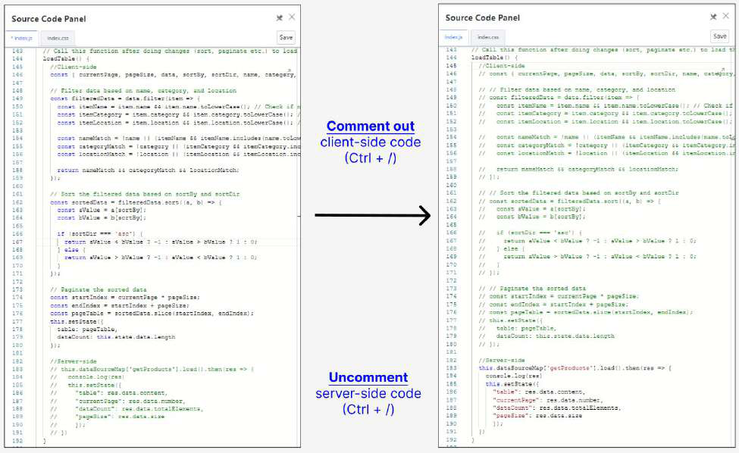

● **Preview** the page and observe Sorting, Searching and Pagination function are all server-side now   
 ○ Inspect “Network tab” in developer tools to see that server side requests are firing (F12)

|  |
| --- |
|  |

**Practical 19.2: Binding API to Formsubmission (POST)**

In this practical, you will learn how to handle form submissions using the Fetch API in JavaScript to send a POST request. This enables the collection of user input and send it to a server for processing, such as saving data to a database or initiating some backend logic.

Adding DataType & Datasource

In the API Designer, defining data types and individual query parameters serves distinct but complementary purposes in the development of a robust API. When you define a data type, you create a reusable structure that represents an object in your application, such as a product or user. This data type encapsulates multiple attributes (fields) and their types, forming a Value Object (VO) in Java. VOs help maintain a clear and consistent representation of complex data throughout the application. By leveraging data types, developers can:

1. **Promote Reusability**: Once defined, a data type can be utilized across multiple endpoints, reducing redundancy and enhancing maintainability.

2. **Simplify Code**: Using VOs simplifies method signatures and enhances code readability by allowing developers to work with well-defined objects rather than primitive types.

● Firstly, in Service API designer, click on **Add Data Type**

|  |
| --- |
|  |

● Define the Data Type with the following details: ○ **Name**: ProductVO   
○ **Params**:

|  |
| --- |
| name |
| category |
| brand |
| color |
| price |
| location |

|  |  |
| --- | --- |
| Single | String |
| Single | String |
| Single | String |
| Single | String |
| Single | String |
| Single | String |

|  |
| --- |
| workflowName |

|  |  |
| --- | --- |
| Single | String |

|  |
| --- |
|  |

● Click **Apply** to create the Data Type

|  |
| --- |
|  |

● Next, select **Add Datasource (+)** under controller

|  |
| --- |
|  |

● Create a **postProduct** datasource with the following details:

|  |  |
| --- | --- |
| **Field** | **Value** |
| **Datasource ID** | postProduct |
| **Identity** | postProduct |
| **Location URL** | /gateway/product/api/v1/betraining/products |
| **Version** | 1 |
| **Params** | ProductVO (Single) |
| **Body** | True |

|  |  |
| --- | --- |
| **Encode Data** | False |
| **Response Type** | <Default> |
| **Method** | POST |
| **Timeout (ms)** | 5000 |
| **Request Headers** | <Default> |
| **Add Function** | <Default> |

|  |
| --- |
|  |

Import Remaining APIs

● In the Service Designer, click on ‘Import Service’ to import in the remaining 3 APIs required for the BETraining application with the following file:

[kaizen-service(cleaned).xml](https://drive.google.com/open?id=1oME7c1abQ5rinnBl3nTWfBmW2MAuClDa)

|  |
| --- |
|  |

|  |
| --- |
|  |

|  |
| --- |
|  |

Binding to FormSubmission   
 ● Go back to the App Designer and navigate to the **Page2FormSubmission** page

|  |
| --- |
|  |

● Select **Datasource** and click **Create**

|  |
| --- |
|  |

● In the pop-up window, select **postProduct** and click **Next**

|  |
| --- |
|  |

● In the datasource configuration panel, click the **slash-icon (/) icon** to change to javascript expression.

*Note: This configuration simplifies the process by reducing redundancy, as you can handle multiple values with a single expression, rather than configuring each parameter individually.

|  |
| --- |
|  |

● Enter the values:   
 ○ **Params**: this.state.productForm

|  |
| --- |
|  |

● Click **Create**

|  |
| --- |
|  |

● Next, Bind Button component to onClick event

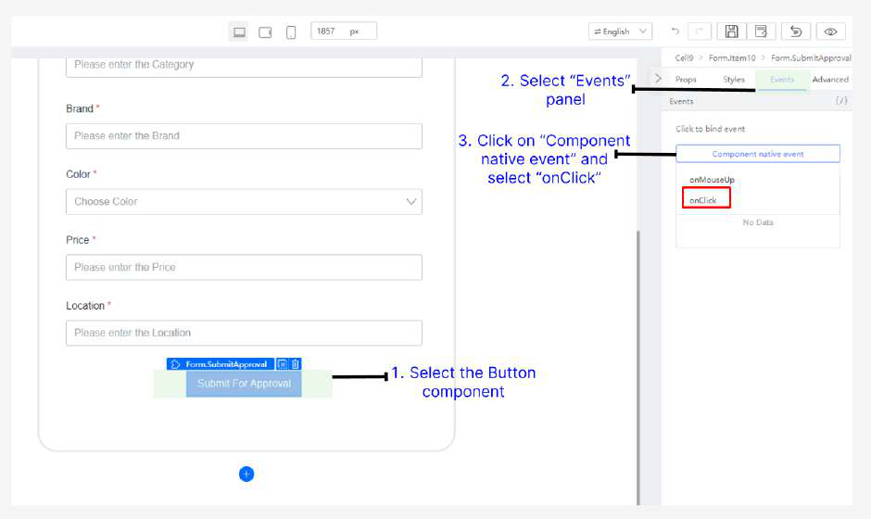

● Select **onSubmit** and click **Confirm**

|  |
| --- |
|  |

● Make sure to publish these changes made and click **Preview** to enter the preview page (which will also automatically publish for you)

● Open “Network tab” via developer tools to inspect the request being sent to server

|  |
| --- |
|  |

The request payload name is set from the Form.Item Advanced property

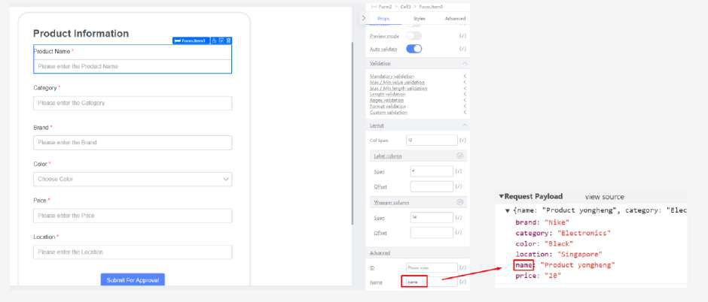

Binding POST Form using “Encode”

To bypass security restrictions by converting special characters into a standardized format, form encoding allows data to be safely transmitted without triggering Web Application Firewall (WAF) rules. This ensures reliable communication with servers by preventing data from being blocked or misinterpreted.

● Modify the ‘postProduct’ API with the following new change: ○ **Encode Data**: true   
○ **Request Headers**: Content-Type:

|  |
| --- |
|  |

● Fire the request, observe the payload is automatically encoded ● Recreate the Datasource by adding the headers **application/json**

|  |
| --- |
|  |

● Fire the request in preview, observe the payload is automatically encoded

|  |
| --- |
|  |

**Tutorial 20: Error Handling**

This tutorial covers the following Learning Objectives:

● Understand how to implement error handling mechanisms within the KAIZEN platform.

● Learn how to manage and resolve common errors encountered during application development.

● Improve application stability and user experience by effectively managing exceptions.

In this tutorial, you will explore error handling techniques within KAIZEN. By implementing robust error handling mechanisms, you will ensure that your application can gracefully handle and recover from errors, improving both the stability of the application and the overall user experience.

**Practical 20.1: Redirect to custom error page**

● Click on Edit Application

|  |
| --- |
|  |

● *(Note)* View the **Error Pages** configuration:   
○ **Forward Error:** Error will be forwarded to page ○ **To Error Page**: Error will be redirected to error page

|  |
| --- |
|  |

● Navigate to the Error page, click on **Save Draft** and **Publish Page**

|  |
| --- |
|  |

|  |  |  |  |
| --- | --- | --- | --- |
| |  | | --- | |  | | |  | | --- | |  | |

● We will go through this error handling effect in a later tutorial on Code Generation to showcase how pages will be redirected to custom error pages.

**Tutorial 21: Workflow Designer**

This tutorial covers the following Learning Objectives:

● Learn how to integrate a workflow system into your application to automate business processes.

● Understand how to manage and structure workflows to ensure efficient task sequencing. ● Enable automation of repetitive tasks through workflow management.

In this tutorial, you will explore how to integrate workflow features into your application, allowing for the automation of business processes. With workflows, you can define specific sequences of tasks required in your application, allowing you to design complex workflows of your business logic effortlessly.

|  |
| --- |
|  |

**Description of workflow:**

**Product Submission:**

● The user submits product details.   
● Product enters "Pending" state.

**Product Approval / Rejection:**

● If approved, the product transitions to "Approved" state. ● Approved products are visible to users.

● If rejected, the product transitions to "Rejected" state. ● Users are notified of rejection and may revise the product.

**Practical 21.1: Using default workflow (Claim-based routing)**

The backend APIs have been integrated with some of the workflow APIs, enabling smooth communication and data exchange between the application's backend system and the workflow management platform.

**Task Claiming**: When a task becomes available within the workflow, it is open for claiming by any eligible participant or user.

**Claim Ownership**: The participant who claims the task takes ownership and responsibility for its completion.

**Task Completion**: Once claimed, the participant is expected to complete the task within a specified timeframe or according to predefined criteria.

● Navigate to the “Workflow Inbox” page   
 ○ **Task Claiming:** When a task becomes available within the workflow, it is open for claiming by any eligible participant or user. Hence, all users can **see the task**  **for any user**.

|  |
| --- |
|  |

● Under “Actions” column, each user claim their own task by clicking on the “Claim” button ○ **Claim Ownership:** The participant who claims the task takes ownership and responsibility for its completion.

|  |
| --- |
|  |

● After claiming their own task, each user is now able to **see only his/her own task**. ○ **Task Completion**: Once claimed, the participant is expected to complete the task within a specified timeframe or according to predefined criteria.

|  |
| --- |
|  |

● Click on **Approve/Reject** button to complete the task

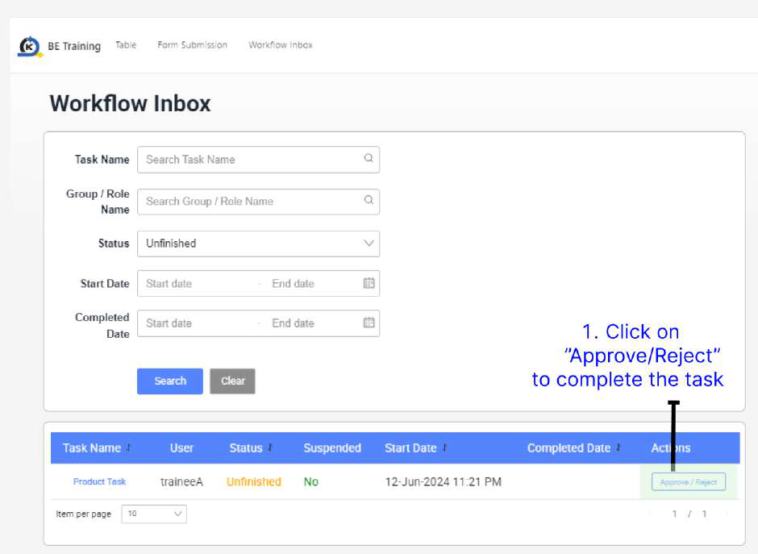

● According to the workflow, the task can either go through ‘Approval' or ‘Rejection’ flow. Click on either **Approve** or **Reject**

|  |
| --- |
|  |

● In the workflow inbox, each user can see their own completed workflow by filtering status ‘Finished’

|  |
| --- |
|  |

|  |
| --- |
|  |

**Practical 21.2: Designing and Deploying customworkflow**

This exercise involves designing and deploying a custom workflow by creating a sequence of automated steps to improve a business process. You'll start by analyzing the requirements, then design the workflow with tasks, conditions, and decision points. Next, implement the workflow by writing code or configuring a workflow tool.

● Click on the “Workflow” icon

|  |
| --- |
|  |

● Import the workflow   
 ○ [BETraining_Workflow.bpmn](https://drive.google.com/open?id=19EVa7dGs4TzKagSbyfE_ARb6fy_w-59A)

|  |
| --- |
|  |

|  |
| --- |
|  |

Disclaimer: For this training , we will focus more on the BPMN workflow.

|  |
| --- |
|  |

Import the downloaded workflow and press Create button.

|  |
| --- |
|  |

Disclaimer: Above is the sample description of workflow element, not representing the imported workflow.

**KAIZEN Workflow Task Elements**

|  |
| --- |
|  |

● In the imported workflow, rename it by changing the Process name to your username ○ <username>

|  |
| --- |
|  |

● Save the workflow

|  |
| --- |
|  |

● Start designing the workflow

|  |
| --- |
|  |

● We will be using the following two tasks for this training:   
 ○ **JDBC Task**: involves connecting to a database using Java Database   
 Connectivity (JDBC) to execute SQL queries and manage database operations. This task allows for reading, updating, and manipulating database records within a workflow, ensuring data consistency and enabling dynamic data-driven processes.

○ **Javascript Task**: involves writing and executing JavaScript code within a workflow to perform custom operations. This task can include data manipulation, making API calls, handling conditional logic, and other dynamic behaviors, allowing for flexibility and control over workflow execution.

|  |
| --- |
|  |

● Drag the JDBC task beside the HTTP Task

|  |
| --- |
|  |

|  |
| --- |
|  |

● Remove the original HTTP Task

|  |
| --- |
|  |

● Update the JDBC task with the following values:

|  |
| --- |
|  |

The JDBC task is trying to update the database directly by setting the status to ‘Approved’.

This database is the training central database that you have connected to via the Training Environment Profile earlier (the Profile feature will be explained in further details in Tutorial 23).

The workflow feature is running on the central db so all trainees can see Approved and Rejected tasks.

|  |  |
| --- | --- |
| Datasource | betraining |
| DML Type | UPDATE |
| Prepared Statement | UPDATE product set status = 'Approved' where id=CAST(:productId AS INTEGER) |
| Result Count Storage Type | Process |
| Result Count Variable | persistStoryCount |

|  |  |  |
| --- | --- | --- |
| Parameters | Column Type | STRING |
|  | Identifier Name | productId |
|  | Use Existing Variable | True |
|  | Parameter Retrieval Type | Process |
|  | Variable Name | productId |

● Drag the Javascript Task to the workflow

|  |
| --- |
|  |

|  |
| --- |
|  |

● Update the Javascript task with the following javascript code:

|  |
| --- |
|  |

This Javascript task ensures that the location must be ‘Singapore’ or ‘Malaysia’, else it will change the ‘isStatus’ to ‘Rejected’ and takes the Reject flow instead

try {  
 if ($processVariable.savedProduct.location=="Singapore"|| $processVariable.savedProduct.location=="Malaysia"){   
 $processVariable.isStatus='Approved';   
 }   
else {   
 $processVariable.isStatus='Rejected';   
}

} catch (error){   
console.log("Error has occurred: "+error.message); }



● Your complete workflow look like this

|  |
| --- |
|  |

● Export your workflow

|  |  |
| --- | --- |
|  | |
|

● Login to Training Environment [(https://kaizen-training.toppanecquaria.com/#/login)](https://kaizen-training.toppanecquaria.com/#/login)○ Username (Example: yongheng)   
○ Password (Password$1234)

|  |
| --- |
|  |

● Navigate to Workflow Admin

|  |
| --- |
|  |

● Deploy the workflow

|  |
| --- |
|  |

● To use your workflow, frontend code logic needs to be modified.

Navigate to BE-Training App

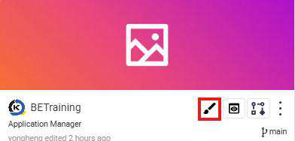

Make Sure Training Profile is selected and configured as below

|  |
| --- |
|  |

na   
Under the Source Code Panel of the FormSubmission page, edit and replace the value with your username

|  |
| --- |
|  |

● Submit a form to trigger user task

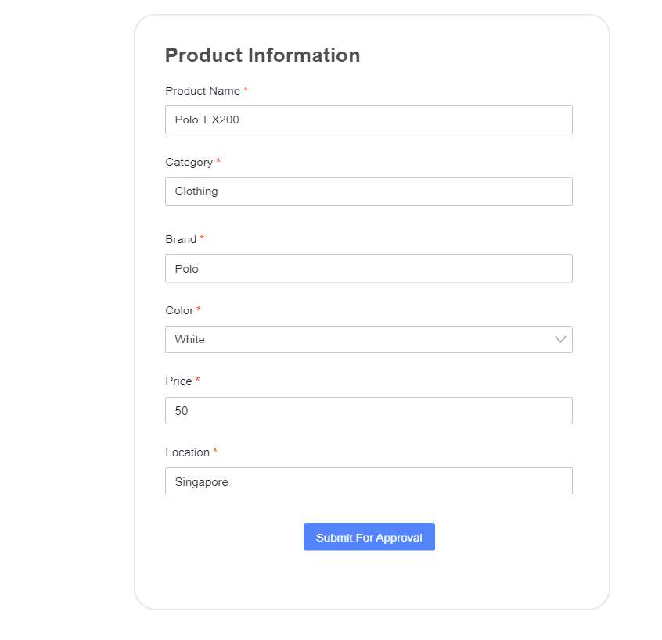

● From the admin page, a new workflow instance was started.

|  |
| --- |
|  |

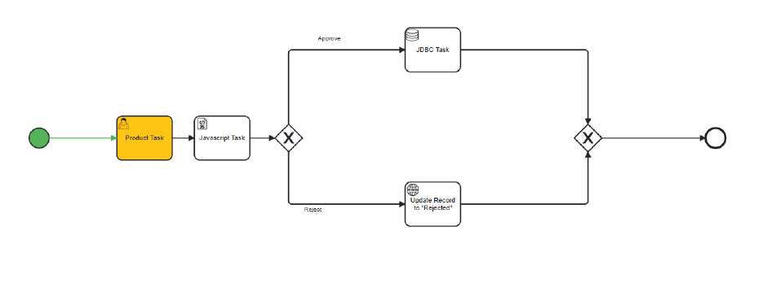

● Open workflow inbox to claim and Reject the task that was submitted

|  |
| --- |
|  |

|  |
| --- |
|  |

|  |
| --- |
|  |

● After rejecting the task , the workflow instance has been completed as shown below.

|  |
| --- |
|  |

● But why does it goes to “Approved” flow?

Previously we have added a javascript task to do location check in javascript in here.Thus if the location of product task was “Singapore” or “Malaysia”, the status will set to Approved”

|  |
| --- |
|  |

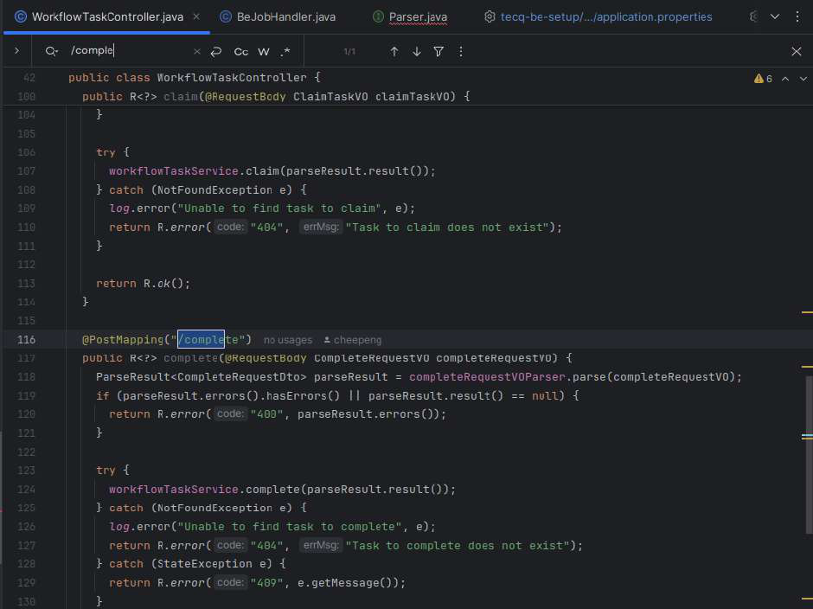

**Practical 21.3: Workflow observability**   
In this practical 4.3, we will look into workflow observability features.

● Workflow Dashboard   
 ● Workflow Instance Tracking   
 ● Workflow Execution Timeline View   
**Workflow Dashboard**   
Dashboard allows users to gain overview of workflow running and status

|  |
| --- |
|  |
|  |

**Workflow Instance Tracking**

Track and monitor the live execution of your workflows visually with color-coded indicators for easy identification, allowing you to spot workflow issues at a glance. Instance variable and allows users to zoom in on specific tasks for quick diagnosis and resolution, by looking into the variables comparison passed between each workflow task. This will be useful in observing the variable transfer and changes in the workflow.

● Workflow Admin can also monitor the status of each workflow instances ○ For example, the two instances were the one created earlier

|  |
| --- |
|  |

● Click on “View Instance”

|  |
| --- |
|  |

● By clicking on the page, we can view the instance variable values before and after the workflow task.

|  |
| --- |
|  |

**Workflow Execution Timeline View**

The timeline feature allows users to look into the time execution of each workflow task. This is useful in observing any bottlenecks and deep dive into individual tasks for debugging in the event of error.

● We can also click on the ‘Timeline’ tab

|  |
| --- |
|  |

● We can see the time execution of the task

|  |
| --- |
|  |

**Tutorial 22: Code Generation (Backend)**

Generating backend code in KAIZEN simplifies the creation of robust server-side applications by converting user-defined configurations into structured Java code, including Value Objects (VOs) and application properties. This automated process enhances productivity by eliminating the need for manual coding, reducing the risk of errors, and ensuring adherence to best practices. Developers can easily integrate business logic, manage data access through DAOs, and configure application settings, all while maintaining a consistent architecture. By leveraging code generation tools, teams can accelerate backend development, streamline workflows, and focus on delivering high-quality applications efficiently.

|  |
| --- |
|  |

**Practical 22.2: Generating and Running Backend Code**

Generate Code

● In Service Designer, select **Generate Code**

|  |
| --- |
|  |

● Ensure **Backend: Product** is selected together with the **Generate service layer**  **classes** option, and click **OK**

|  |
| --- |
|  |

A zip file is downloaded

|  |
| --- |
|  |

● Unzip the file

|  |
| --- |
|  |

Understanding Generated Backend Code Structure

In KAIZEN, the backend code is often auto-generated to streamline development. However, understanding the structure of this generated code is crucial for customization, debugging, and integrating new features. The backend typically includes components like controllers, services, repositories, and models, each serving a specific role in handling API requests, business logic, and database interactions. By familiarizing yourself with this structure, you can make targeted modifications, optimize performance, and ensure the backend aligns with your application's requirements.

**Directory Structure**

The generated backend code in low-code platforms is organized into a clear directory structure to manage different functionalities efficiently. Common folders include:

● **Controllers**: These handle incoming API requests and map interactions between the frontend and backend. Controllers can be customized to change specific API behaviors based on your application's needs.

● **Dao (Data access object)**: These are responsible for managing database interactions, using auto-generated methods to access and manipulate data. Repositories can be customized to add complex queries or optimize performance.

● **Models and Entities**: Models represent your application's data and map directly to database tables. You can modify them to include additional fields or relationships, aligning with evolving business requirements.

● **Services**: Services manage the core business logic and interact with controllers. They encapsulate reusable logic and can be extended or modified to introduce additional functionality.

● **Configuration**: The configuration files in the generated backend code are essential for managing environment-specific settings like security, database connections, and API credentials

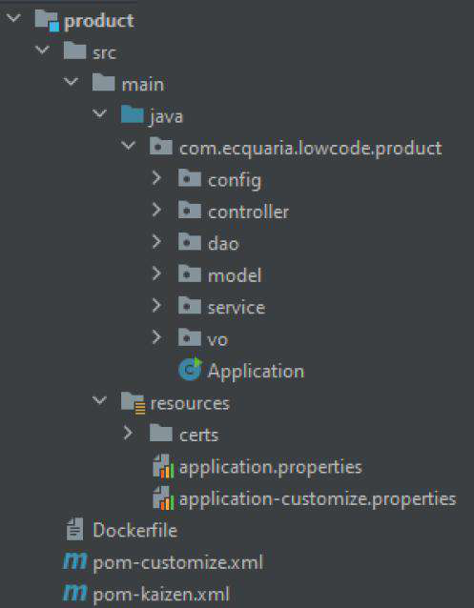

|  |  |
| --- | --- |
| **application.properties** | Default application configuration settings. |
| **application-customize.properties** | A separate properties file for custom  configurations without modifying defaults. |
| **pom-kaizen.xml** | The primary Maven configuration file for the server module. |
| **pom-customize.xml** | A customizable Maven file to override dependencies or configurations. |

● **Download** the zip file below containing the custom code and environment configurations to run your product service   
 ○ **[product-custom.zip](https://drive.google.com/open?id=1ckkLLvS6082tkvECtZaQ6u8tOU7NRN9-)**

○ This source code has the core business logic implemented which interacts with interfaces generated by KAIZEN.

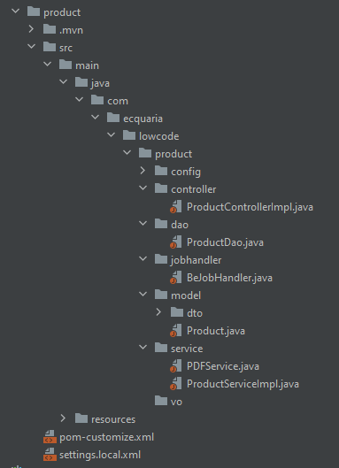

● **Unzip** and **Copy** the necessary code over.

○ For Windows:   
 Copy the product folder into the product folder of your generated code.

|  |
| --- |
|  |

○ For macOS:   
.mvn will be hidden, use command+shift+dot to show hidden files $ rsync -av /source_folder/ /destination_folder/

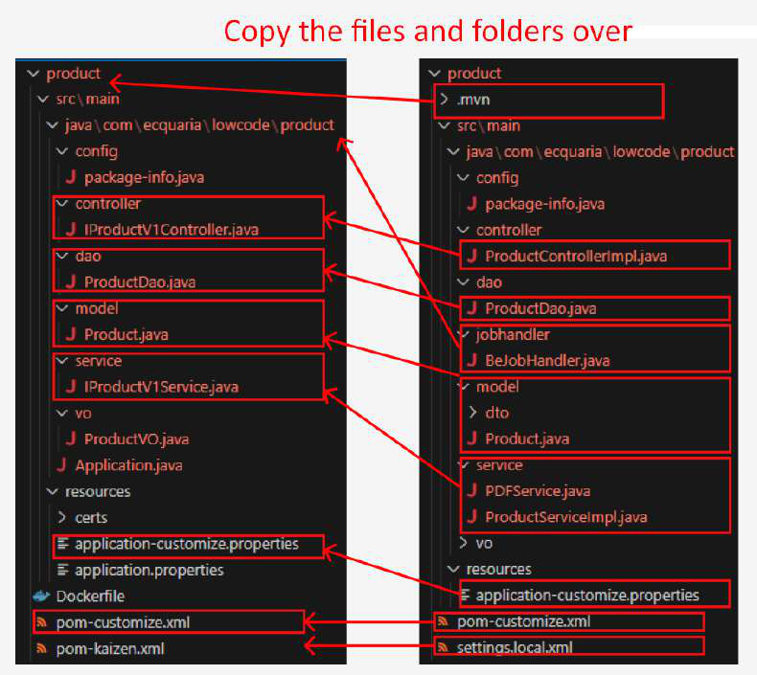

● The result will look something like below

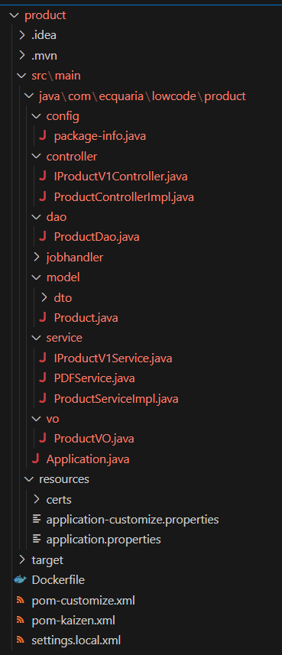

● Open your now updated generated code “Training<username>” in your IDE ● Update the properties configuration in your **application-customize.properties**  file:   
 ○ (\TrainingAmandaLam\product\src\main\resources) to your own schema name highlighted in red below

Spring.datasource.url: <username>_schema   
(Example: amandalam_schema)

○ Add the config property “spring.jpa.properties.hibernate.default_schema” with the value as your username. See the area highlighted greenbelow

spring.jpa.properties.hibernate.default_schema: <username>_schema

(Example: spring.jpa.properties.hibernate.default_schema: amandalam_schema)

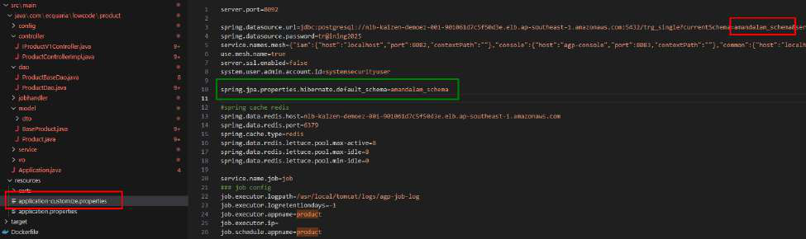

● Open your terminal in the product directory (Training<username>/product) ● **mvn clean package -f pom-customize.xml**

|  |
| --- |
|  |

● **java -jar target/product.jar**

|  |
| --- |
|  |

**Tutorial 23: Profile for local development**

This tutorial covers the following Learning Objectives:

● Learn how to configure profiles for local development within your application.

● Understand how to redirect traffic to different resources based on the environment. ● Improve local development workflows by integrating API calls with KAIZEN seamlessly.

In this tutorial, you will learn about configuring profiles that allow you to redirect traffic to different resources, enhancing local development. This feature enables smooth development of APIs in a local environment while still interacting with KAIZEN resources, improving the overall development experience.

Essentially, you can use profile to configure and connect to different environments, allowing you to easily access the APIs there from your frontend pages in the app designer. All these can be done without having to build and run your entire frontend application locally. Note that you can only connect to 1 profile at a time.

|  |
| --- |
|  |

**Practical 23.1: Running be-services**

For local development, the application requires running multiple services to simulate the production environment effectively. Developers need to run four jar files locally, each   
representing a critical component of the application. These jar files work together to provide the necessary backend functionality for testing, debugging, and developing features.

● **Download** the following based on your Operating System: ○ If you are using Windows:   
 ■ [BETraining_JAR(CloudDaaSenv)-Windows.zip](https://drive.google.com/open?id=1qK2ufQFAscZHPvUQ9LTo4PjR0Znoc44D)

● **Unzip** the zip file. There should be a script file included (either a .sh for MacOS or Linux or .bat for Windows)

|  |
| --- |
|  |

● Open command prompt in the unzipped folder

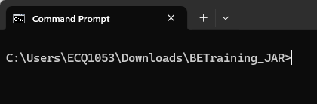

● Run the jar files through the script provided:   
 ○ For Windows:   
 ■ Run the script using ./start.bat

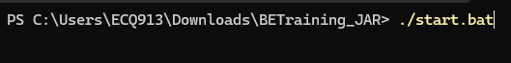

● The script should open 5 terminal windows with the following KAIZEN microservices: IAM, Common, Console, Gateway, IAM Proxy:

|  |
| --- |
|  |

Ensure that the applications run with no exceptions/stack traces. Alternatively, you can look out for the default Spring Boot Application started message (ie. Started Application in xx.xxx seconds (process running for xx.xxx))

**Practical 23.2: Update Profile feature**  ● Click “Profiles” plugin

|  |
| --- |
|  |

● Add a new “localhost” profile

|  |
| --- |
|  |

● Click on **Test Connection** to test connectivity

|  |
| --- |
|  |

● Select “Use by viewer”. Selecting this feature will ensure that the application’s users with external or internal viewer roles will use this profile when previewing the application.

|  |
| --- |
|  |

● **Click** to switch the profile

|  |
| --- |
|  |

● Click OK to reload the site

|  |
| --- |
|  |

● Ensure a **Tick sign** appears on the **localhost** profile

|  |
| --- |
|  |

● Refresh the page, note that API calls are made using your configured profile “localhost”, which allows users to do local development.

|  |
| --- |
|  |

|  |
| --- |
|  |

Notice that all these data loaded on your application’s ‘Page1 Table’ page are taking the data you have added in your schema earlier using the Database Designer Tutorial.

**Tutorial 24: Customize Privilege for Page**

**Permission**

This tutorial covers the following Learning Objectives:

● Understand the Importance of Page Permissions in securing application pages and controlling user access.

● Learn to Define Custom Page Privileges and configure custom privileges for specific application pages to grant access.

Now that you are able to get your application successfully running on your local profile, you can easily develop and test the integration between your backend code logic and your frontend application screens. However, the concern with your current application is that any user will be able to access all pages in your application. In this tutorial, you’ll explore how you can configure your pages with custom privileges to control its access privileges. We will go into more detail about all the other Identity and Access Management (IAM) features in the last tutorial.

● Click on setting and select **Privileges**

|  |
| --- |
|  |

● Click **Create** to open a popup

|  |
| --- |
|  |

● Enter the following value:   
○ **User Domain:** training_product   
○ **Privilege Name:** betraining_<username> (example: betraining_yongheng) ○ **Privilege Code:** be001   
○ **Subject Type:** betraining

|  |
| --- |
|  |
|  |

● Click **Save**

|  |
| --- |
|  |

● Edit each page to add in the necessary privileges

|  |
| --- |
|  |

|  |
| --- |
|  |

|  |
| --- |
| **Page** |
| Error |
| Login |
| Table |
| FormSubmission |
| WorkflowInbox |
| ProductTask |

|  |
| --- |
| **Privileges** |
| Anonymous Resource |
| Anonymous Resource |
| betraining_<username> |
| betraining_<username> |
| betraining_<username> |
| betraining_<username> |

The above configuration of privileges for the respective pages mean that only users with roles that have the corresponding privilege would be able to access the respective page in the application. This step will ensure that your local application would be able to run smoothly after the next tutorial on code generation for backend.

More details on the other IAM features will be covered in the last tutorial.

**Tutorial 25: Code Generation (Frontend)**

This tutorial covers the following Learning Objectives:

● Understand the process of code generation for both frontend and backend components using KAIZEN.

● Gain insights into the structure and organization of the generated code to facilitate easier navigation and modifications.

● Learn best practices for integrating and maintaining generated code within your development workflow to ensure consistency and scalability.

In this tutorial, you'll explore the code generation feature of KAIZEN, which allows you to automatically create frontend and backend code components tailored to your application. This feature streamlines the development process by eliminating repetitive coding tasks, enabling you to focus on business logic and functionality. You will also learn how to customize the generated code to align with your project’s architecture, ensuring a seamless integration with your existing codebase and improving overall maintainability.

**Practical 25.1: Generating and Running Frontend Code**

Generating frontend code in KAIZEN streamlines the creation of interactive user interfaces by transforming user-defined JSON Schemas into functional React code. This automated process accelerates development, ensures consistency, and minimizes errors, allowing developers to focus on business logic and user experience rather than repetitive coding tasks. By using visual design tools and pre-defined templates, teams can quickly prototype, iterate, and deploy applications, making KAIZEN an effective solution for efficient software delivery.

Installation of Necessary Prerequisites:

● Install Node.js (18.20.4) and Yarn to manage frontend dependencies. ● Set up Nginx

Generate Code

● Click setting and select **Generate FE Code**

|  |
| --- |
|  |

A zip file is downloaded

|  |
| --- |
|  |

● Unzip the file

|  |
| --- |
|  |

|  |
| --- |
|  |

● Open with your code editor or using command prompt○ Visual Studio Code   
○ Command Prompt

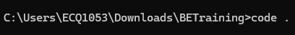

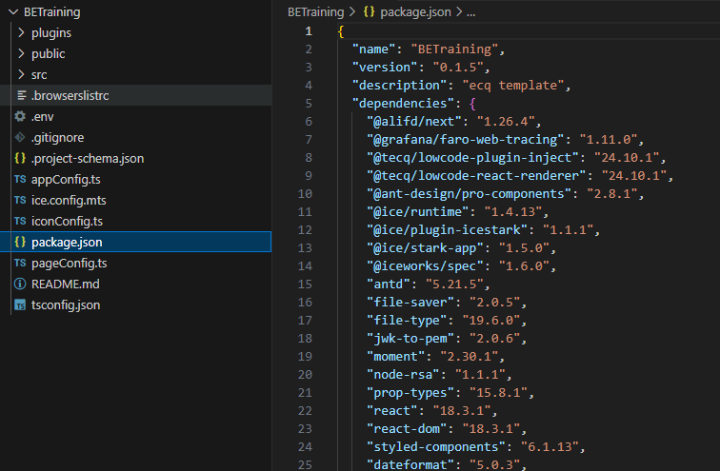

● Ensure you’re using node version of 18.20.4   
 ○ node -v

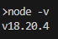

● Change yarn registry path as some custom dependencies are hosted internally in Toppan network nexus   
 ○ **Install yarn (Skip this step if you’ve already installed yarn)**   
 ■ **npm install -g yarn**   
 ○ **yarn config set registry http://alb-kaizen-daasez-001-673358367.ap-** **southeast-1.elb.amazonaws.com:8081/repository/npm-group**



|  |
| --- |
| **Windows (Run as administrator):**  java -jar be-common/tecq-be-common-24.10.1.jar -- spring.config.location=file:be-common/application.properties  **macOS:**  sudo java -jar be-common/tecq-be-common-24.10.1.jar -- spring.config.location=file:be-common/application.properties |

● Install the dependencies

○ yarn install

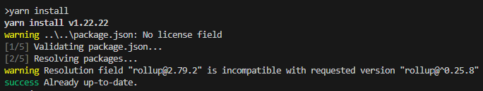

● Run the application

○ **yarn run start**

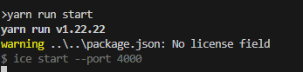

Running nginx

|  |
| --- |
|  |

● Edit the **nginx/nginx.conf** value in the nginx folder to your username ○ betraining_traineename (Example: betraining_amandalam)

|  |
| --- |
|  |

New nginx conf

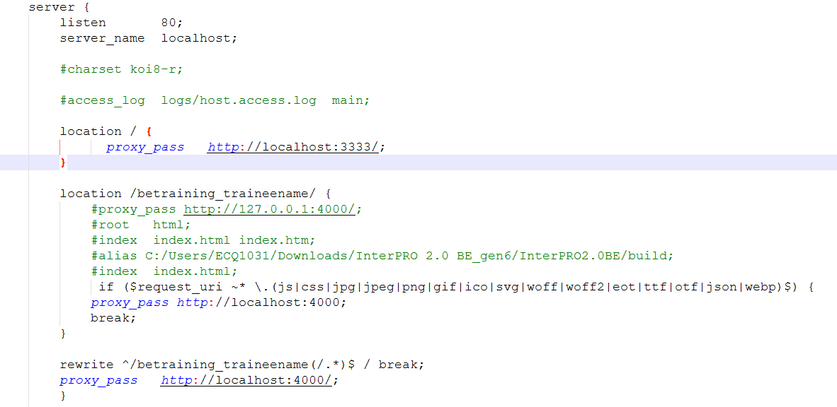

**For macOS:**   
Copy paste [nginx.conf](https://drive.google.com/open?id=1EeBtK5v7ETB0whGTBUwdwT_DbBhhzzKF)file inside /opt/homebrew/etc/nginx folder

● Double click the nginx.exe to start the service. Some helpful command for debugging: ○ start nginx   
○ nginx.exe -s stop   
○ tasklist /FI "IMAGENAME eq nginx.exe"

**For macOS:**   
○ sudo nginx   
○ sudo nginx -s stop

|  |
| --- |
|  |

Running the generated code   
 ● Navigate to **http://localhost/betraining_traineename/#/loginpage**, you should be able

to see your login screen.

(Example: **http://localhost/betraining_amandalam/#/loginpage**)

|  |
| --- |
|  |
|  |

After login to your account, you will be redirected and see the table listing

|  |
| --- |
|  |
|  |

Triggering Error

● **Ctrl + C** and **stop** the running of product.jar

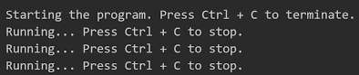

● **Click** on Download. As the API is no longer present, it will trigger a 500 error

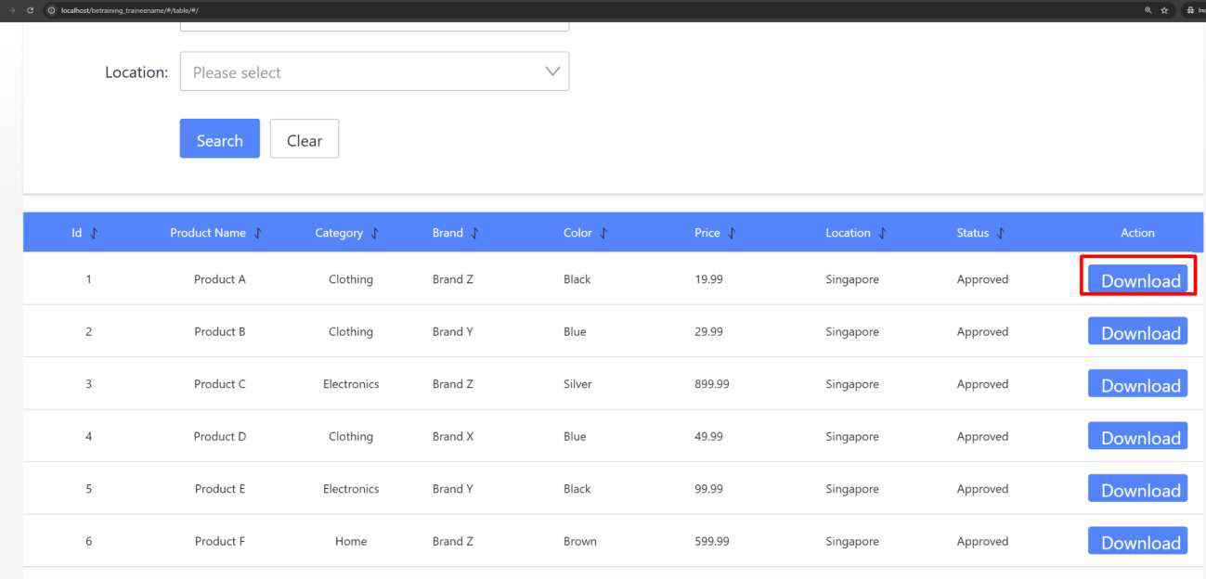

● Notice your page is redirected to error page

|  |
| --- |
|  |

**Tutorial 26: Push and Merge Code to Git**

This tutorial covers the following Learning Objectives:

● Managing branches and tags within KAIZEN.

● Learn to push changes to a Gitlab repository from KAIZEN for both frontend and backend code.

In earlier tutorials, we have learnt how to set up the connection to Git and switch to a new branch to work on various enhancements and test your application to run locally. Now, we’ll learn how to automate the process of committing and pushing changes in KAIZEN, thus improving efficiency and collaboration. We will demonstrate how the integration with GitLab’s CI/CD pipeline feature automates the testing and deployment, streamlining the release process directly from KAIZEN.

Practical 26.1: Frontend Git Management

In KAIZEN, frontend Git branch management is essential for maintaining an organized and efficient workflow. By creating separate branches for UI changes, such as theme updates or new features, developers can isolate modifications, avoid conflicts, and ensure smooth collaboration across teams. This approach supports parallel development, minimizes disruption to the main codebase, and allows for better testing and integration of frontend updates, ultimately enhancing project quality and stability.

Once you enter the design page, you will be able to see the theme design button and the published theme.

Create New Tag and Git Push

● On the App Designer, click on the commit icon of the branch you are on and proceed to commit changes, which will generate the FE code and push into Git.

● When the branch is ready to be released, as you push your code to Git, you may also tag your commit to mark a specific commit as a release version (e.g., v1.0, v2.1.3) and is immutable.

|  |
| --- |
|  |

|  |
| --- |
|  |

|  |
| --- |
|  |

● You should be able to see this code changes pushed onto the branch on Git as well.

|  |
| --- |
|  |

● Another way to push FE Code onto the current branch on Git is from the project itself on the studio console by clicking **Generate FE Code & Push**.

|  |
| --- |
|  |

|  |
| --- |
|  |

Merge Code to Main Branch + Push Main Branch

● Once you are done making relevant enhancements on your current enhancement branch, we will now proceed to merge your FE changes to the main branch.

● Switch back to the **main** branch by clicking the Git branch on your application from the studio console.

|  |
| --- |
|  |

● In your app designer, click on the merge button beside the application and select your enhancement branch to merge into the main branch.

|  |
| --- |
|  |

|  |
| --- |
|  |

● Before you merge, notice that the new additions will be highlighted in green. You will need to specify what you want to merge in by clicking on the blue arrows at each individual addition or on top to merge in all new additions.

|  |
| --- |
|  |

● In this case, the red colour coded indication indicates that there are changes to existing lines in the code. You may click into the file icon of each of the pages to view the

changes.

|  |
| --- |
|  |

● Click on the blue arrow on top to merge in all new changes made by the theme change. After which, click on the ‘merge’ button.

|  |
| --- |
|  |

|  |
| --- |
|  |

● You may now verify that your enhancements have been successfully merged and reflected on your application screens on the main branch.

● Note that KAIZEN’s merge feature is not a replica of merging on Git. Refer to the additional information below for more information on KAIZEN’s Git features.

● Next, we will proceed to push these changes on the main branch onto Git. As done in the earlier step, click on the commit icon of the branch you are on and proceed to commit changes, which will generate the FE code and push into Git.

|  |
| --- |
|  |

● Once again, you may verify these code changes pushed onto the main branch on Git as well.

Practical 26.2: Backend Git Management (Optional)

In KAIZEN, using Git branches for backend enhancements, such as adding a new API, is critical for maintaining clean, structured development workflows. By creating a separate branch for each enhancement, developers can work independently on new features without affecting the stability of the main application. This approach allows for safe testing, minimizes conflicts, and enables smoother collaboration among team members. Once the changes are tested and validated, the new API enhancements can be easily merged back into the main codebase, ensuring a stable and organized development process.

Create New Tag and Git Push

|  |
| --- |
|  |

● Earlier you have configured your respective service and controller in the Service Designer. Now we will proceed to generate the BE code and push these changes onto this new branch.

|  |
| --- |
|  |

|  |
| --- |
|  |

|  |
| --- |
|  |

● This will successfully push both the FE and BE code onto the specified branch on Git. ● Similar to FE code push, notice that we can also create a tag for the BE code that we want to push to allow us to manage releases for features built.

Merge Code to Main Branch + Push Main Branch   
 ● Once you are done making relevant enhancements on your current enhancement branch, we will now proceed to merge your BE changes to the main branch as well. Switch back to the main branch.

|  |
| --- |
|  |

● Click on this merge button to merge into the main branch.

|  |
| --- |
|  |

● Select the new branch you pushed your code to earlier to merge into the main branch.

|  |
| --- |
|  |

|  |
| --- |
|  |

● Before you merge, notice that the new additions will be highlighted in green. You will need to specify what you want to merge in by clicking on the blue arrows at each

individual addition or on top to merge in all new additions. After which, click on the ‘merge’ button.

|  |
| --- |
|  |

● Notice that your main branch on KAIZEN’s Service Designer now has the newly merged new datasource from the enhancement branch.

● Next, we will proceed to push these changes on the main branch onto Git. As done in the earlier step, click on the commit icon of the branch you are on and proceed to commit changes, which will generate the BE code and push into Git.

|  |
| --- |
|  |

|  |
| --- |
|  |

● You may verify these code changes pushed onto the main branch on Git as well.

Additional Information - Branch Management

● **KAIZEN Merge Feature** : For both frontend or backend development, KAIZEN’s merge feature is not a replica of merging on git. It solely handles the merging for the interfaces and code generated by KAIZEN (labelled in red). As for the custom logic in the service layer, it will be developed by the project team (labelled in green). Merging of code for the custom logic by the project should still be done through Git. KAIZEN **only** supports the pushing of code onto Git.

|  |
| --- |
|  |

● **Branch Switching tied to individual users:** Switching of branches on KAIZEN is a personal setting and is tied to individual users. Hence, if another project member switches branches, it will not be reflected on your application.

● **Separate FE and BE Branch Management**: Backend branch switching operates independently from frontend branch management.

● **No Automatic Switching**: Switching to a new branch on the frontend does not automatically switch the backend branch.

● **Resolve merge conflicts**   
 ○ When you work in a team, you may come across a situation when somebody pushes changes to a file you are currently working on. If these changes do not overlap (that is, changes were made to different lines of code), the conflicting

files can be accepted and merged straight away. However, if the same lines were affected, one side cannot randomly be picked over the other, and you will need to resolve the conflict.

○ Take the following scenario:   
 ■ Dev 1 creates branch A from main   
 ■ Dev 2 creates branch B from main   
 ■ Dev 1 merges Branch A into main   
 ■ Dev 2 now wants to merge Branch B into main. There is no pull function from main and we want to avoid changes being overwritten.

○ In this scenario, you may continue to merge Branch B into main and perform merge conflict resolution by accepting the additions or changes made in branch B.

For more information on the behaviour performing various actions in your application design on KAIZEN, refer to the Appendix below for User Actions in the **App Designer** (Frontend Development) and **Service Designer** (Backend Development).

**Appendix**

App Designer (Application Level)

|  |  |  |  |
| --- | --- | --- | --- |
| **User Action** | **KAIZEN Operation** | **Git Operation** | **Remarks** |
| Create a New App | New App is Created with a “main” branch by default | - |  |
| Create New Page | New Page Definition is Created under the App | - |  |
| Modify Page & Publish Page | Page Definition is Updated under the App  A new Revision is Created under the current branch’s Page’s Revision History | - | Revision History is tied to KAIZEN branch |
| Connect to Git | Git Connection Details & Status is Saved | Git connection is Authenticated | Git connection Details & Status saved to both App Designer and Service  Designer |
| Initialize to Git | 2 Git Repo Names are Saved | 2 Git Repo are  Created - one for  definitions, one for generated FE code |  |
| Generate FE Code & Download | Generate FE Code  FE Code Downloaded | - |  |

|  |  |  |  |
| --- | --- | --- | --- |
| Generate FE Code & Push without New  Tag | Generate FE Code | Git Commit & Git Push Definitions to Definition Git repo  Git Commit & Git  Push Generated FE (Reactjs) Code to  code repo |  |
| Generate FE Code & Push with New Tag | Generate FE Code New Tag is Created | Git Commit & Git  Push Definitions to Definition Git repo New Tag is created with the Commit ID  Git Commit & Git  Push Generated FE (Reactjs) Code to  code repo  New Tag is created with the Commit ID |  |
| Create New Branch | New Branch is Created based on latest revision on KAIZEN  All Pages will have the 1st  Revision created under the new branch | New Branch is  Created in both Git Repo | Branch creation is based on the latest revision on KAIZEN and not based on the base branch  pushed onto Git. |
| Switch to Target Branch | All Pages will be shown based on the Target Branch’s revision | - | Switching of Branch will only take effect on the user account who  performed this action. It will not affect another user’s view in the App Designer if they want to view/work on a different branch. |
| Merge from Source Branch to Target  Branch | Changes are merged to target branch | - | After merging to the  target branch, if the user wants to commit to the 2 git repo, the user should verify in KAIZEN and  then perform a commit at the target branch. |

Service Designer (Application Level)

|  |  |  |  |
| --- | --- | --- | --- |
| **User Action** | **KAIZEN Operation** | **Git Operation** | **Remarks** |
| Connect to Git | Git Connection Details & Status is Saved | Git connection is Authenticated | Git connection Details & Status saved to both App Designer and Service  Designer |
| Create a New Service | New Service is Created with a “main” branch by default | - |  |
| Initialize to Git | Git Repo Name is Saved | Git Repo created for Microservice |  |
| Generate Code & Download | Generate BE Code  BE Code Downloaded | - |  |
| Generate Code & Push without New Tag | Generate BE Code | Git Commit & Git Push Definitions to Definition Git repo  Git Commit & Git  Push Generated BE Code to code repo |  |
| Generate Code & Push with New Tag | Generate BE Code New Tag is Created | Git Commit & Git  Push Definitions to Definition Git repo New Tag is created with the Commit ID  Git Commit & Git  Push Generated BE Code to code repo New Tag is created with the Commit ID |  |
| Create New Branch | New Branch is Created  All Pages will have the 1st  Revision created under the new branch | New Branch is  Created in both Git Repo |  |
| Switch to Target Branch | All Pages will be shown based on the Target Branch’s revision | - | Switching of Branch will only take effect on the user account who  performed this action. It will not affect another user’s view in the App Designer if they want to view/work on a different branch. |

|  |  |  |  |
| --- | --- | --- | --- |
| Merge from Source Branch to Target  Branch | Changes are merged to target branch | - | After merging to the  target branch, if the user wants to commit to the 2 git repo, the user should verify in KAIZEN and  then perform a commit at the target branch. |

**Tutorial 27: Job Scheduler**

This tutorial covers the following Learning Objectives:

● Understand how to set up and configure a job scheduler within your application. ● Learn to automate tasks at predefined intervals to improve efficiency.

● Manage task execution to ensure the smooth operation of automated processes.

In this tutorial, you will learn how to configure a job scheduler within your application. The job scheduler allows you to automate tasks, enabling predefined processes to run at specific times or intervals. This feature helps manage routine tasks more efficiently, reducing manual effort and ensuring consistent operations.

|  |
| --- |
|  |

A JobHandler function is already prepared for the training. We will go through a demonstration of how a Job can be created and used. The Job Scheduler is only accessible to an admin role.

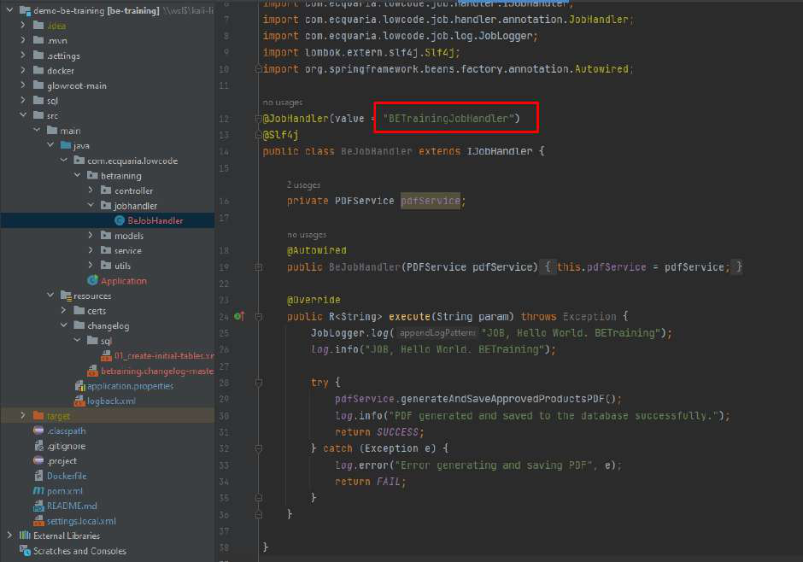

**Practical 27.1: Creating and RunningJob(Demonstration)** ● The PDF generation of product listing has been configured to run via job scheduler. If we click the Download button, no file is downloaded because the job is not running.

|  |
| --- |
|  |

● As an admin, you can create a job scheduler via the “Create” button.

|  |
| --- |
|  |

|  |  |
| --- | --- |
| **Field Name** | **Description** |
| Job Name | The unique identifier for the scheduled job. |
| Executor | The service responsible for executing the job. |
| Cron | The cron expression defines the job's schedule. The cron syntax is using Quartz scheduler library. |
| Validity Start Date/Time | The date and time when the job becomes active. |
| Validity End Date/Time | The date and time when the job becomes inactive. |
| Job Handler | The specific handler or method that executes the job logic. |
| Route Strategy | The strategy used to route the job to an executor.  Route Strategies supported:   1. **Round Robin** - Jobs are distributed sequentially to the executor across application instances. This strategy is ideal for high-availability (HA) setups with multiple instances.  2. **Sticky** - A job is assigned to an executor on the first workflow instance, ensuring consistent handling.  3. **Broadcast** - Jobs are executed by all executors across all application instances simultaneously. This strategy is suitable for tasks that require uniform application across all instances. |
| Block Strategy | The strategy to handle job execution conflicts. Block Strategies supported: |

|  |  |
| --- | --- |
|  | 1. **Serial** - Waits for the current job to execute first.  2. **Discard Later** - Discards incoming job and continues running the previous job in the event it has not  finished running yet.  If the job blocks and is unable to complete, that is where the Job Timeout Period comes into picture to terminate the job. |
| Job Timeout Period | The maximum duration the job is allowed to run before timing out. |
| Job Description | A brief description of the job's purpose and functionality. |
| Schedule Forecast | Plan the timing and execution of your scheduled jobs |

● Endpoint assignment is also required for JobHandler to execute.

|  |
| --- |
|  |

● **Run** the Job function by clicking on the dropdown.

|  |
| --- |
|  |

|  |
| --- |
|  |

● From the “Job Log”, note that we can view the job execution success or failure.

|  |
| --- |
|  |

JobLogger function allows log to be written to the Job Scheduler log

JobLogger.log("JOB, Hello World. BETraining");



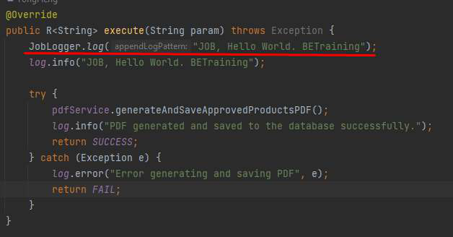

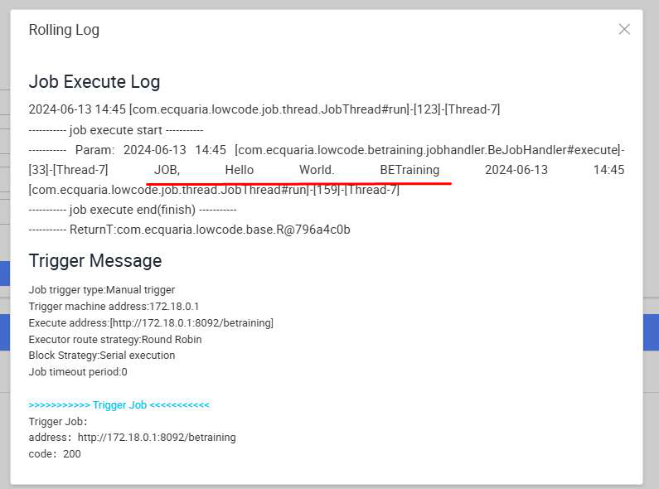

● Back to our application, when we click the “Download” button, a PDF file is downloaded.

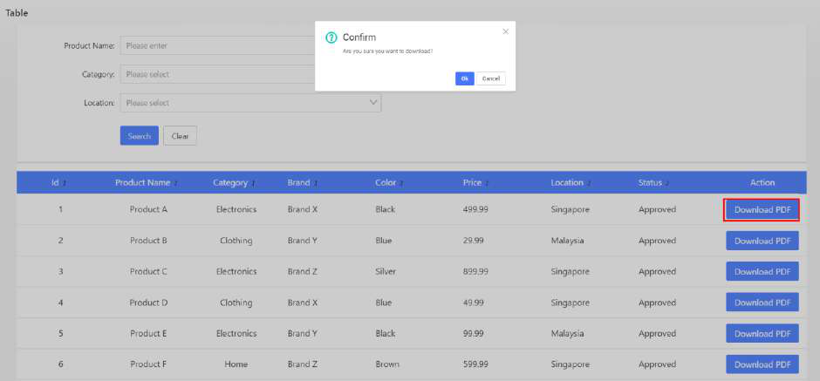

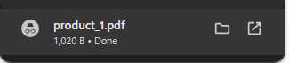

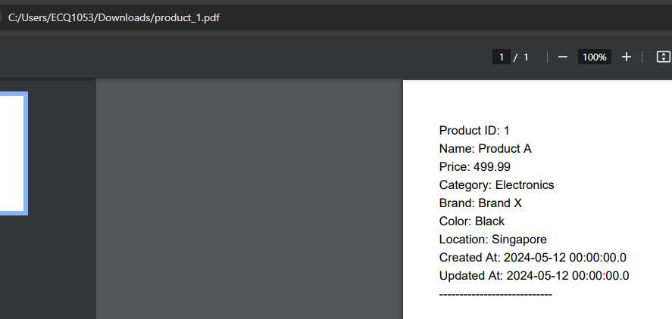

Note:   
1) For custom service to appear in the dropdown, it needs to be added to the “service.names.mesh” property in application.properties file.

Example:   
**application.properties**file

...

...

service.names.mesh:'{"iam":{"host":"kaizen-trg-be-iam-service.kaizen-  
trg.svc.cluster.local","port":8082,"contextPath":"/iam"},"console":{"host":"kaizen-trg-be-console-service.kaizen-  
trg.svc.cluster.local","port":8083,"contextPath":"/console"},"common":{"host":"kaizen-trg-be-common-service.kaizen-  
trg.svc.cluster.local","port":8084,"contextPath":"/common"},"job":{"host":"kaizen-trg-be-job-service.kaizen-  
trg.svc.cluster.local","port":8085,"contextPath":"/job"},"gateway":{"host":"kaizen-trg-be-gateway-service.kaizen-  
trg.svc.cluster.local","port":8081,"contextPath":""},"pagescan":{"host":"kaizen-trg-be-lighthouse-scanner-service.kaizen-  
trg.svc.cluster.local","port":8086,"contextPath":""},"workflow":{"host":"kaizen-trg-be-workflow-engine-service.kaizen-  
trg.svc.cluster.local","port":8087,"contextPath":"/workflow"},"setup":{"host":"kaizen-trg-be-setup-service.kaizen-  
trg.svc.cluster.local","port":8089,"contextPath":"/setup"},"betraining":{"host":"kaize n-trg-be-training-service.kaizen-  
trg.svc.cluster.local","port":8092,"contextPath":"/betraining"},"iamproxy":{"host":"ka izen-trg-be-iam-proxy-service.kaizen-  
trg.svc.cluster.local","port":8091,"contextPath":"/iamproxy"}}'   
...

...



|  |
| --- |
|  |

**Tutorial 28: IAM**

This tutorial covers the following Learning Objectives:

● Understand the concepts of IAM (Identity and Access Management) and Role-Based Access Control (RBAC).

● Explore the relationships between user domains, users, roles, privileges, and endpoints.

● Learn how to manage user roles, assign privileges, and secure access to endpoints in an application’s domain environment.

In this tutorial, you will understand KAIZEN’s IAM system with RBAC, including defining user domains, assigning roles to users, configuring privileges, and managing access to endpoint resources securely and efficiently. This structure supports dynamic role and privilege assignments, allowing administrators to fine-tune access control. Privileges and resources ensure least-privilege access, aligning with security best practices. By leveraging this RBAC model, your application can provide efficient, scalable, and secure user access management tailored to organizational needs.

KAIZEN’s IAM features can be accessed here via the ‘Access Controller’ menu, which can be accessed only if you have the admin role assigned to your user account.

|  |
| --- |
|  |

Note that these are all actual runtime IAM features configurable for your application. In addition to this, KAIZEN also allows you to create your IAM configurations during the design phase of your application in the application level from the studio console.

|  |
| --- |
|  |

You may access the admin user account in the Training Playground domain to access the IAM features.

**URL**: <https://kaizen-training.toppanecquaria.com/#/login>

**User Domain:**Training Playground   
**Username**: admin   
**Password**: Password$1234

**Relationship: User domain ->* User ->* role ->* privileges ->* resources (API**

**endpoints/menu/page)**

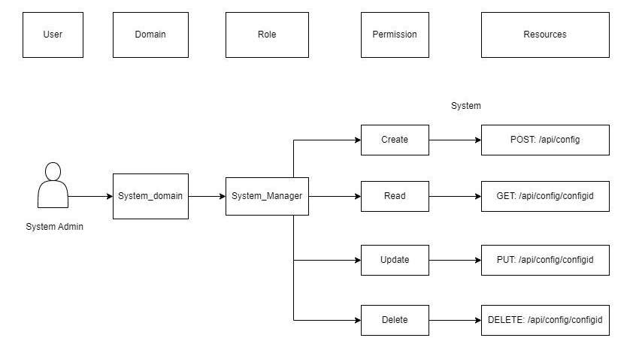

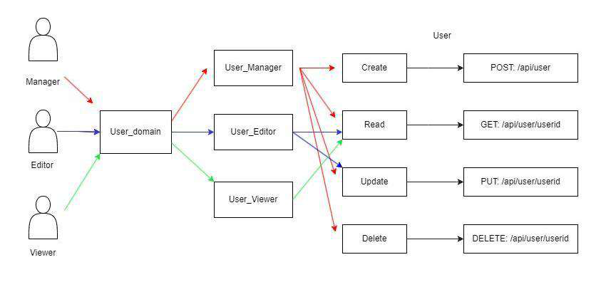

Example Flow

1. Currently there are 3 users in the "Sales" domain who are assigned to 3 roles: “Manager”, "Editor" and "Viewer."   
**2.** The Editor role has privileges to READ and UPDATE sales data endpoints.

**3.** The Viewer role has privileges to READ sales data endpoints.

**4.** The Manager gains combined access to CREATE,READ,UPDATE,DELETE sales data endpoints

**1. User Domain**

The User Domain acts as a boundary for user management and access control. It groups users, roles, privileges, and resources to enforce segregation of duties and multi-tenancy. Each domain defines its unique policies, ensuring users and roles within one domain do not conflict or overlap with those in another. For example, a project might have 2 applications, one being a customer facing portal (Internet) and the other being an internal staff portal (Intranet). In this case, the User Domain is introduced to maintain separation and enforce access control between the two user groups.

The user domain can only be accessed and configured by the ‘super admin’ role from the ‘Kaizen Default’ domain. You are also able to see this domain from KAIZEN’s login screen.

|  |
| --- |
|  |

|  |
| --- |
|  |

**2. User**   
A User represents an individual entity with a unique identity within a specific domain. ● Each user can belong to only one domain.

● A user can be assigned one or more roles, depending on their responsibilities. ● Users can inherit privileges indirectly through their assigned roles.

|  |
| --- |
|  |

|  |
| --- |
|  |

**3. Role**

A Role is a collection of privileges that represent a job function or responsibility within the domain.

● Roles define what actions a user can perform by grouping privileges. ● Users can have multiple roles, enabling flexible access control.

● Roles are reusable and can be assigned to multiple users.

|  |
| --- |
|  |

In a project scenario, our application offers some predefined roles that can be assigned to users, such as **Project Manager**, **Developer**, **UI Designer**, **Internal Viewer**, and **External**

**Viewer**. Each role is tailored with specific access levels, enabling precise control over features and functionalities for managing both applications and the overall project.

|  |  |
| --- | --- |
| **Subject Type** | **Role Name** |
| Project | Project Manager |
| Maintainer |
| Application | Project Leader |
| Application Manager |
| Developer |
| UI Developer |
| Internal Viewer |
| External Viewer |

More information on Subject will be explained below.

**4. Privileges**

Privileges are granular permissions that define specific actions a role can perform on specific resources.

● A role can have multiple privileges, specifying the allowed operations.

● Privileges enforce fine-grained control over application features and functionalities.

|  |
| --- |
|  |

**5. Resources (Endpoints)**

Resources refer to the endpoints or specific system assets that users can access. In our case, KAIZEN segregates access to various resources through endpoints.

● Privileges are directly linked to resources, ensuring precise control over what each user or role can access.

● Resources can include APIs, web pages, data objects, or any system element exposed through an endpoint.

● Privileges define how resources are accessed, ensuring security and preventing unauthorized actions.

|  |
| --- |
|  |

|  |
| --- |
|  |

**Subject** adds a contextual layer to RBAC, by ensuring that roles and privileges apply only within a defined scope.

**Court Case Example: How "Subject" Works**   
We can use Subject to add RBAC control to the data level. In a Court Case Management system, we can use Subject to control the access rights for each court case.

Imagine a judicial system where different individuals take on roles such as Judges, Lawyers, and Clerks. Each role comes with specific privileges, but access to court cases should be restricted based on assignment.

● **Admin users** may oversee case management but should not influence case outcomes.

● **Lawyers** should only access the cases they are representing and file documents, but they cannot assign judges.

● **Judges** should have full decision-making privileges over cases they are assigned to, but they cannot access or modify cases they are not involved in.

In this scenario, the court case itself acts as the Subject. A judge is not simply assigned a role, they are assigned a role in relation to a specific case.

**Practical Example: Judge Case Assignment**   
Consider Judge Alice and Judge Bob. They are both Judges, but their privileges are scoped to the cases they preside over.

● Judge Alice is assigned with Judge role to Case #1001. She can review evidence, issue rulings, and set hearings for this case.

● Judge Bob is assigned with Judge role to Case #1002. He has similar privileges but only within the context of his case.

● Neither Judge Alice nor Judge Bob can interfere in each other's cases, even though both are Judges.

This fine-grained control is achieved by defining the court case as a Subject, ensuring that privileges are only valid within the assigned scope.

Practical 28.1: Assignment of custom menu (Optional)

This tutorial covers the following Learning Objectives:

● Learn how to assign custom menus and pages to your application.

● Enhance navigation and user experience by providing tailored menus.

● Understand how to structure your application to meet user needs more effectively.

In this tutorial, you will explore the process of assigning custom menus and pages to your application. This customization enables a personalized user experience, where navigation and page layout are adapted to meet the specific needs of your users or organization.

|  |
| --- |
|  |

**Create and Assign Menu**

● In the menu edit/create, you can fill in different fields such as name, label, path and target.

|  |
| --- |
|  |

● Menu also supports nested layer

|  |
| --- |
|  |

● Click on More > Assign

|  |
| --- |
|  |

● Users can assign custom privilege to allow only authorized users to view the menus

|  |
| --- |
|  |

Practical 28.2: Endpoint Assignment (Optional)

This tutorial covers the following Learning Objectives:

● Understand how to assign endpoints to different functionalities within your application. ● Learn how to organize and manage API endpoints efficiently.

● Enhance application performance by structuring endpoints according to functional needs.

In this tutorial, you will learn how to assign and manage API endpoints for various functionalities within your application. Organizing endpoints ensures that each API is structured and   
accessible, making your backend services more efficient and easier to maintain.

|  |
| --- |
|  |

**Create new endpoint assignment**  
 ● In the endpoint assignment page, click on “Create” button.

|  |  |
| --- | --- |
| **Field** | **Description** |
| **Endpoint** | The specific URL or path where the API request is directed. |
| **Method** | The HTTP method used for the request (e.g., GET, POST, PUT, DELETE). |
| **Match Type** | The criteria used to match the request to the endpoint (e.g., exact match, prefix match, regex). |
| **Service Name** | The name of the service or functionality that the endpoint is associated with.  Note: For custom service to appear in the dropdown, it needs to be added to the “service.names.mesh” property |
| **Status** | The current status of the endpoint (e.g., active, inactive). |

|  |
| --- |
|  |

● Endpoint also support regex expression

|  |
| --- |
|  |

● After creating endpoint, click on More > Assign

|  |
| --- |
|  |

● Users can also assign custom privilege to the endpoint to allow only authorized users to call the endpoint

|  |
| --- |
|  |

Note:   
1) For custom service to appear in the dropdown, it needs to be added to the “service.names.mesh” property in application.properties file.

Example:

**application.properties**file

...

...

service.names.mesh:'{"iam":{"host":"kaizen-trg-be-iam-service.kaizen-  
trg.svc.cluster.local","port":8082,"contextPath":"/iam"},"console":{"host":"kaizen-trg-be-console-service.kaizen-  
trg.svc.cluster.local","port":8083,"contextPath":"/console"},"common":{"host":"kaizen-trg-be-common-service.kaizen-  
trg.svc.cluster.local","port":8084,"contextPath":"/common"},"job":{"host":"kaizen-trg-be-job-service.kaizen-  
trg.svc.cluster.local","port":8085,"contextPath":"/job"},"gateway":{"host":"kaizen-trg-be-gateway-service.kaizen-  
trg.svc.cluster.local","port":8081,"contextPath":""},"pagescan":{"host":"kaizen-trg-be-lighthouse-scanner-service.kaizen-  
trg.svc.cluster.local","port":8086,"contextPath":""},"workflow":{"host":"kaizen-trg-be-workflow-engine-service.kaizen-  
trg.svc.cluster.local","port":8087,"contextPath":"/workflow"},"setup":{"host":"kaizen-trg-be-setup-service.kaizen-  
trg.svc.cluster.local","port":8089,"contextPath":"/setup"},"betraining":{"host":"kaize n-trg-be-training-service.kaizen-  
trg.svc.cluster.local","port":8092,"contextPath":"/betraining"},"iamproxy":{"host":"ka izen-trg-be-iam-proxy-service.kaizen-  
trg.svc.cluster.local","port":8091,"contextPath":"/iamproxy"}}'   
...

...



|  |
| --- |
|  |

2) After editing Endpoint Assignment, backend deployment needs to be restarted for the change to take effect

|  |
| --- |
|  |